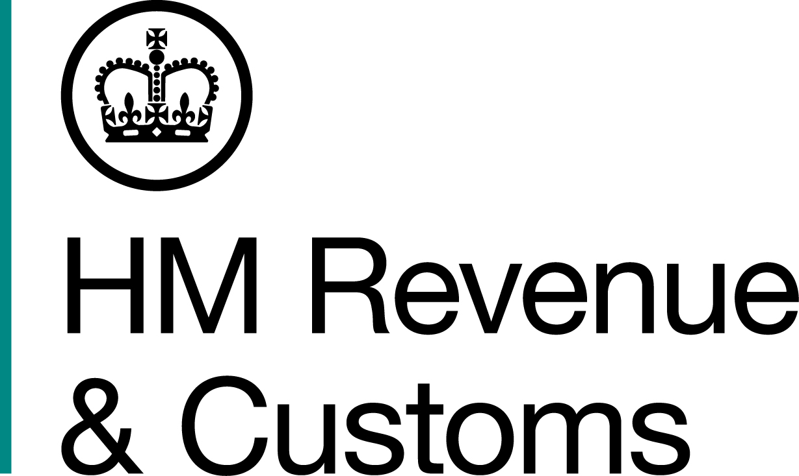
News Release

 | For the attention of News Desks |  | No of pages: 2
 | Date: | 27 July 2018 | Ref: | WM 11 18

HMRC unearths seven tonnes of tobacco inside potato sacks

Investigators have seized nearly seven tonnes of illegal tobacco after a raid at a farm in Warwickshire.

Around 20 officers from HM Revenue and Customs (HMRC) found 6.97 tonnes of tobacco, worth more than £2 million in evaded duty, inside potato bags at two rented agricultural buildings, in Bedworth, near Coventry.

The buildings were lined with black sheet plastic and were being used to process and cut hand rolling tobacco, without the landlord’s knowledge.

Officers also discovered counterfeit packaging, a cutting machine, and more than 10,000 cigarettes, which were all seized.

Richard Paris, Assistant Director, Fraud Investigation Service, HMRC, said:

“Tobacco fraud costs the UK £2.5 billion a year in lost tax, money that should be funding vital public services in the UK. This is theft from the taxpayer and it undermines legitimate traders.

“We encourage anyone with information regarding the smuggling, storage or sale of illegal tobacco to report it to HMRC online, or contact our Fraud Hotline on 0800 788 887.”

No arrests have been made and enquiries are ongoing.

Information about any type of tobacco or tax fraud can also be reported to HMRC online at www.gov.uk/report-an-unregistered-trader-or-business.

Notes for Editors

- HMRC seized 6.97 tonnes of tobacco, along with 10,160 cigarettes, at the rented properties in Bedworth, near Coventry, on July 12.

- Follow HMRC’s Press Office on Twitter @HMRCpressoffice

Issued by HM Revenue & Customs Press Office

Press enquiries only please contact:

Nick McCarthy
Tel: 03000 589 546 or 07741 615 634
Email: nick.mccarthy@hmrc.gsi.gov.uk

Out of hours
Tel: 07860 359544
Website: www.gov.uk/hmrc

