Yanmar Compact Tractors on the Streets of Europe
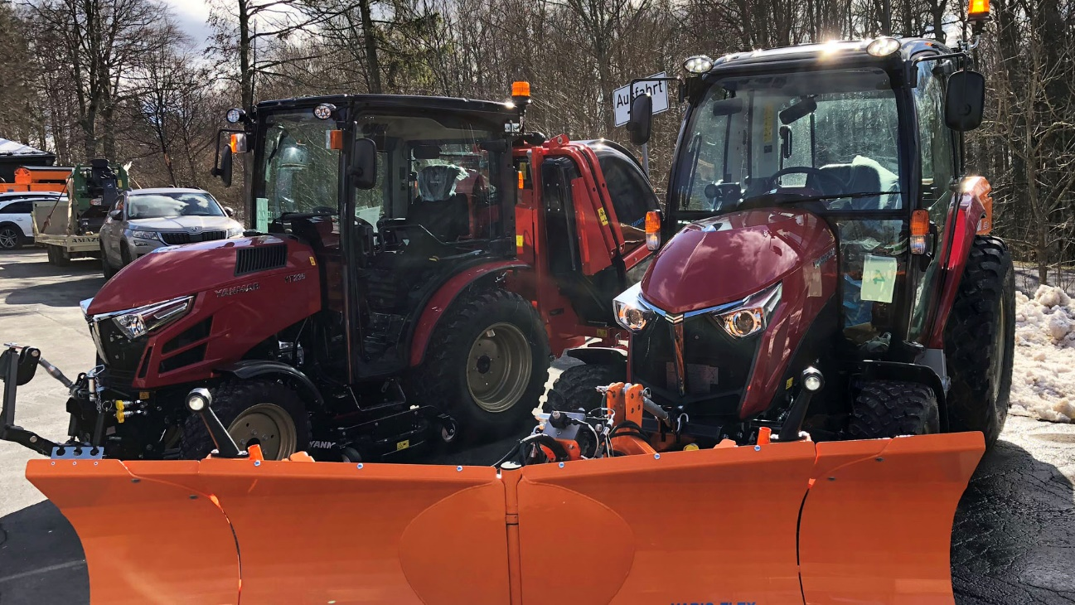
Yanmar’s tractors show off their winter service abilities.

BayWa Winter Service Days
The BayWa Winter Service Demo Event, organized by Yanmar’s agricultural equipment dealer in Germany, BayWa AG in Munich, takes place every two years and has already become a tradition. Over two weeks, the event visits five locations in Germany. The many visitors to the event can see and experience nearly 100 machines landscaping, municipality services and green management, but most importantly, for Winter Service The focus of the event is on personal testing and experience, as well as on individual advice.
The visitors who attend these “demonstration days” are compact tractor dealers, landscapers, municipalities contractors and contractors for winter service, and employees of the municipalities.
At Baywa Demo Days, the focus is on the winter service customer. The official German name is: “Winterdienst Vorführtage” – can be translated as Winter Service demonstration days. Winter service is the work required to keep roads and through ways open and clear from snow in the winter months.
The BayWa Demo Event is an excellent opportunity for visitors to orientate themselves on the latest tractors because they can see, touch and drive the machines and ask the demonstrating companies everything they want to know.

Yanmar on the streets of Europe
In the urban setting, the compact tractor carries out a wide variety of jobs, generally categorized in to Green: mowing and greens maintenance, Grey: street cleaning and maintenance, White: snow removal, and Brown: soil preparation or even agricultural work.
Explains Bernd Albrecht, Yanmar’s Sales Manager for Germany, “The people who look at Yanmar’s tractors are landscapers and municipalities who want to them for winter service. So, the most common uses are Green, Grey and White. The white being the most important, then the green part.”
In the urban setting, Yanmar’s compact tractors are an indispensable tool in fulfilling these roles.
This year was Yanmar’s second outing at Baywa, the first visit being at the 2017 edition.
What sets Yanmar apart is that it is currently the only company demonstrating compact tractors at BayWa. Seven tractors were demonstrated: SA221B-Q, SA424B,-Q (2 machines), YT235-Q (2 machines), YT347-Q and the YT359-Q. Visitors enthusiastically praised the modern design, advanced technologies and clean engines of the tractors.
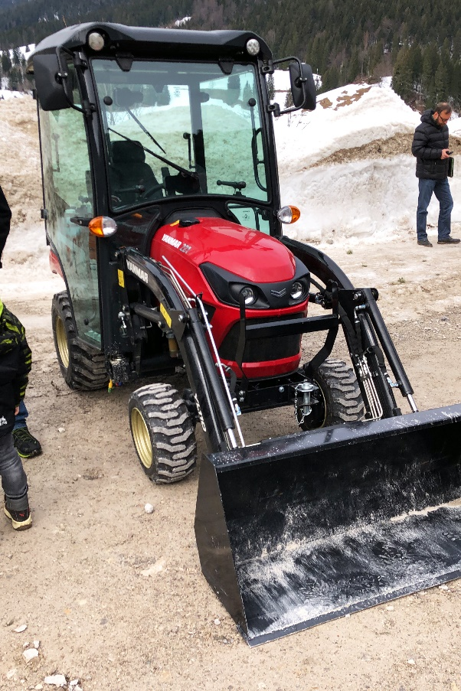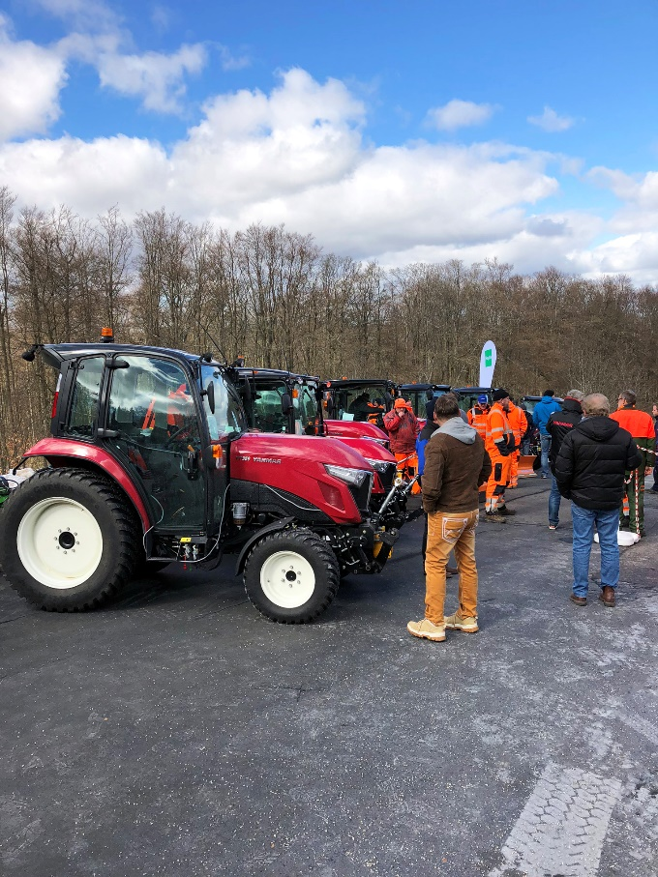
Dealers and users inspect the Yanmar tractor lineup

Hands on demonstration
A key characteristic of BayWa is the hands-on nature of the event.
Exhibitors first present the tractors and they are driven and demonstrated in front of the visitors, then later, the visitors have a chance to examine the tractors in detail and even drive them to see how they really operate.
Activities at the Yanmar stand began with demonstrations, including some clearing of snow using a new Wiedeman Hybrid (foldable) Snow Blade.
Visitors who joined Yanmar at the stand then had the chance to drive the equipment and get to know the features. By operating the equipment, users can experience first-hand how comfortable the tractor is, and most importantly, check the dimensions of the vehicle. In the up to 40hp range, winter service customers require a tractor that is exceedingly compact to allow it to operate on Europe’s streets, and in fact, height and width are among the most closely examined specifications. Yanmar’s equipment helps customers realize these strict requirements with heights of approximately 2 meters or less and width of under 1.3 meters for the YT2 and less than 1.2 meters for the SA series.

Yanmar highlights
At Yanmar’s first BayWa Winter Service days in 2017, the company was something of an unknown quantity, but 2019 is a different story, with more visitors now familiar with the Yanmar name and keen to learn about the features, specifications and capabilities of the Yanmar tractors.
The integrated hydro-mechanical transmission (i-HMT) in the YT3 drew a lot of interest. Similar systems are more frequently found in larger tractors, but currently no other compact tractor manufacturer offers anything like it.
Also turning heads among winter service and municipality customers was the YT235. The Yanmar YT235-Q is compact and strong, but also very comfortable - qualities much in demand by the Winter Service customer.
The same can be said for the SA424B-Q but being even smaller it is found more in the cities.

For Yanmar, the BayWa demonstration event is a great way to meet old and new customers and get immediate feedback on what they see and experience. It also reinforces our already strong relationship with BayWa and strengthens Yanmar’s agricultural activities in the market. We look back on a lively, successful and well-organized event.
