KONGSBERG wins first full-scope expedition cruise vessel tender, with gensets and propulsion equipment

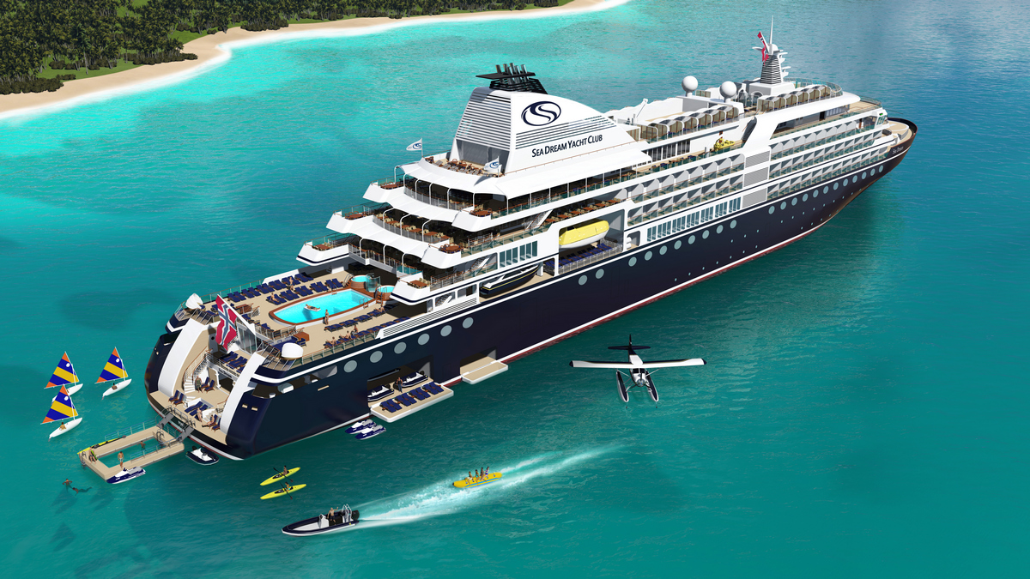

Kongsberg, Norway, 04th September 2019 – KONGSBERG has just signed a contract with Damen Shipyards in the Netherlands for the delivery of a fully integrated Kongsberg Maritime solution to the SeaDream Yacht Club cruise line.
Valued at more than NOK 190 million, KONGSBERG’s most extensive ‘Full Picture’ delivery for an expedition cruise ship, Innovation, also encompasses the supply and integration of propulsion equipment including the new ELegance azimuth pod system, Bergen engines, stabilizers, bridge and automation systems, accompanied by a comprehensive electrical, navigation and hybrid technology package. Delivery is expected to be accomplished in the second quarter of 2020, with the engineering and construction phases taking an estimated two years to complete.
The ship will be fully compliant with the IMO’s forthcoming 2020 emission rules and regulations. An energy consumption and analysis system based on KONGSBERG’s digital platform will provide tools for detailed monitoring and energy optimisation.
“Both Damen and SeaDream are synonymous with peerless quality, attention to detail and environmentally-conscious principles,” says Egil Haugsdal, President, Kongsberg Maritime, “The Full Picture portfolio offers the most diverse mix of technology, engineering and digital solutions. When applied to an integrated delivery for the Innovation, it will enable highly efficient operations regardless of location and conditions.

“With KM’s expertise in energy management systems and fuel-saving technology,” Haugsdal continues, “this delivery not only raises the bar for sustainability in the cruise sector, but also represents a positive strategic step as our first expedition cruise contract with full scope for Kongsberg Maritime.”
Ends

For further information, please contact:

Gunvor Hatling Midtbø, VP Communication
Kongsberg Maritime
Tel: +47 9921 4209
gunvor.hatling.midtbo@km.kongsberg.com

Saul Trewern
Saltwater Stone
Tel: +44 (0)1202 669244
s.trewern@saltwater-stone.com

About Kongsberg Maritime
Kongsberg Maritime is a global marine technology company providing innovative and reliable ‘Full Picture’ technology solutions for all marine industry sectors including merchant, offshore, cruise, subsea and naval. Headquartered in Kongsberg, Norway, Kongsberg Maritime has manufacturing, sales and service facilities in 34 countries.
Kongsberg Maritime solutions cover all aspects of marine automation, safety, manoeuvring, navigation, and dynamic positioning as well as energy management, deck handling and propulsion systems, and ship design services. Subsea solutions include single and multibeam echo sounders, sonars, AUV and USV, underwater navigation and communication systems.
Training courses at locations globally, LNG solutions, information management, position reference systems and technology for seismic and drilling operations are also part of the company’s diverse technology portfolio. Additionally, Kongsberg Maritime provides services within EIT (Electro, Instrument & Telecom) engineering and system integration, on an EPC (Engineering, Procurement & Construction) basis.
Kongsberg Maritime is part of Kongsberg Gruppen (KONGSBERG), an international, knowledge-based group that celebrated 200 years in business during 2014. KONGSBERG supplies high-technology systems and solutions to customers in the oil and gas industry, the merchant marine, and the defence and aerospace industries.
Web: Kongsberg Gruppen | Kongsberg Maritime
Social media: LinkedIn | Twitter | Facebook

