AddQ releases a Result Management Plugin for National Instruments TestStand.

**The Quality Result Management (QRM) plugin is a web based result storage system that solves all your problems with local result storage and long database transaction times.**

QRM - Improved Yield, Quality and Better Decision Making.

Install our TestStand Result Processor and get instant access to Production data, SPC-statistics and Six Sigma analysis.

QRM (Quality Result Management) is a distributed system that can be configured in different ways to match the needs of your infrastructure.

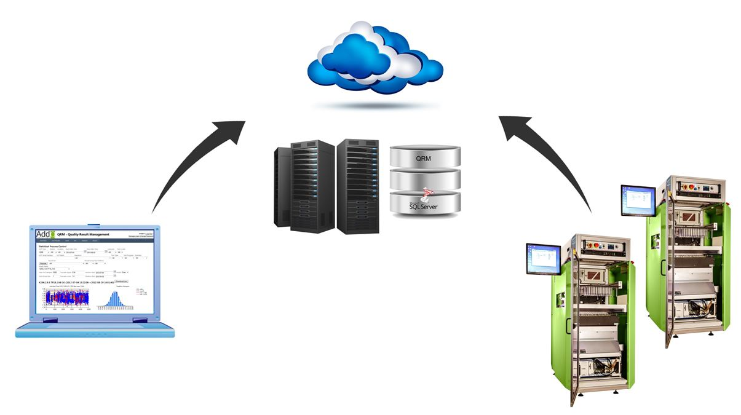

The QRM tool is a web based result management system that stores and analyzes test results.

Its flexible system uses web servers, databases and ATML XML data which can easily be setup on a single computer, a server or a cloud solution.

ATML (Automated Test Markup Language) is an XML standard for test reports.

QRM has a powerful web interface for easy web access where the user can view and analyze the test results, it is also possible to generate PDF-reports and export data to both Excel and Minitab.

QRM data consists not only of measurement data, but also includes a lot of additional information such as traceability of the station, equipment used, configuration version and additional UUT (Unit Under Test). Additionally, sites can be connected by the distributed architecture of QRM.

It is also possible to attach any kind of file with the reports (graphs, log files etc).

By using the QRM web application test results can be viewed and analyzed as products are produced.

Download the plugin [here](http://www.addq4.se/download/).

**Want to know more about QRM?**

Come and talk to us at the [Nordic Test Forum](http://www.nordictestforum.org/home) on the 25th and 26th of November.

Or visit our webpage at:<http://www.addq.se/>  
<http://www.addq.se/qrm>

**For purchasing information, please contact:**

[Mats Backlund](mailto:mats.backlund@addq.se?subject=NI%20Days%202014), Sales Manager at AddQ Consulting, +46 (735) 142 190