Maritime Academy of Asia and the Pacific adopts Kongsberg Digital’s simulation-based eLearning solutions
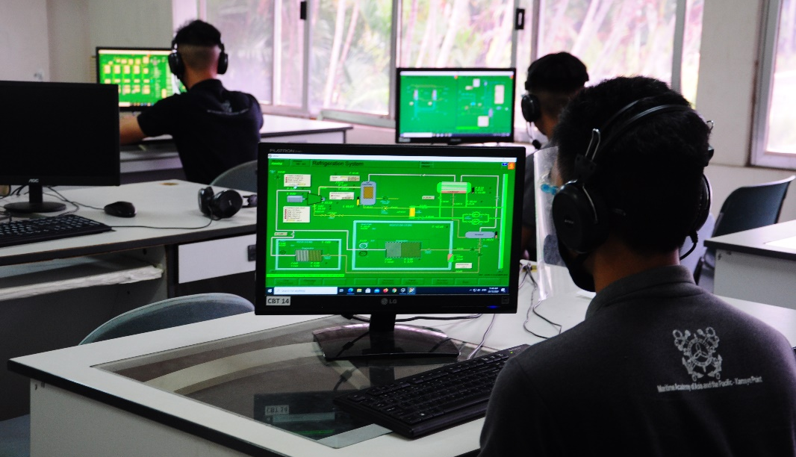
Kongsberg Digital’s K-Sim Connect platform enables MAAP to provide online volume training to its students, who can then efficiently train and prepare for exams anytime and anywhere
Kongsberg, Norway, January 5th, 2021 – Kongsberg Digital reports that the Maritime Academy of Asia and the Pacific (MAAP) has adopted its new
K-Sim eLearning solution, as well as commissioning installation of a cutting-edge K-Sim Safety firefighting simulator at its premises in the Philippines.
Kongsberg Digital is heading the digitalization of the maritime training industry and is continuously adding new simulation-based training applications to its digital platform, K-Sim Connect. Already adopted by many training institutes, K-Sim Connect provided more than 23,000 cloud-based simulations to customers worldwide during 2020.
MAAP – a leading institution of excellence for maritime education and training in the Asia-Pacific region – has for decades been a pioneer in the use of new simulation-based training tools. Now, the Academy has started using Kongsberg Digital’s K-Sim Engine eLearning solutions to deliver cloud-based tuition to its student engineers, consolidating its position as a leading adopter of the new digital technology.
Designed to provide highly realistic representations of real engine models, this cutting-edge eLearning tool allows students to practice and prepare for their exams anytime, anywhere and at their own pace, whilst providing a comprehensive simulation resource.
“The K-Sim Connect platform with its applications and services is a timely and cost-effective solution for the limitations posed by the recent global coronavirus pandemic on maritime education and training in the Philippines,” comments Admiral Eduardo Ma. Santos, President at MAAP. “MAAP signed up for 100 simultaneous user licenses that will provide our students continuing access to simulation-based engine room exercises online, without the need for face-to-face collaboration with the instructor-facilitator.”
Engr. Gerardo Ramon Galang, Director for IT and Simulator Support, added: “Our new normal now consists of combining video conferencing and other collaboration apps with the K-Sim Connect eLearning solutions during the actual conduct of simulation exercises, enabling a seamless transition from the traditional mode of learning while maintaining the same high standards in delivering quality maritime simulator training services to our students and customers.”
“We’re very pleased to see how well received our digital solutions for the maritime training market have been since we started rolling them out last year,” says Andreas Jagtøyen, VP, Kongsberg Digital. “As a leading educational establishment in Asia, MAAP have always been among the first to adapt to the latest training methods. Their choice to add our cloud-based simulation solutions to their physical KONGSBERG simulators is a welcome endorsement of our new digital simulation services.”
Also included in the latest contract with MAAP is Kongsberg Digital’s new full-mission
K-Sim Safety simulator, which will deliver the ability to carry out safe, realistic advanced firefighting and onboard search and rescue procedures in a cost-efficient manner. Using a replica of the layout on board a real crude oil carrier, an interactive 3D environment combines precise object and equipment models with immersive visuals, exposing trainees to a broad range of situations related to preventing and dealing with onboard fires. As with all Kongsberg Digital’s simulation solutions, K-Sim Safety is designed to conform with relevant STCW regulations.
Ends

For further information, please contact:

Anne Voith
Marketing and Communications Manager, Simulation
Kongsberg Digital
Tel: +47 3303 2000
anne.voith@kdi.kongsberg.com
David Pugh
Saltwater Stone
Tel: +44 (0)1202 669244
d.pugh@saltwater-stone.com

About Kongsberg Digital
Kongsberg Digital is a provider of next-generation software and digital solutions to customers within maritime, oil and gas, and renewables and utilities. The company consists of more than 500 software experts with leading competence within the internet of things, smart data, artificial intelligence, maritime simulation, automation and autonomous operations.
Kongsberg Digital is subsidiary of KONGSBERG (OSE-ticker: KOG), an international, knowledge-based group delivering high-technology systems and solutions to clients within the oil and gas industry, subsea, merchant marine, defence and aerospace. KONGSBERG has 11,000 employees located in more than 40 countries.
Web: Kongsberg Gruppen | Kongsberg Digital
Social media: LinkedIn | Twitter | Facebook

