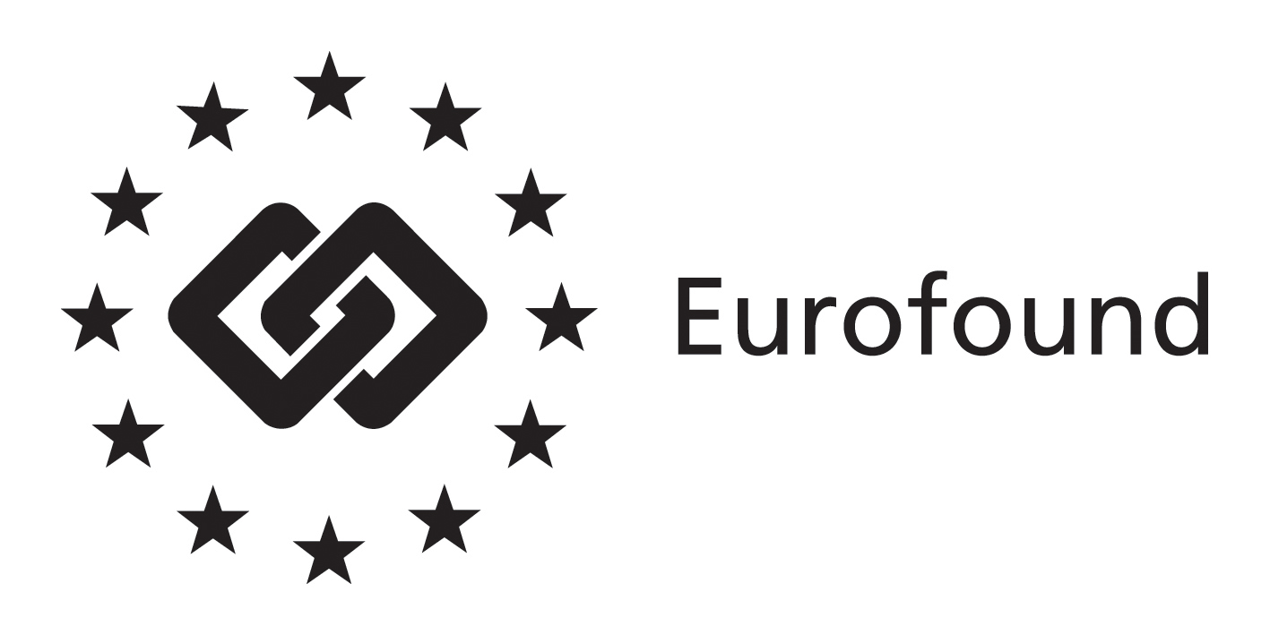
Press Release

14 July 2014
---------------------------------------

www.eurofound.europa.eu @eurofound

Eurofound publishes it 2013 yearbook on living and working Europe:
Europe is struggling to deliver improved living and working conditions for all
(Dublin, Ireland): Towards the end of 2013, labour market conditions showed signs of stabilising. However, unemployment remained high and the economic recovery remained fragile, and Europe is clearly struggling to deliver improved living and working conditions for all. Eurofound’s fifth annual yearbook ‘Living and working in Europe’, based on the Agency’s research from 2013, describes developments in the EU in the wake of the crisis, focusing on major topic areas including changes in labour markets and employment, efforts to tackle youth unemployment, innovation in workplaces and public trust in institutions. The yearbook is accompanied by the Annual activity report of the Authorising Officer 2013, which is the Agency’s formal reporting on operations, staff and budgets.
While unemployment showed signs of stabilising in 2013, it remained high at 10.7%. Striking differences across Member States persisted: rates of 28% in Greece and 26% in Spain, contrasted sharply with rates of 5%–6% in Austria, Germany and Luxembourg. Manufacturing and construction continued to sustain the highest levels of job loss, while the greatest job growth was seen in high-skilled service activities, such as ICT and healthcare. Despite high unemployment, however, the first findings from Eurofound’s European Company Survey showed that 4 out of 10 European managers report having difficulties finding employees with the skills they need.
The yearbook review of 2013 suggests that Europe is struggling to deliver improved living and working conditions for Europeans. Large differences exist not only between different groups of citizens, but between Member States. This state of affairs is antithetical to the goals of the European project and presents considerable challenges to policymakers. Eurofound’s mission is to contribute through the knowledge it creates to the work of policymakers as they address these challenges.
Eurofound’s labour market analyses in 2013 showed that middle-paying jobs, which declined heavily in the crisis, continue to be lost. While growth is occurring in higher-paying jobs, it does not outweigh that job loss. The jobs being lost are those that employ men mostly.
Meanwhile, employment of women has been growing modestly and they are taking a greater share of those high-paying jobs. Still, seven and a-half million young people are out of work and not in any form of education, which represents an estimated loss of about €163 billion annually in welfare transfers and lost incomes and taxes. The failure to secure a job is delaying their transition into adulthood, preventing them from achieving economic independence (and often delaying their establishment of families), with potentially detrimental consequences for their long-term financial security and well-being.
In this context, decline of trust in public institutions (parliaments and governments) across Europe comes as little surprise, but what is perhaps unexpected is that the main influence on people’s trust, uncovered by Eurofound’s research, is not the perceived economic situation of their country but the quality of public services. In this difficult context, Eurofound also focused its analysis on such issues as changing working conditions, the evolution of pay and undeclared work.

Download the Living and Working in Europe report at http://bit.ly/1rG7WTz
Access the Annual activity report of the Authorising Officer 2013 at http://www.eurofound.europa.eu/publications/htmlfiles/ef1432.htm

For further information contact xx, xx, on email: xxx@eurofound.europa.eu, or telephone: +353-1-204 3xxx.

NOTES TO THE EDITOR
The European Foundation for the Improvement of Living and Working conditions (Eurofound) is a tripartite European Union Agency, whose role is to provide knowledge in the area of social and work-related policies. Eurofound was established in 1975 by Council Regulation (EEC) No. 1365/75.
For more information about Eurofound and its work, and free access to all our data and findings, visit our website and follow us on these social media channels: Twitter, Facebook, Google+, YouTube, or Flickr.

