Why Cloud Computing?
It’s useful to begin with a loose definition of the rather nebulous concept that is cloud computing , so see here for a full explanation of what the term means, but for our purposes here, let’s define it as computing resources, (computation and storage) packaged as a metered service similar to public utilities like electricity.

In IT terms, the true value of cloud computing lies in the flexibility it delivers to the organisation; the capability of adding new capacity without needing additional infrastructure, personnel or software licences. In hard cash terms, it means taking the financial pain out of adding new applications, or additional users by converting IT from a capital intensive balance sheet asset to a pay as you go subscription based system.

So, why cloud computing? Simply, it’s cheaper and more efficient but let’s be more specific here:

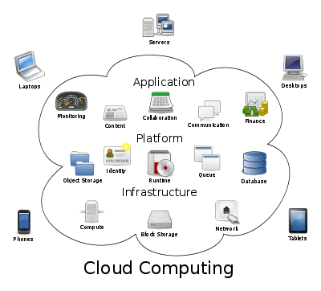

Increased efficiency through outsourcing servers.
Running your own servers into your own data centre means they need power, cooling and running by people with the expertise to do so. Outsourcing these hardware needs means dealing with a provider who does this on a vast scale, far larger than most businesses can afford and so take advantage of the economies of scale they realise. So, the need for server hardware disappears along with the need for server licences. In undertaking this, IT staff are either redeployed or laid off; the old maxim that it’s an IT man’s job to make himself (or herself) redundant holds true.

Reduced hardware costs at the user level.
Computing in the cloud means users need very little computing power on the desktop to run the applications they need for their day to day work; the reason for this is simple, all computing (processing etc.) is done remotely by the servers at the data centre. Consequently many users’ applications can be delivered using either a dumb terminal or a mobile device. Traditionally mobile devices are laptops which confer major problems on the organisation both as a direct cost and/or indirectly through theft, breakages or imprudent loss (leaving in taxis, on aircraft etc.). Like mobile phones it is now possible to dispel that overhead by paying the user a fixed allowance typically monthly and making them responsible for sourcing the device of their choice and being responsible for its availability, safekeeping, insurance and so on. This arrangement is known as Bring Your Own Device or BYOD for short.

Elimination of need for software licences.
Not owning servers means not needing the server licences either! Any IT person will appreciate this is a major cost saving. The same goes for desktop licences, outsourcing means not needing a licence for each machine you operate.

Organisational agility.
Traditionally adding people needing IT or new applications has meant investment in new hardware and software to serve them. Conversely, ceasing use of a product or reducing headcount has meant bearing the additional cost of excess IT capacity in one form or another. Leading on from this, short term project work such as sales campaigns, product launches etc. have been onerous in terms of the cost burdens placed on IT. The real benefit of using a cloud based application means usage can be turned on and off with users added almost instantaneously and when needed removed just as quickly. Consequently short term projects are similarly straightforward to accommodate.

Green computing.
Outsourcing servers means outsourcing the energy costs of powering and cooling them; whether this is a total energy saving is subject to question and dependent on local conditions and energy costs. What you can say with certainty is that taking full account of build and disposal costs does represent a significant reduction in the environmental impact of IT on an organisation. Using lower powered machines on the desktop also means reducing this total environmental impact of IT on the organisation both in terms of power usage and asset disposal. In addition, In house data centres have typically utilise servers around 5 to15% occasionally much less, whereas cloud data centres achieve 30-40% which again has significant effect on the environmental impact of IT.

Reduction in staff costs.
Shifting IT into the cloud means you do not need staff to support your servers; it also drastically reduces the need to support users. The consequence of this is IT staff can be redeployed on to more productive tasks or laid off.

Shift to pay-as-you-go cost model.
Traditionally IT has been a capital-intensive long-term investment with assets firmly anchored on the balance sheet. Moving to the cloud computing model means the costs shift to a pay-as-you-go model which in accounting terms moves costs to the statement of income off the balance sheet. Looking again at the traditional IT model, desktop licencing has meant that all users are licenced to use products they may never use or have any inkling of how to use. Using a desktop delivered over the web means if you are using Word, Excel and PowerPoint, that is all you pay for.

