MEDIA RELEASE

Pan Pacific Hotels Group rolls out B2B and B2C loyalty programmes
Offering guests and corporate bookers more meaningful rewards and benefits

5 September 2018, Singapore — Today’s discerning travellers place greater value than ever on authenticity, customisation and flexibility. Pan Pacific Hotels Group (PPHG) has positioned its Pan Pacific and PARKROYAL brands closer to the customers of today by rejuvenating and introducing new loyalty programmes, Pan Pacific DISCOVERY for guests and Pan Pacific Connections for corporate bookers, offering them more meaningful rewards and benefits.

Pan Pacific Connections, a B2B loyalty programme

A by-invitation only bookers’ programme, Pan Pacific Connections recognises, retains and rewards loyal corporates bookers for booking rooms, meetings and events at all hotels, resorts and serviced suites under PPHG. Membership is open to both corporate accounts and individual booker accounts, where members earn points for every eligible stay and meeting.
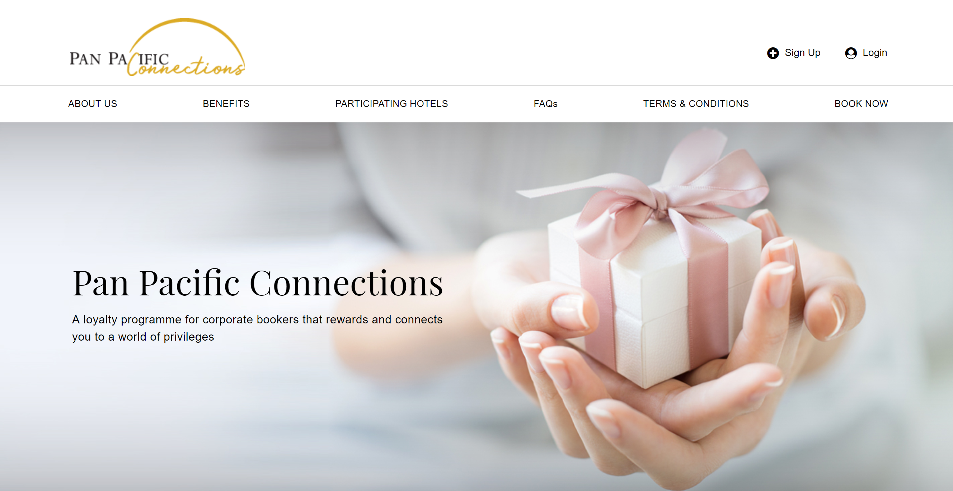

Delivered through a seamless digital platform, members can log-in to their account round-the-clock and book negotiated corporate rates or special corporate rates directly through the website, www.panpacificconnections.com. Members enjoy instant reward points for their bookings, which can be used to redeem a rich selection of rewards from hotel stays, dining, wellness, lifestyle and shopping products.

Pan Pacific DISCOVERY, a B2C loyalty programme

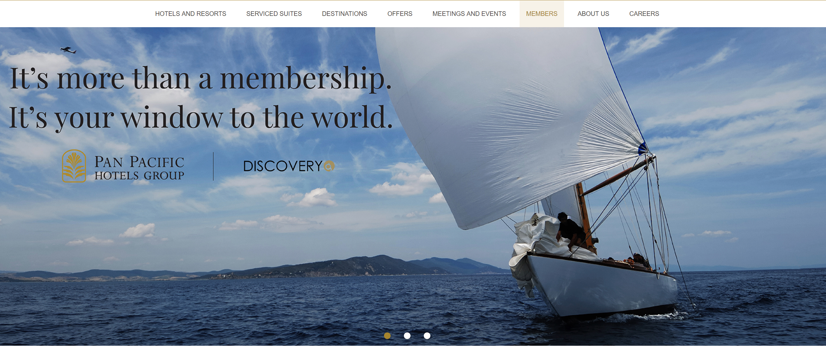

As a founding member of the Global Hotel Alliance (GHA), the world’s largest alliance of hotel brands, PPHG offers membership to DISCOVERY, a guest loyalty programme with a special selection of benefits, personalised services and intriguing Local Experiences to make travel unforgettable.

PPHG has private-labelled this loyalty programme to become Pan Pacific DISCOVERY (Panpacific.com/discovery). Along with that, PPHG is proud to introduce more meaningful benefits to members including an exclusive members’ rate, late check out till 3pm and upgrades to the next room category with direct bookings. As the only Asia-based hotel chain with three product offerings – hotels, resorts, and serviced suites, PPHG will also be extending customised privileges for residents of its Serviced Suites, with a range of benefits such as branded toiletries and complimentary laundry to make their stay as seamless and comfortable as possible.

Ms Cinn Tan, Chief Sales & Marketing Officer, said, “Aligned with our aspirations of sincerity in service, we developed these loyalty programmes from inside out by first looking at the rewards and benefits which are most meaningful to our customers across both B2B and B2C segments. Through Pan Pacific Connections and Pan Pacific DISCOVERY, we hope to generate more brand love and loyalty to our hotels. We keep our customers’ trust in us as their preferred hotel brand in the region by not resting on our laurels but through continuous innovation and improvement.”

-END-

Media Contact

Cuili NG
Brand & Corporate Communications Manager
Pan Pacific Hotels Group
DID: +65 6808 1269
Mobile: +65 9634 4425
Email: ng.cuili@pphg.com

About Pan Pacific Hotels Group

Pan Pacific Hotels Group is a wholly-owned hotel subsidiary of Singapore-listed UOL Group Limited, one of Asia’s most established hotel and property companies with an outstanding portfolio of investment and development properties.

Based in Singapore, Pan Pacific Hotels Group owns and/or manages more than 40 hotels, resorts and serviced suites including those under development in 24 cities across Asia, Oceania, North America and Europe.

Voted “Best Regional Hotel Chain” by readers in Asia in 2017, Pan Pacific Hotels Group comprises two acclaimed brands: its signature brand, Pan Pacific and its deluxe brand, PARKROYAL.

Sincerity is the hallmark of Pan Pacific Hotels Group. The Group is known to its guests, partners, associates and owners for its sincerity in people and the sense of confidence which alleviates the stresses of today’s complex world.

Visit us at www.panpacific.com.

About Global Hotel Alliance

Global Hotel Alliance (GHA) is the world’s largest alliance of independent hotel brands, bringing together 32 brands with over 500 hotels in 78 countries. GHA uses a shared technology platform to drive incremental revenues and create cost savings for its member brands. GHA’s award-winning loyalty programme, DISCOVERY, provides 12 million members exclusive opportunities to immerse themselves in local culture wherever they travel. For more information, visit discoveryloyalty.com

