Kongsberg Digital’s K-Sim® Fishery simulator wins
the coveted SAFETY4SEA 2020 Training Award

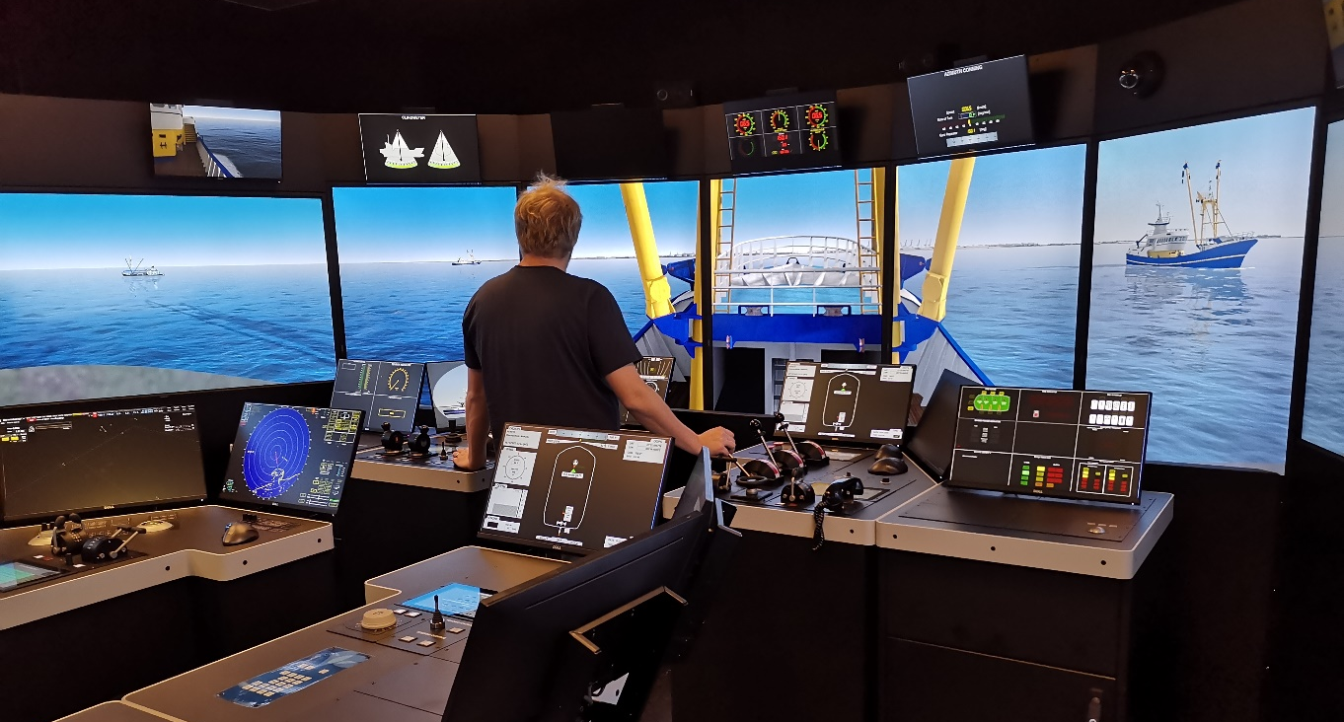
Contributing in enhancing skills, safety and sustainability in the fishing industry, the K-Sim Fishery simulator won the prestigious SAFETY4SEA Training Award 2020

Kongsberg, Norway, October 20th, 2020 – Kongsberg Digital’s acclaimed K-Sim Fishery simulator training solution has secured an important industry accolade by winning the SAFETY4SEA 2020 Training Award. After being shortlisted back in July, K-Sim Fishery was voted into first place by a substantial number of instructors and students who have been impressed by this vessel-specific training resource.
Tone-Merete Hansen, Sr. VP in Kongsberg Digital accepted the prize on behalf of Kongsberg Digital with a speech delivered by video link at a virtual awards ceremony which was streamed on YouTube, Facebook and LinkedIn on Tuesday, October 20th. Presenting the award, Romanos Rodopoulos, Head of Maritime Academy and a board member of category sponsor Metropolitan College, noted that the award recognizes “the contribution of Kongsberg Digital to the technological evolution of maritime education. The K-Sim Fishery simulator complies with STCW training requirements, DNV GL certification standards and the UN Sustainability Goal 14.”
SAFETY4SEA is widely regarded as an influential source of global shipping news with an unswerving emphasis on stories which promote and engender maritime safety, sustainability, regulatory compliance and pivotal developments in smart technology. The K-Sim Fishery simulator training solution exemplifies these values, providing trainees with a safe, environmentally-responsible and high-tech means of gaining all the operational skills and experience they will require when tackling their job roles on fishing boats in the real world.
In line with newly intensified STCW training requirements, the K-Sim Fishery simulator enables instructors to monitor and evaluate each exercise undertaken by individual users. These exercises can be repeated as many times as is necessary for trainees to attain the mandated standard of competence in operating onboard navigation and control equipment as well as gaining essential winch-handling expertise. By precisely replicating the instrumentation and working environment on the bridge of a fishing vessel in all weathers, sea states and situations, the simulator produces an immersive experience which is effectively indistinguishable from the real thing. The main difference, of course, is that users can learn from their mistakes without causing any hardship or suffering any consequence.
“We are delighted to receive this recognition for our K-Sim Fishery simulator, which we believe is an essential tool in building a safer, more sustainable and ethical future for the fishing industry,” commented Tone-Merete Hansen. “The power of simulation training to enhance crew safety, best-practice operations, fuel savings and carbon-footprint reduction is clear, and directly relevant to over 50 million people who rely on fisheries and aquaculture for their livelihoods. By equipping fishermen with the right knowledge, delivered in a secure, accessible and relevant way, they can build experience with the vessel and equipment, learn to increase the quality and repeatability of their catch, and help to reduce the risk of overfishing.
“We would like to commend SAFETY4SEA for their ongoing work in highlighting and advancing topics and innovations which will shape a safer and more sustainable future for our oceans; and we would also like to thank everyone who voted for us to win the Training Award.”
Visit http://www.youtube.com/watch?v=P5alDu-nhBM&t=389m51s to view Tone-Merete Hansen’s speech and the awards ceremony.
Ends

For further information, please contact:

Anne Voith
Marketing Manager, Maritime Simulation
Kongsberg Digital
Tel: +47 4567 8255
anne.voith@kdi.kongsberg.com

David Pugh
Saltwater Stone
Tel: +44 (0)1202 669244
d.pugh@saltwater-stone.com

About Kongsberg Digital
Kongsberg Digital is a provider of next-generation software and digital solutions to customers within maritime, oil and gas, and renewables and utilities. The company consists of more than 500 software experts with leading competence within the internet of things, smart data, artificial intelligence, maritime simulation, automation and autonomous operations.
Kongsberg Digital is subsidiary of KONGSBERG (OSE-ticker: KOG), an international, knowledge-based group delivering high-technology systems and solutions to clients within the oil and gas industry, subsea, merchant marine, defence and aerospace. KONGSBERG has 11.000 employees located in more than 40 countries.
Web: Kongsberg Gruppen | Kongsberg Digital
Social media: LinkedIn | Twitter | Facebook

