PRESS RELEASE
Att: Head of News 2015-02-04
Sweden’s best computer dealer expands in the Stockholm area
Inet to open new store in Barkarby
Inet, who was recently named Sweden’s best computer retailer, is now opening another store in the Stockholm area, more particularly in Barkarby shopping center. The store opening is taking place in April, with a big launch party.
– There is great potential in the Stockholm area. With this additional store we will increase our online sales and at the same time continue to develop our brand, says Peter Kumlin, Sales Manager at Inet.
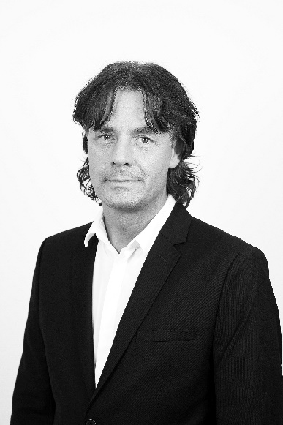
The contract is finally signed and Inet’s second store in Stockholm, and sixth in total, will open shortly.
– Barkarby Gate will be a perfect complement to our existing store on Sveavägen in downtown Stockholm. We will begin recruiting new store coworkers shortly – initially we will recruit upwards of six full-time employees and as many hourly employees.
Inet’s latest store opening took place in Malmö two years ago, but Peter Kumlin is confident it will not be that long until the next.
– Inet is currently in a very expansive phase and we are in fact already scoping out locations for our third Stockholm branch. At the same time we are looking over the possibility to expand in other Swedish cities as well – we will eventually open several more stores around Sweden.
Inets Sales Manager Peter Kumlin look forward to opening the company's second store in Stockholm and sixth overall.
Inet is famous for their high quality and award-winning customer support, and the new store in Barkarby will not be an exception – it will feature a computer repair shop as well as the Inet at home service.
– We will continue to give our customers world class support and services. We will in fact allocate even more space than usual for our repair shop in the Barkarby store, this will allow us to offer repairs of mobile phones and tablets in addition to computers and computer parts. We have had big success with Inet at home, reparations and installations on site, in our other stores, and we will definitely bring that concept to Barkarby as well.
For further information
Peter Kumlin, Sales Manager, Inet, 0708 - 65 27 03, peter.kumlin@inet.se
Magnus Sjöbäck, Press Officer, Inet, 0704 - 45 15 99, magnus.sjoback@inet.se
http://www.inet.se/

