Pressrelease

2022-09-12

**Dogman opens a pet-shop in Kongsberg, Norway**

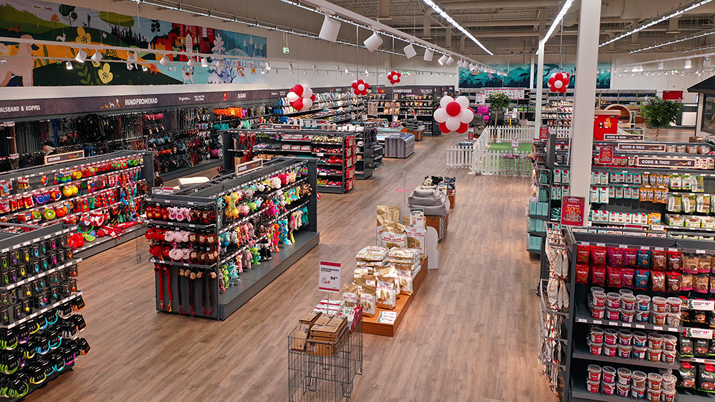

**Dogman will open a new store at Berja Senter in Kongsberg in the autumn of 2022. To create the best offer of both goods and services to Kongsberg's pet owners, the store will be combined with trim & spa, activity area for dogs and owners and an integrated e-commerce solution.**

"We are very happy to now step into Kongsberg and be able to offer our local customers Dogman's entire range of goods and services", says Lars Holtskog, CEO of Dogman. "We have been running pet stores in Norway since 2017 and are experiencing a need for greater choice among Norwegian end customers. Opening a Dogman store in Kongsberg will strengthen our brand and give us the opportunity to further develop our range to ensure that we should be perceived as "The best choice for the best friend". In addition to merchandise, we will offer trim and spa and an activity area for dog owners where you will have the opportunity to meet other pet owners and enjoy a coffee in our café."

Dogman is one of the Nordic region's leading players in the pet segment and has for over fifty years developed products in the categories dog, cat, horse, small animals and aquaristics. Since 2017, Dogman has been driving end-customer sales via physical stores and e-commerce and is today one of the fastest growing players in the Nordic region.

"Despite strong numbers in 2021 and the problems we are experiencing with supply disruptions and increased costs, Dogman has greatly increased its growth in 2022. The fact that our market share is increasing is a good rating from our customers who seem to value Dogman's commitment to our two- and four-legged friends with high-quality products at competitive prices".

Dogman's establishment in Kongsberg will increase the attractiveness of Berja Senter and over the next few years generate between 6 and 8 new jobs.

For more information about Dogman, please visit [www.dogman.no](http://www.dogman.no) , for other questions please contact our CEO, Lars Holtskog, [lars.holtskog@dogman.com](mailto:lars.holtskog@dogman.com) +4748884191