DAMIEN RICE

CLASSIC ALBUM O RELEASED ON VINYL FOR THE FIRST TIME

RHINO TO RELEASE DOUBLE-LP JUNE 1, 2018

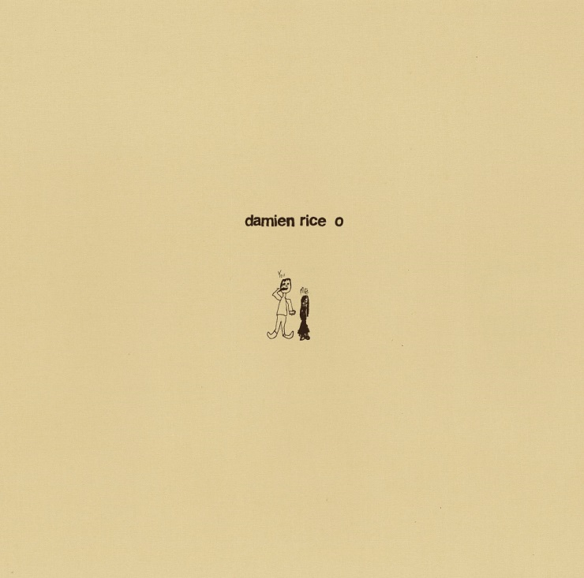

Rhino release an expanded double-vinyl version of Damien Rice’s album O - June 1, 2018.

Pre-order the Deluxe (limited edition) vinyl and Standard vinyl from May 4, 2018.

This is the first time O will be available on vinyl, and this extended 16-track edition includes four additional recordings:

‘The Professor & La Fille Danse’ and ‘Moody Mooday’ which were both originally b-sides to ‘The Blower’s Daughter’ – ‘Moody Mooday’ also appeared alongside ‘Lonelily’ as a limited edition 7” single release in 2004.
‘Woman Like A Man’ was recorded live in session at Galway Bay FM and was the lead track for the song’s single release.

‘Prague’ and ‘Silent Night’ (featuring Lisa Hannigan) which were hidden bonus tracks after the album’s closing song ‘Eskimo’ are also included.

O, originally released in the summer of 2002, was one of the last albums to build a true word-of-mouth following before widespread streaming, and The Guardian wrote, ‘Rice's personality and deft songwriting hoist him above the mass of bedsit mumblers… at its best, o is gorgeous and understated, never too introverted to include a lovely melody.”

Three singles were released from O, ‘The Blower’s Daughter’ in 2001, followed in 2002 by ‘Cannonball’ and ‘Volcano’, with many other tracks from the album being audience favourites and mainstays of Rice’s live set, notably ‘Delicate’, and ‘I Remember’.

The Deluxe (limited edition) version comprises 2 x 180g hand-numbered vinyl housed in a bespoke, cloth bound, hard-back book and comes complete with lyrics, a full colour booklet of the original O artwork and 4 additional tracks. Limited to 1000 (one thousand) copies, and only available from damienrice.com
Pre-order here: http://www.damienrice.com/

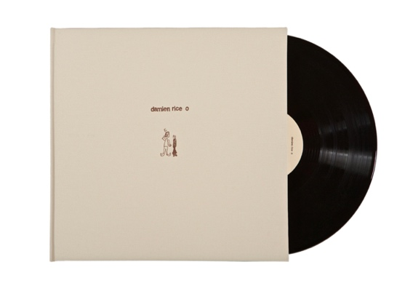

The Standard version comprises 2 x 180g vinyl housed in a gatefold with lyrics and album artwork, and 4 additional tracks. Pre-order here: https://lnk.to/DRO2LP

The tracklisting for the extended 2LP edition of O is:

Side A
1. Delicate
2. Volcano
3. The Blower's Daughter
4. Cannonball

Side B
5. Older Chests
6. Amie
7. Cheers Darlin'
8. Cold Water

Side C
9. I Remember
10. Eskimo
11. Prague
12. Silent Night

Side D
13. The Professor & La Fille Danse
14. Lonelily
15. Woman Like A Man (live radio session)
16. Moody Mooday

_ _ _

Upcoming European Tour Dates:

15 July: Anfiteatro “Falcone Borsellino” - Zafferana Etnea (CT), Italy
19 July: Belvedere di San Leucio – Caserta, Italy
22 July: Teatro Romano di Ostia Antica - Ostia Antica (RM), Italy
29 July: CAP ROIG Festival - Calella de Palafrugell, Spain
02 August: Auditorium de Palma – Palma, Mallorca, Spain
07 August: Teatre Principal de Maó - Maó, Menorca, Spain

http://www.damienrice.com/
https://open.spotify.com/artist/14r9dR01KeBLFfylVSKCZQ
https://www.facebook.com/damienrice
https://www.youtube.com/user/Damienrice
https://twitter.com/damienrice
https://www.instagram.com/damienrice/

