Pressmeddelande 2011-11-16

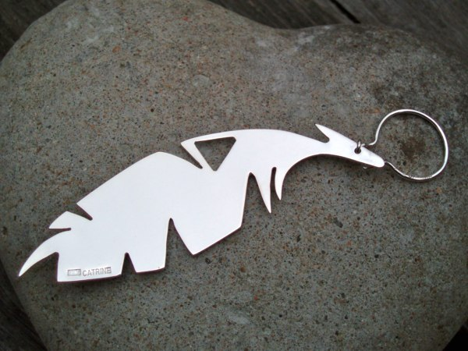

Do you love feathers? The fascination of feathers is old and a symbol of many things. For 925 Catrine Linder it is the spirit of nature - and of course, for the love of silver! A very thoughtful gift for the season!   
Inspired by a White-Tailed Eagle soaring above as she was rock climbing in Lofoten, Catrine came up with the new design. Rock Hard & Feather Light is a good description of her brand!  
Norwegian Design handmade in Sweden coming your way! Exclusively sold @ www.925catrinelinder.com. Free delivery and packaging as well as personal service of course.

Make sure you don't miss the limited offer of buying 3 items online and receive a Dots Snow Ring or Dots Snow Studs for free!

Catrine Linder Sandberg

Hackspettvägen 15, 13568 Tyresö

Tel 0762093388

[catrine@925catrinelinder.com](mailto:catrine@925catrinelinder.com)

[www.925catrinelinder.com](http://www.925catrinelinder.com)