Press images for download

On the trail of Marco Polo's travels through China – Quinsai Garden: The timeless elegance of Asian blossoms
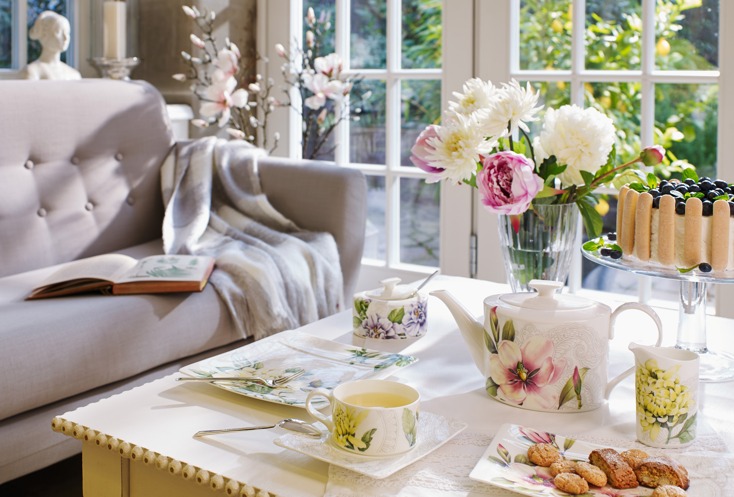

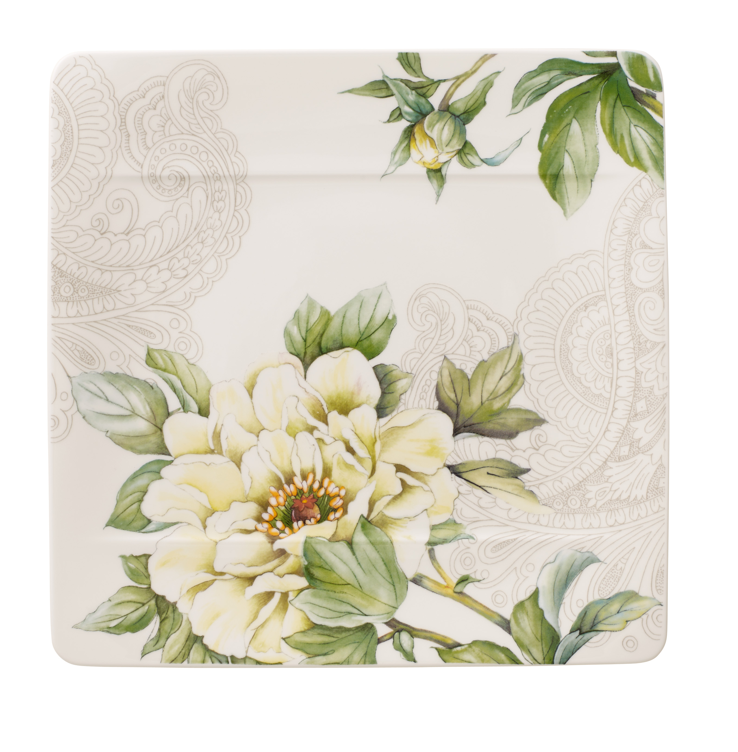
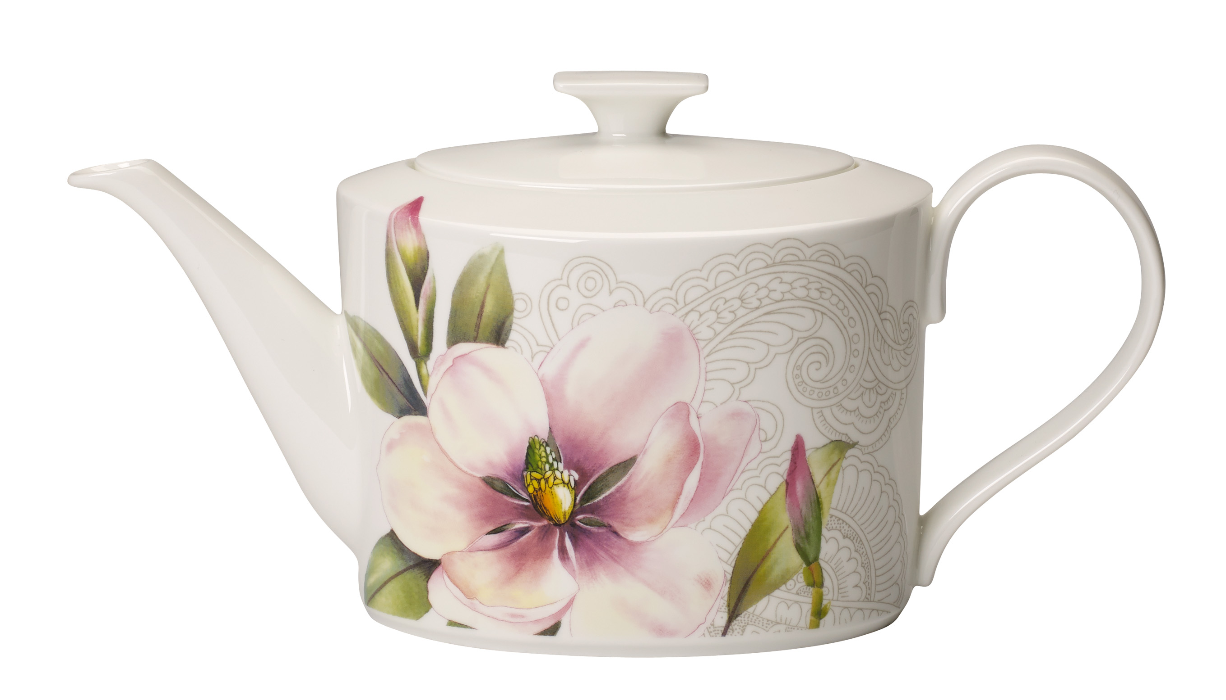
Thirteenth-century Asia: cities are flourishing, gigantic palaces are being built, exotic trade is thriving. The largest harbour of the time was in the city of Quinsai, known today as Hángzhōu. Its presence helped the city achieve international importance; indeed it was apparently the largest medieval city on earth before Baghdad. For round-the-world voyager Marco Polo, the city was simply the "loveliest and greatest city in the world". The young Venetian had travelled to China with his father and his uncle and was overwhelmed – so overwhelmed that he recorded his impressions. "Le divisament dou monde" (Marco Polo's Travels) made literary history, fascinating Marco Polo's contemporaries and triggering a European enthusiasm for Asia that is now firmly established. Stylistic quotations from the Asian world are today found everywhere, in fashion, in interiors – and now also on porcelain.

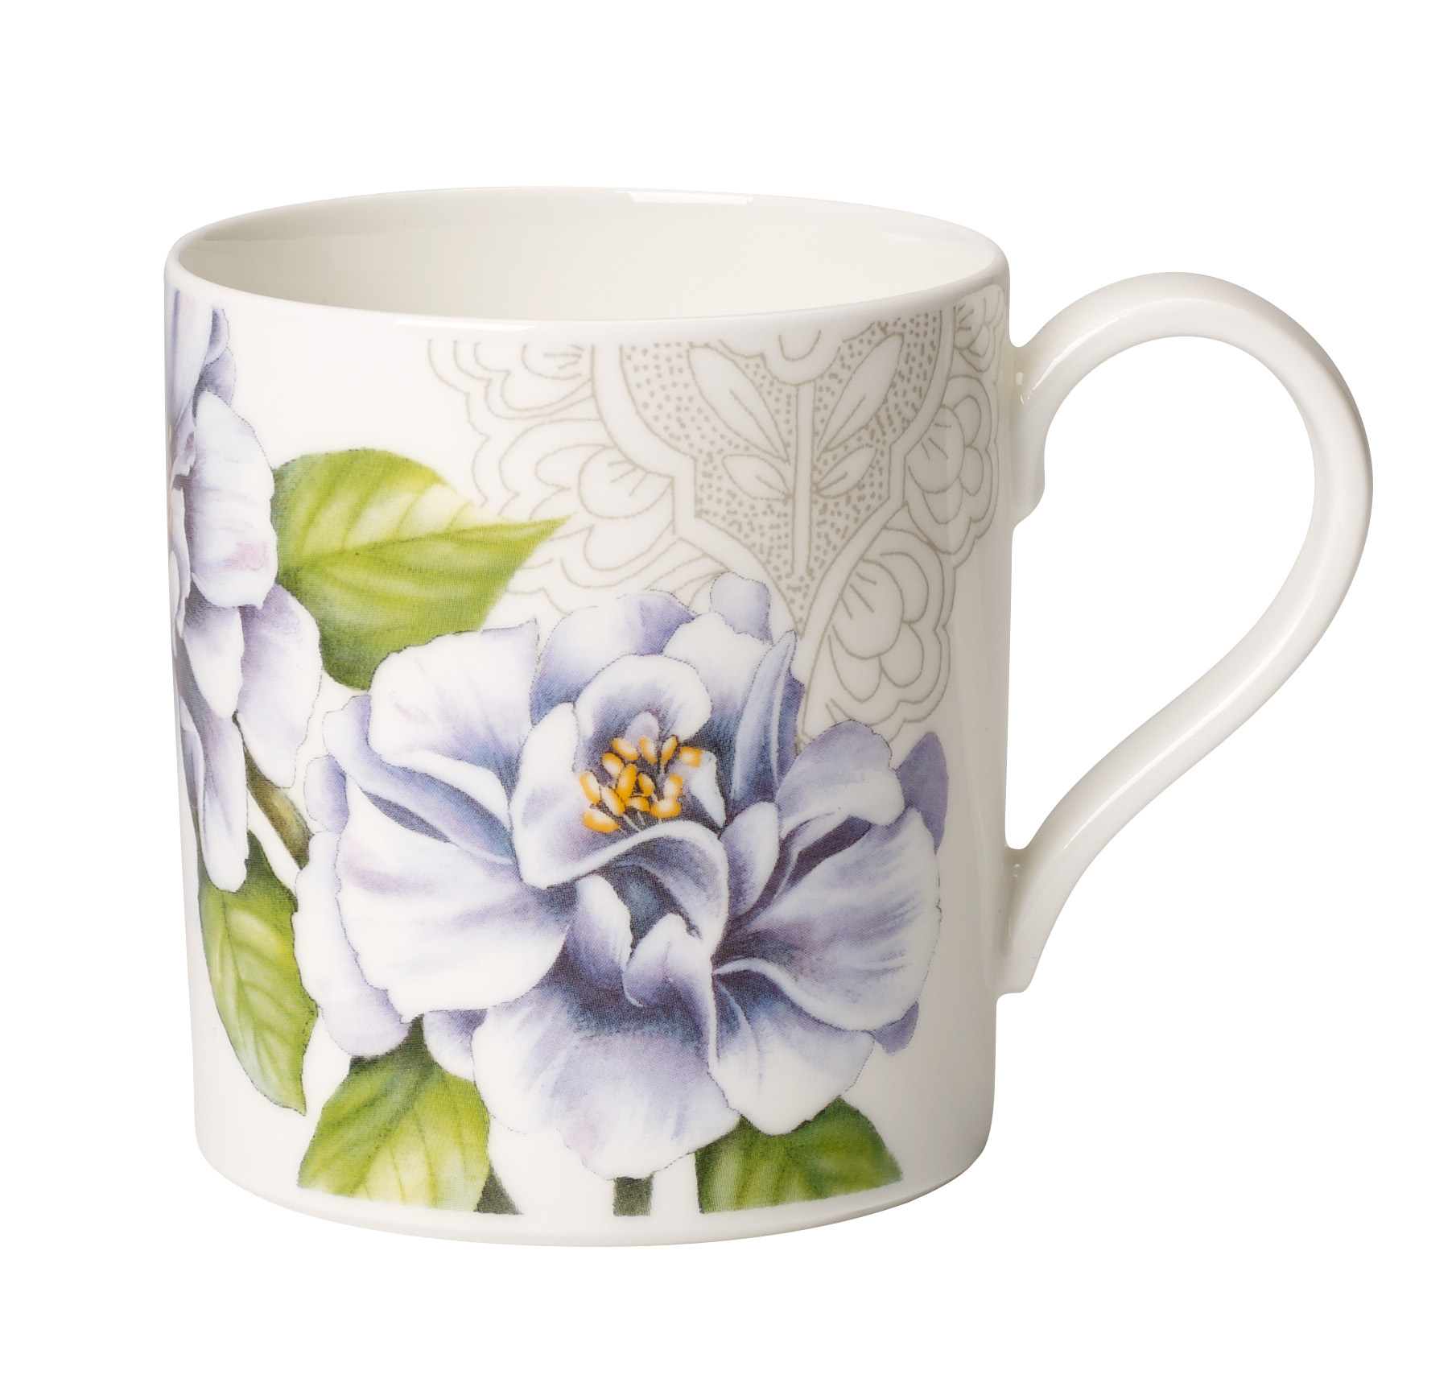
For Quinsai Garden Villeroy & Boch has taken a décor of Asian blossoms, combined it with a paisley pattern in delicate green, and applied it to the successful Modern Grace form. The floral décor features four different blossoms that Marco Polo could have seen on his journey to and around China. All of the flowers have been faithfully drawn by hand: the opulent peony, standing for wealth and noblesse; the delicate camellia, associated with generosity; the colourful chrysanthemum, symbolising courage, stamina and a long life; and the magnificent magnolia, the flower of the emperor and beautiful women. The monochrome paisley pattern provides a bold contrast to the blossoms.

Six different plates, one overall composition
If the six differently decorated plates are placed next to one another the décor creates a striking overall impression. Wall mounting is available that allows the six plates to be displayed together, forming a convincing decorative highlight.

Product information:
- Premium Bone Porcelain
- decorated using lithographic techniques
- dishwasher proof

Price information – examples:

Product (article no) Price
Flat (2620) 369 NOK
Deep (2700) 369 NOK
Side (2640) 335 NOK
Teapot (0460) 999 NOK
Cup & Saucer (1290) 365 NOK

For further information please contact Rebecca Duvemyr
PR & Communication Manager Nordics
Tel.: +46 (0) 76-135 83 62
Mail: rebecca.duvemyr@gustavsberg.com

Villeroy & Boch
Villeroy & Boch is one of the world's leading premium brands for ceramic products. The family business, which was founded in 1748 and is headquartered in Mettlach/Germany, stands for innovation, tradition and exceptional style. As a renowned lifestyle brand, Villeroy & Boch offers products from the sectors Bathroom and Wellness and Tableware, and is active in 125 countries.

