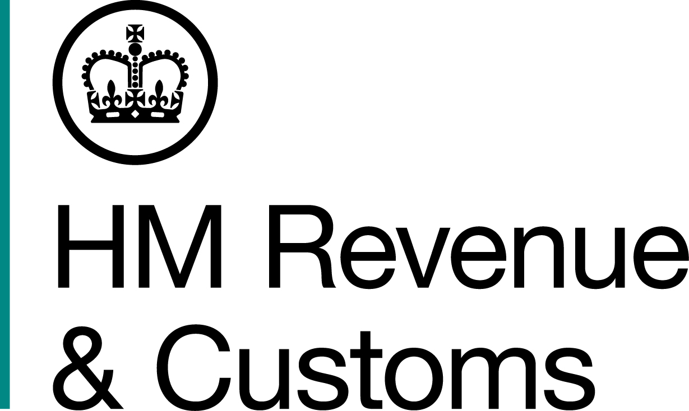
News Release

 | For the attention of News Desks |  | No. of pages: 3
 | Date: | 20 January 2017 | Ref: | LON 02/17

Offshore cash seized from crime couple

A London couple who ran a criminal money laundering service from their family-owned bureaux de change have been stripped of cash in offshore bank accounts, jewellery and property to repay more than £1.2m.

Moothathamby Sriskantharajah, 61, and his wife Thilageswary, 50, were jailed for a total of 19 years in December 2014 after an HM Revenue and Customs (HMRC) investigation found they had ‘cleaned up’ £96m of dirty cash.

The pair laundered the proceeds of crime, including money from a major drug trafficking ring that saw three people jailed for 44 years after police found drugs worth £12 million and £2.1 million in cash

Today, the pair were ordered to repay £1,218,163.54 and, as a result, were stripped of assets including:
- A £480,000 house in Middlesex
- A property in Stuttgart, Germany worth £200,000
- Jewellery stored in a Harrods safe deposit box worth £82,162.00
- A Mercedes A160
- Around £535,000 in bank accounts in the UK, Singapore, Canada and Germany.

Simon York, Director, Fraud Investigation Service, HMRC, said:

“This couple helped many of the UK’s most serious and dangerous criminal gangs. Now they’ve lost everything – their liberty and all their assets.

“HMRC treats money laundering extremely seriously. We will pursue and prosecute those who facilitate and enable serious, organised crime. This case clearly shows we will not hesitate to take criminal assets no matter whether they are in the UK or offshore.”

The Sriskantharajah’s three bureaux gave the impression of legitimate, high street currency exchanges serving the London tourist market. But HMRC found their main trade was swapping Sterling for high denomination, easily concealable Euro notes for their criminal counterparts.

The bureaux traded as Universal Money Exchange (UME), on Shaftesbury Avenue and Oxford Street, and Buckingham Money Exchange (BME), on Buckingham Palace Road.

HMRC officers raided Universal Money Exchange in September 2011 and found more than £100,000 in cash. They also discovered keys for two safe deposit boxes at Harrods, both registered to Thilageswary Sriskantharajah, containing £223,000, $90,000 and €50,000 in cash – money that has been forfeited to the Crown – and high-value gold jewellery.

Investigators discovered much of the cash had been spent on jewellery, property investments in the UK and abroad and school tuition fees.

Notes to Editors

- A hearing under the Proceeds of Crime Act 2002 took place at Southwark Crown Court on January 19 2017.
- Moothathamby Sriskantharajah (DOB 07/03/55) of HM Prison Service and formerly of Marlborough Road, Isleworth, Middlesex, TW7, was ordered to repay £435,373.25 within three months or remain in prison for a further four years. He was previously found guilty of offences under the Proceeds of Crime Act 2002 and sentenced to 12 years in jail at Southwark Crown Court on 18 December 2014. He was also banned from being a director for 12 years.
- Thilageswary Sriskantharajah (DOB 07/04/66) of HM Prison Service and formerly of Marlborough Road, Isleworth, Middlesex TW7, was ordered to repay £435,373.25 within three months or remain in prison for a further four years. She was previously found guilty of offences under the Proceeds of Crime Act 2002 and sentenced to seven years jail. She was also banned from being a director for eight years.
- Assets:
- A property on Marlborough Road, Isleworth, Middlesex: £488,874.59
- A property in Kornwestheim, Stuttgart, Germany: £205,412.00
- Jewellery stored in a Harrods safe deposit box: £82,162.00
- Mercedes A160: £3,280.00
- Bank account balances (Singapore): £202,428.02
- Bank account balances (UK): £247,664.65
- Bank account balances (Canada): £70,516.03
- Bank account balances (Germany): £22,288.80
- A copy of the news release issued on sentencing is available at: http://www.mynewsdesk.com/uk/hm-revenue-customs-hmrc/pressreleases/four-jailed-in-ps145-million-money-laundering-plot-1101107
- Follow HMRC Press Office on Twitter @HMRCpressoffice.
- HMRC's Flickr channel: www.flickr.com/hmrcgovuk.

Issued by HM Revenue & Customs Press Office

Press enquiries only please contact:

Joshua Shrimpton-Dean
Tel: 03000 554556 / 07469 023445
Email: joshua.shrimpton-dean@hmrc.gsi.gov.uk
Or
Natalie Brown
Tel: 03000 519 123/ 07464 982005
Email: natalie.brown@hmrc.gsi.gov.uk

Out of hours
Tel: 07860 359544

Website www.gov.uk/hmrc

