**Swedish company introduces USB flashdrive for Smartphones**

Jun 04, 2013 12:19 CEST

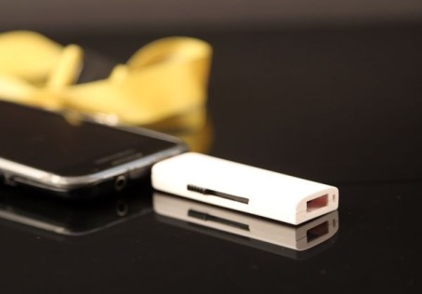

Combostick  
is like an ordinary flashdrive but with the difference it has two  
connectors. With the slide button on the  
side you can chose between a standard USB-B connector that plugs into a PC, and  
a micro-USB connector for Smartphones/Tablets.   
When the micro-USB connector is used the device automatically switches  
into OTG mode for seamless interaction with the mobile device. With the slide button in the mid position  
both connectors are protected inside the flashdrive.

Combostick  
has high transfer speeds and is designed with the steady increase in professional  
use of Smartphone’s and Tablets in mind.

The  
flashdrive is available in capacities 8GB, 16GB and 32GB. It comes in purple (PMS 665), blue (PMS 636),  
yellow (PMS 136) and color of the year, Emerald green (PMS 17-5641). For the gift and promotion industry  
Combostick is available in neutral black and white versions, suitable for  
customized logo-print and styling.

Combostick will  
be available in many computer stores and online web shops. Check [www.combostick.com](http://www.combostick.com/) for details.

*“We believe  
we are first on the market with this type of flashdrive. We haven’t found  
anything like it. There are solutions  
involving cables and adapters where the same function probably can be achieved,  
but it’s not very user friendly”* says  
Kent Skagvik, head of marketing at Techimport.

Techimport  
Skagvik & Ericson AB (Techimport for short) is a Swedish technology and  
trading company specialized in flash storage.   
Techimport is the company behind the Audio-book listening device used in  
Swedish libraries and AudioStick, the combined flashdrive/MP3-player..

For more information:

[info@techimport.se](mailto:info@techimport.se)

[info@combostick.com](mailto:info@combostick.com)