NorSat-3 maritime traffic monitoring microsatellite is launched with state-of-the-art KONGSBERG technology
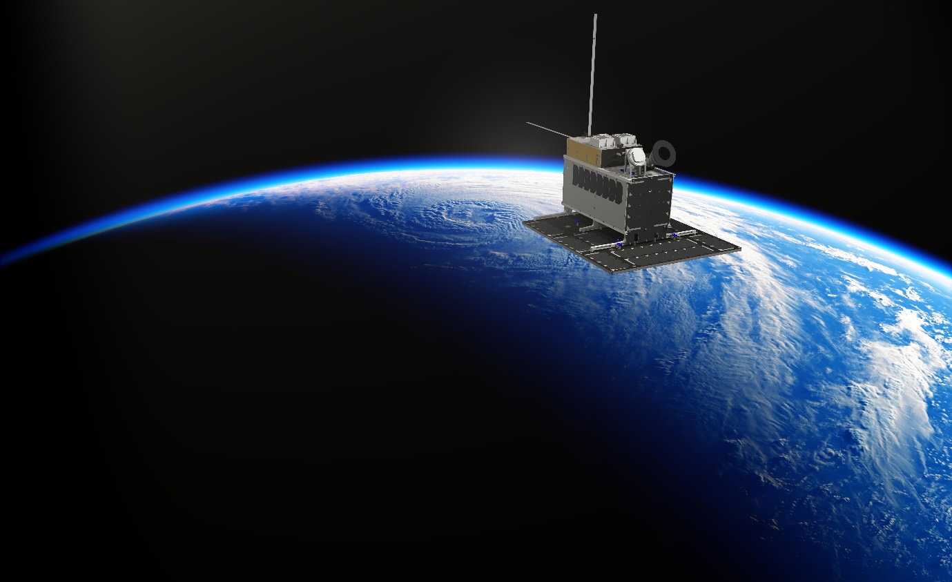
Photo: Norsk Romsenter / Norwegian Space Agency
NorSat-3 carries AIS and radar detection payloads developed by or in collaboration with KONGSBERG
Kongsberg, Norway, 26th May 2021 – KONGSBERG technology is set to play a pivotal role in the working life of a recently-activated microsatellite. The Norwegian Space Agency’s new NorSat-3, launched on April 29th, 2021 from Vega Flight VV 18 which took off from the European spaceport in Kourou, French Guyana, will be used by the Norwegian Coastal Administration for monitoring maritime traffic in Norway’s busy seaways. Its AIS and NRD (navigation radar detector) payload draws upon KONGSBERG’s most advanced, future-proof developments in space-based vessel detection.
NorSat-3 will take its place 605km above the Earth in a polar LEO (Low Earth Orbit) constellation alongside four other microsatellites. These have already been in service for years and have all exceeded their working life expectancy, but are nevertheless still operating efficiently. The new 16.5kg satellite has been designed to provide next-level functionality, so it has been equipped with KONGSBERG’s ASR x50 SAT-AIS receiver as its primary payload – the sophisticated fourth-generation outcome of a developmental AIS (Automatic Identification System) timeline which stretches back over two decades.
The ASR x50 sets a new standard for sensitivity in space-based SAT-AIS receivers, with its ability to detect even AIS Class B vessels. Extremely reliable and offering built-in redundancy, it deploys next-generation de-collision algorithms for optimal vessel detection in areas with a medium or high density of ship traffic. Its miniature, best-in-class EEE (Electrical, Electronic and Electromechanical) components have been selected for their radiation-tolerant design principles and their low power usage.
In addition, its substantial onboard data storage is matched with multi-antenna support, a superior dynamic range and reconfigurable, in-orbit SDR (Software-Defined Radio) technology, ensuring compatibility with forthcoming algorithm enhancements or amendments to AIS/VDES standards. As a part of KONGSBERG’s new eXtended lifetime product series, the ASR x50 is designed for a service life in Low Earth Orbit of more than seven years.
Meanwhile, the new microsatellite’s secondary payload consists of an experimental NRD (Navigation Radar Detector) antenna and receiver, supplied by the Norwegian Defence Research Establishment (FFI) and developed in collaboration with KONGSBERG, the French space agency CNES and the German electronics company ILFA. This cutting-edge equipment can detect and locate signals transmitted by civilian navigation radar systems, which will give the Norwegian Coastal Administration a more complete situational image by including vessels which aren’t sending AIS signals, for reasons ranging from errors and malfunctions to transponders being switched off.
“The launch of NorSat-3 represents a significant step forward in terms of the quality and quantity of the data we can receive, evaluate and share with other government organisations,” says Arve Dimmen, director for navigation technology and maritime services, Norwegian Coastal Administration. “The benefits for safer, better-informed sailing in Norwegian waters, both now and in the future, are obvious, and it’s to KONGSBERG’s credit that the company’s technology should be so central to realising our aims.”
“Enhancing situational awareness for seafarers and vessel traffic controllers alike provides great benefits, and NorSat-3 is an excellent example of how microsatellites provide crucial contributions to this picture,” adds Erlend Vågsholm, Vice President Research & Development, Kongsberg Seatex. “It also shows how KONGSBERG’s strong focus on microsatellite solutions is well adapted to Norwegian needs for monitoring vast ocean areas and for maritime safety at large.”
Ends

For further information, please contact:
Gunvor Hatling Midtbø, VP Communication
Kongsberg Maritime
Tel: +47 9921 4209
gunvor.hatling.midtbo@km.kongsberg.com
David Pugh
Saltwater Stone
Tel: +44 (0)1202 669244
d.pugh@saltwater-stone.com

About Kongsberg Maritime
Kongsberg Maritime is a global marine technology company providing innovative and reliable ‘Full Picture’ technology solutions for all marine industry sectors including merchant, offshore, cruise, subsea and naval. Headquartered in Kongsberg, Norway, Kongsberg Maritime has manufacturing, sales and service facilities in 34 countries.
Kongsberg Maritime solutions cover all aspects of marine automation, safety, manoeuvring, navigation, and dynamic positioning as well as energy management, deck handling and propulsion systems, and ship design services. Subsea solutions include single and multibeam echo sounders, sonars, AUV and USV, underwater navigation and communication systems.
Training courses at locations globally, LNG solutions, information management, position reference systems and technology for seismic and drilling operations are also part of the company’s diverse technology portfolio. Additionally, Kongsberg Maritime provides services within EIT (Electro, Instrument & Telecom) engineering and system integration, on an EPC (Engineering, Procurement & Construction) basis.
Kongsberg Maritime is part of Kongsberg Gruppen (KONGSBERG), an international, knowledge-based group that celebrated 200 years in business during 2014. KONGSBERG supplies high-technology systems and solutions to customers in the oil and gas industry, the merchant marine, and the defence and aerospace industries.
Web: Kongsberg Gruppen | Kongsberg Maritime
Social media: LinkedIn | Twitter | Facebook

