Kongsberg Maritime supply four HUGIN AUV survey systems to Garden Reach Shipbuilders & Engineers Ltd., India
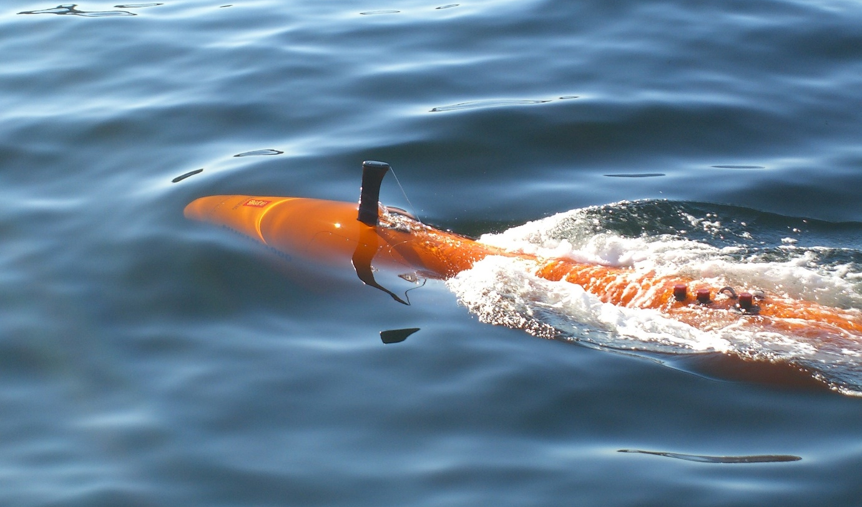
Kongsberg Maritime’s HUGIN AUV is a powerful tool for deep-water hydrographic surveys
Kongsberg, Norway, 25th September 2020 – Kongsberg Maritime is pleased to announce the sale of four HUGIN AUV systems to the Indian Defence Public Sector shipyard Garden Reach Shipbuilders & Engineers Limited (GRSE), located in Kolkata, India. This sale has been conducted in collaboration with Kongsberg Maritime India, a subsidiary of Kongsberg Maritime.
The purchase, which also includes HiPAP 502 high-accuracy acoustic positioning and communication systems to support AUV operations, will be installed on the four Large Survey vessels currently in build for the Indian Navy. GRSE Chairman and Managing Director Rear Admiral (Ret’d) Vipin Saxena said: “We are pleased and look forward to making use of the HUGIN AUVs from KONGSBERG, which will augment the Indian Navy’s capabilities for coastal and deep-water hydrographic surveys to aid maritime operations, and will act as a force multiplier.”
The AUVs will be supplied with containers and launch and recovery systems, plus training and support.
Kongsberg Maritime is the world leader in deep water AUV systems. Since the first dive in 1993, HUGIN has become the most successful AUV in the deep-water realm, with more kilometres surveyed than any other untethered underwater vehicle. Developed in partnership with FFI – the Norwegian Defence Research Establishment – HUGIN continues to improve with new capabilities, sensors and behaviours being added each year.
“We are honoured to have successfully demonstrated the capability of the system to the Indian Navy and to have them as a returning customer for the HUGIN AUV system,” said Stene Førsund, SVP Sensor and Robotics Sales, Kongsberg Maritime. “Their new HUGIN AUV systems are configured for their needs today and tomorrow with a multi-role capability. We are looking forward to working with GRSE.”
Ends

For further information, please contact:
Gunvor Hatling Midtbø, VP Communication
Kongsberg Maritime
Tel: +47 9921 4209
gunvor.hatling.midtbo@km.kongsberg.com
David Pugh
Saltwater Stone
Tel: +44 (0)1202 669244
d.pugh@saltwater-stone.com

About Kongsberg Maritime
Kongsberg Maritime is a global marine technology company providing innovative and reliable ‘Full Picture’ technology solutions for all marine industry sectors including merchant, offshore, cruise, subsea and naval. Headquartered in Kongsberg, Norway, Kongsberg Maritime has manufacturing, sales and service facilities in 34 countries.
Kongsberg Maritime solutions cover all aspects of marine automation, safety, manoeuvring, navigation, and dynamic positioning as well as energy management, deck handling and propulsion systems, and ship design services. Subsea solutions include single and multibeam echo sounders, sonars, AUV and USV, underwater navigation and communication systems.
Training courses at locations globally, LNG solutions, information management, position reference systems and technology for seismic and drilling operations are also part of the company’s diverse technology portfolio. Additionally, Kongsberg Maritime provides services within EIT (Electro, Instrument & Telecom) engineering and system integration, on an EPC (Engineering, Procurement & Construction) basis.
Kongsberg Maritime is part of Kongsberg Gruppen (KONGSBERG), an international, knowledge-based group that celebrated 200 years in business during 2014. KONGSBERG supplies high-technology systems and solutions to customers in the oil and gas industry, the merchant marine, and the defence and aerospace industries.
Web: Kongsberg Gruppen | Kongsberg Maritime
Social media: LinkedIn | Twitter | Facebook

