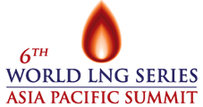
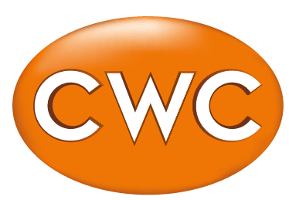

CWC Group Announces Dates and Speakers for the
6th World LNG Series: Asia Pacific Summit

30 April 2014 – LONDON, UK – The 6th World LNG Series: Asia Pacific Summit will take place from 23-26 September 2014 at the newly refurbished Grand Hyatt Hotel, Singapore.

“Conferences such as these are important to the LNG business in Asia,” said Patricia Roberts, Associate Director, CWC Group Ltd. She continued, “We are seeing several new LNG projects focusing their sales in the Asian market. LNG agreements committing long-term volumes to Asia are being signed by a variety of established players as well as new inter-regional sellers. The Asian region is expected to grow strongly over the next decade and remain the pace-setter of the global industry. That is why the inter-personal relationships made at this Summit prove critical over the long term”.

In addition to the conference and networking events, delegates are exclusively invited to tour the Singapore LNG Terminal (SLNG) – the first LNG terminal in Singapore. This S$1.7 billion facility commenced operations in May 2013 and it is a critical infrastructure that ensures the security of supply sources to meet Singapore’s energy demand. The Terminal is designed to serve multiple users and support the development of Singapore as an LNG hub for the region.

Speakers confirmed for the event currently include:
Jonty Shepard, COO- LNG, BP
Philip Olivier, President, GDF Suez LNG
Stephan Roeper , Vice President LNG Marketing, ExxonMobil Asia Pacific Pte. Ltd.
Rajeev Mathur, Executive Director, GAIL (India) Ltd.
Yasushi Sakakibara, Chief Representative, Asia Pacific Regional Office, Tokyo Gas Co. Ltd
Martin Lambert, Senior Vice President, NWS Australia LNG
Andrew Seck, Assistant Director East of Suez Marketing, Qatargas
Masahiro Nakamura, Manager of Planning- Fuels Department, Chubu Electric Power Co.
Dr Anthony Barker, General Manager, BG Singapore Gas Marketing Pte Ltd.
Rod Duke, Vice President Gladstone LNG, Santos
Joanna Hardinge, Director LNG Marketing- Asia, Gazprom Marketing & Trading Singapore
Asish Mohanty, Director, Galway Group
Sid Bambawale, Director LNG, Citi
Mark da Roza, Manager, LNG Trading & Origination, ConocoPhillips
Debbie Turner, Director- Senior Shipping Advisor, SSY Gas
Dan Rogers, Partner, King & Spalding (Singapore) LLP
Raj Goswami, Head of Gas & Consulting for Asia & Middle East, Wood Mackenzie
Pat Roberts, Associate Director – Gas, CWC Group Ltd.
Merrick White, Partner, King & Spalding (Singapore) LLP

In 2013, some 350 delegates attended the Summit. A larger number, representing at least 30 countries are expected this year. Sponsors of the event currently include Trafigura, Cheniere, Oman LNG, ABS, Exxon Mobil, BP, ConocoPhilips, Gazprom, Galway Group, King & Spalding and GTT.

- ENDS -

