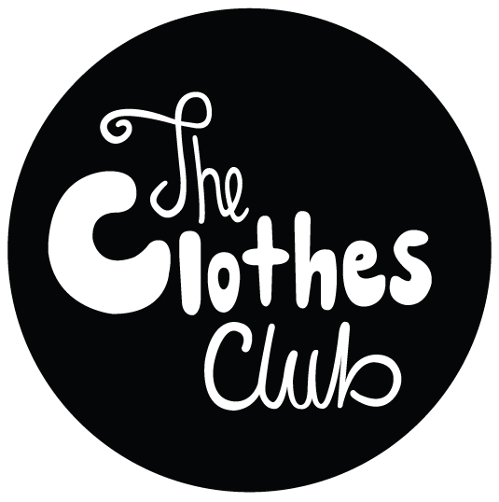

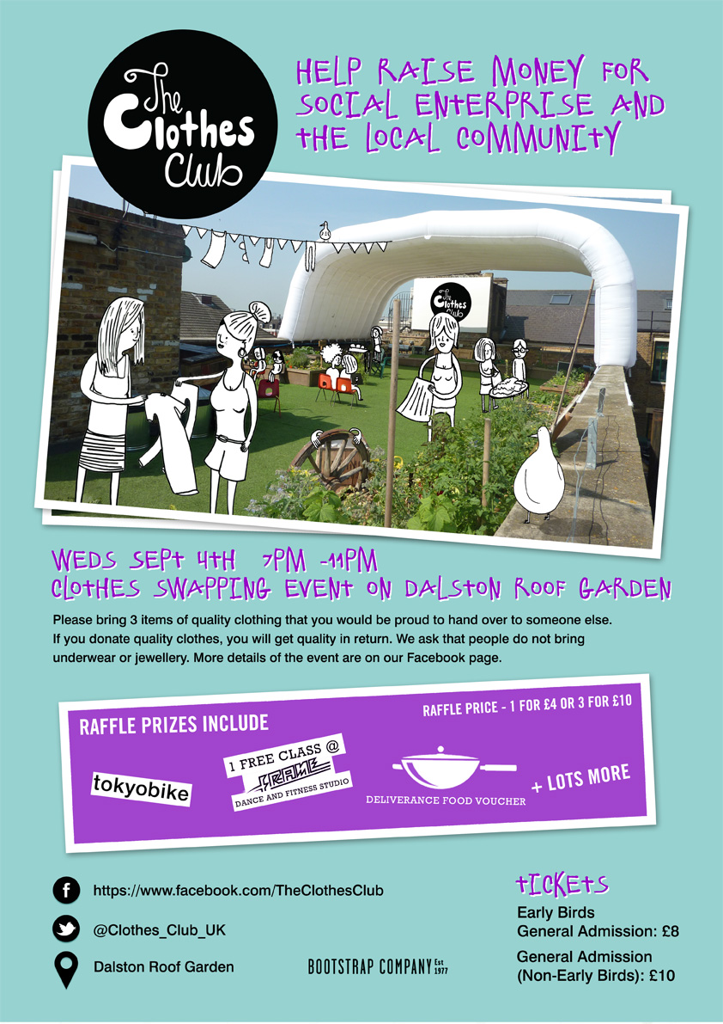

[The Clothes Club](http://www.facebook.com/theclothesclub) was launched by Emily de Groot to form a community of clothes swappers - with the aim of raising money for local social enterprises.

The team consists of Lucy Dunleavy, Carmen Guillen and Leon Nikoosimaitak who all kindly volunteer their time. Come and join them on Twitter @Clothes_Club_UK or Facebook www.facebook.com/theclothesclub

The first clothes swapping evening in April raised £600 for Hackney Pirates enabling them to print the guidebook on Hakcney the kids created:

*"We were really excited to have been supported by the first ever Clothes Club event to make our very own Guidebook to Hackney. This is a great boost to our work in supporting young people develop their literacy and creative skills by publishing their work professionally. What a brilliant mix of a fun event and helping local organisations like us. Massive thanks to the Clothes Club to supporting us!"****Hackney Pirates***

It’s a great way to inject some new life into your wardrobe, without spending lots of money, whilst reducing the environmental effects of the fashion industry and raising money for good causes.

Super early bird tickets are on sale now and are just £8, the money raised will be donated to a community art project with young people in Hackney. You'll take home new items too! <https://www.facebook.com/events/194513874048017/>

Come along, have a drink, food, swap your clothes and network. Some amazing brands have donated items for the raffle including [Tokyo bike](http://www.tokyobike.co.uk) and [Move Your Frame](http://www.moveyourframe.com).

7.00-8.00 - arrive with clothes & clothes organised

8.00-9.00 - clothes swap & raffle

7-11 - dj and networking

11 - close

Bring up to 3 items of quality clothing you no longer wear and swap them for someone else’s unwanted garments.

You'll be given tokens on the night for your items. If you really want an extra garment, you can always buy additional tokens.

Only bring clothes you are proud to pass on please; The Clothes Club want everyone to get back what they give.

They’re asking people to refrain from bringing underwear and jewellery for obvious reasons.

If you bring shoes, they’re allowing average sizes of 4-7 and please only bring 1 pair out of your 3 items, just so it's not a shoefest.

Lets help put some conscience into our closets!

For further information contact [clothesclubuk@gmail.com](mailto:clothesclubuk@gmail.com)

Or Emily de Groot 07812 159 228