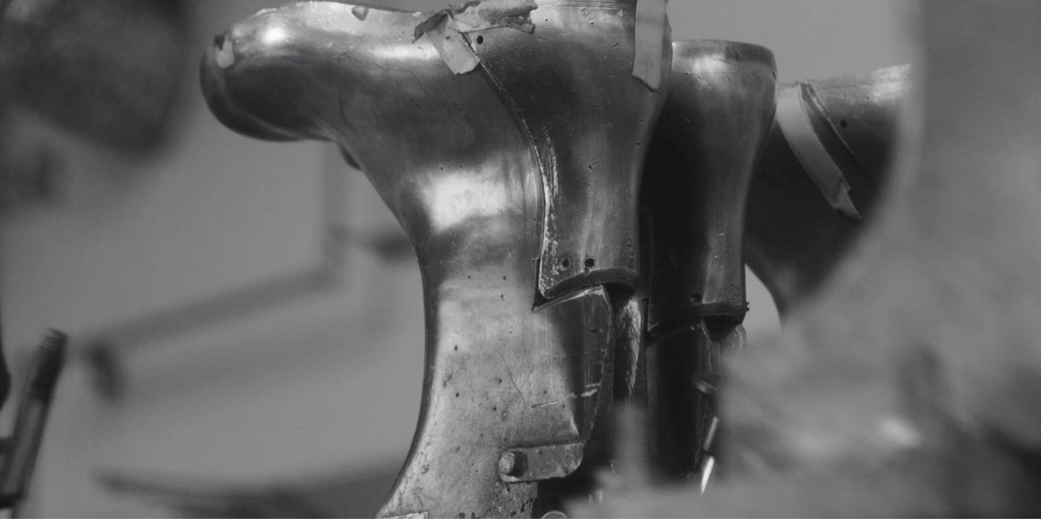

ARBESKO FORCED TO TAKE ACTIONS DUE TO COVID-19

The Swedish Arbesko have been making shoes since 1839 and during these troubled times, they are closely following the authorities' recommendations in the countries where they are operating. The past weeks’ rapid decline in sales, combined with a higher sick leave among the employees, is now forcing the shoe company to act.
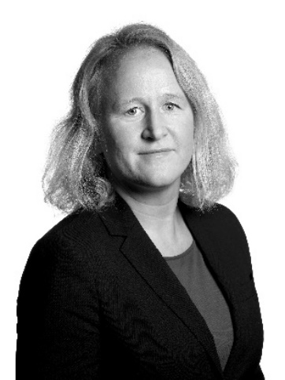
“The most important thing for us right now is to ensure a healthy working environment for our employees, while at the same time making sure that we can give our customers the service they need,” says Karin Lidman, CEO Arbesko.
After careful consideration, Arbesko has decided to take several measures that are valid for the time being, including short-term work for all employees, which means:
- The head office in Kumla will be closed on Fridays
- Customer service is available Monday-Thursday
- The production in the shoe factory will be temporarily stopped during April

“Despite the current situation, we are still confident that we are able to guarantee our deliveries in the coming six months. We will secure flexibility within our production in order to be able to quickly react to avoid any upcoming lack of models or sizes. Our sales crew is still available and will adapt to the needs and wishes of our customers when it comes to meetings and support”, explains Karin.

For further information, please contact:
Karin Lidman
CEO
karin.lidman@arbesko.se
+ 46730783641

Jonny Ljungberg
Head of Sales
jonny.ljungberg@arbesko.se
+46706379264

Ana Paula Geisler
COO
anapaula.geisler@arbesko.se
+46736006404

