DT: 18 JUNE 2018
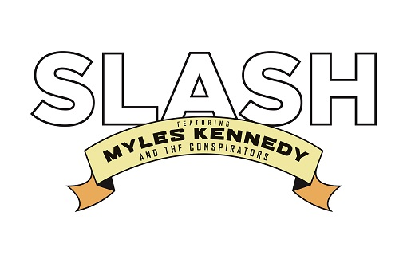
SLASH FT. MYLES KENNEDY & THE CONSPIRATORS
ANNOUNCE
‘LIVING THE DREAM’
NEW ALBUM TO BE RELEASED ON THE 21ST SEPTEMBER 2018
THROUGH SNAKEPIT/ROADRUNNER RECORDS

GROUP ANNOUNCE U.S. HEADLINING TOUR STARTING THURSDAY 13TH SEPTEMBER 2018 IN LOS ANGELES
ONSALE FRIDAY 22ND JUNE (here)

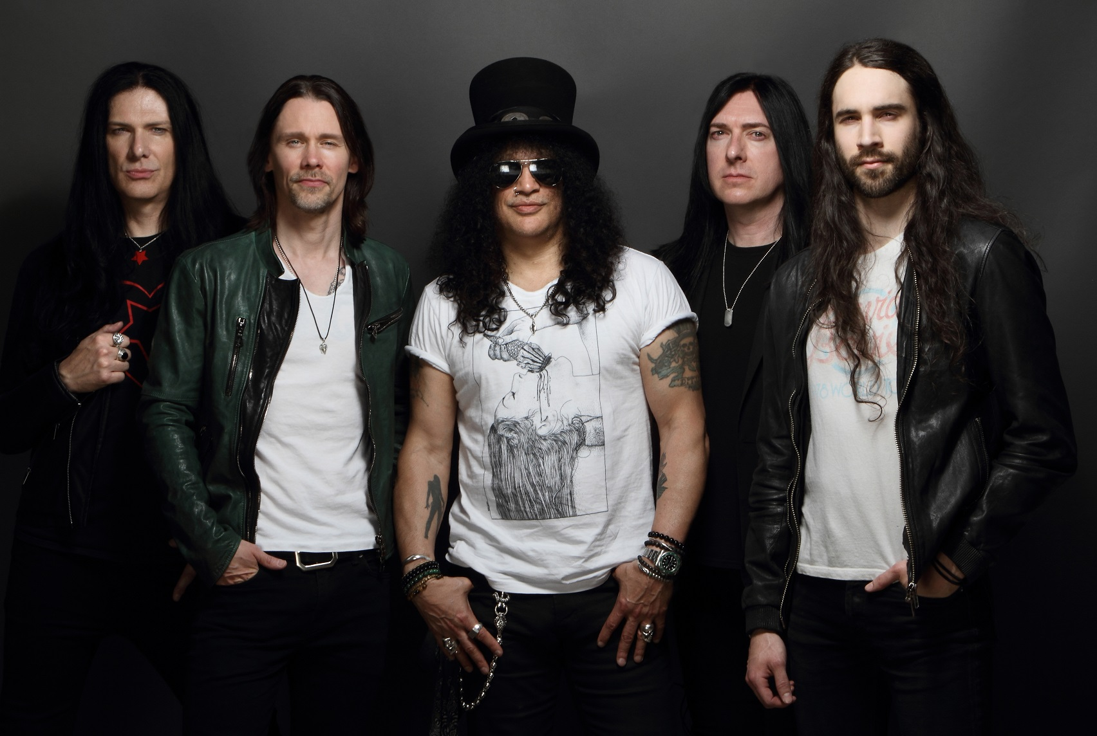
Slash Ft. Myles Kennedy & The Conspirators. Photo and logo download (here).
SLASH FT. MYLES KENNEDY & THE CONSPIRATORS have announced today, 18 June they’ll release their new album entitled LIVING THE DREAM on the 21st September via SLASH’s own label Snakepit Records in partnership with Roadrunner Records. LIVING THE DREAM is SLASH’s fourth solo album, and third with his band featuring MYLES KENNEDY (Vocals), BRENT FITZ (Drums), TODD KERNS (Bass & Vocals) and FRANK SIDORIS (Guitar & Vocals). A pre-order for the new album will begin on the 25th July.
For LIVING THE DREAM, SLASH and his band re-teamed with producer Michael “Elvis” Baskette (Alter Bridge, Iggy Pop, Incubus); the group are currently putting the finishing touches on the powerful 12 song collection. The band’s previous albums World On Fire and Apocalyptic Love, debuted in the Top Ten on 12 charts globally, spawned three #1 hit singles at U.S. Rock Radio and earned worldwide praise garnering SLASH some of the best critical acclaim of his career. World On Fire was tagged by Guitar World as “another bold and unapologetically riffy statement” and “a varied, immersive and incredibly hard rocking effort” (December 2014). Rolling Stone described Apocalyptic Love--the band’s debut album--as “filled with head bangers and plenty of fancy fretwork” and Revolver declared it “a collection of lean, high-octane rock-and-roll tunes built to be blasted out of open-top sports cars, or more suitably, open-air stadiums” (May 2012).
The group have announced they’ll kick off a U.S. headlining tour beginning the 13th September 2018 in Los Angeles. Citi is the official credit card of the “Living The Dream” tour, as such Citi cardmembers will have access to presale tickets beginning Tuesday, 19th June at 10am local time to Thursday 21st June at 10pm. For complete details, visit: citiprivatepass.com. SLASH fanclub presales will begin on the 19th June at 10:00am local time, with general onsales starting Friday 22nd June at 10:00am. Each ticket purchased online to a headlining show will include a digital copy of LIVING THE DREAM (out 21/09/18); all tickets are available at: http://www.slashonline.com. The full itinerary (see below), encompasses three festival appearances: Sunday 16 September at KAABOO Festival, Friday 28 September at Louder Than Life Festival and Sunday 14 October at Aftershock Festival.
Following are SLASH FT. MYLES KENNEDY & THE CONSPIRATORS USA tour dates:

DATE | CITY | VENUE | TICKETS
Thu-Sep-13-18 | Los Angeles, CA | Whisky A Go Go | 9/13 Tickets
Sat-Sep-15-18 | Phoenix, AZ | The Van Buren | 9/15 Tickets
*Sun-Sep-16-18 | Del Mar, CA | KAABOO Music Festival | 9/16 Tickets
Tue-Sep-18-18 | Salt Lake City, UT | The Depot | 9/18 Tickets
Wed-Sep-19-18 | Denver, CO | Fillmore Auditorium | 9/19 Tickets
Fri-Sep-21-18 | Tulsa, OK | Paradise Cove Margaritaville | 9/21 Tickets
Sat-Sep-22-18 | Thackerville, OK (Dallas) | WinStar World Casino | 9/22 Tickets
Mon-Sep-24-18 | Austin, TX | Stubb’s Waller Creek Amphitheater | 9/24 Tickets
Wed-Sep-26-18 | Houston, TX | House of Blues | 9/26 Tickets
Fri-Sep-28-18 | Louisville, KY | Louder Than Life Festival | 9/28 Tickets
Sat-Sep-29-18 | New Buffalo, MI | Four Winds Casino Resort | 9/29 Tickets
Mon-Oct-01-18 | Montclair, NJ | Wellmont Theater | 10/1 Tickets
Tue-Oct-02-18 | Silver Spring, MD | The Fillmore Silver Spring | 10/2 Tickets
Thu-Oct-04-18 | Rama, ON | Casino Rama | 10/4 Tickets
*Fri-Oct-05-18 | New York, NY | Pier 17 @ South Street Seaport | 10/5 Tickets
Sat-Oct-06-18 | Uncasville, CT | Mohegan Sun - Wolf's Den | 10/6 Tickets
Tue-Oct-09-18 | Huntington, NY | The Paramount | 10/9 Tickets
Wed-Oct-10-18 | Philadelphia, PA | Electric Factory | 10/10 Tickets
Thu-Oct-11-18 | Boston, MA | House of Blues | 10/11 Tickets
Sun-Oct-14-18 | Sacramento, CA | Aftershock Festival | 10/14 Tickets

*Indicates date is already on-sale.

For more information on SLASH FT. MYLES KENNEDY & THE CONSPIRATORS, visit:
WEBSITE
FACEBOOK
TWITTER
SPOTIFY
INSTAGRAM
YOUTUBE

About Slash Ft. Myles Kennedy & The Conspirators:
SLASH--the iconic, GRAMMY-winning, American rock guitarist, songwriter and film producer--has amassed album sales of over 100 million copies, garnered a GRAMMY Award and seven GRAMMY nominations and was inducted into the Rock and Roll Hall of Fame. SLASH landed on the top of the charts with his first solo album, Slash (2010) which featured Ozzy Osbourne, Fergie, Myles Kennedy and more. Shortly after, he formed his current band SLASH FT. MYLES KENNEDY & THE CONSPIRATORS--which features MYLES KENNEDY (lead vocals), BRENT FITZ (drums), TODD KERNS (bass/vocals) and FRANK SIDORIS (rhythm guitar)--who’ve been touring worldwide and making music for over four years. SLASH FT. MYLES KENNEDY & THE CONSPIRATORS released the critically acclaimed Apocalyptic Love (2012) which stormed the Billboard Top 200 Albums Chart debuting at #4 as the top rock album. Apocalyptic Love has the added distinction of spawning SLASH’s first-ever #1 rock radio solo hits: “You’re A Lie” and “Standing In The Sun.” SLASH released Nothing Left To Fear (2013) the first-ever motion picture he co-produced from SLASHfiction, his film/TV production company specializing in the horror genre. He is currently working on a new film project. SLASH FT. MYLES KENNEDY & THE CONSPIRATORS unleashed their second album World On Fire to worldwide praise garnering SLASH some of the best critical acclaim of his career. SLASH’s third straight solo album to debut in the Top Ten, World On Fire achieved over 12, Top Ten chart debuts around the world. The album’s title track, first single “World On Fire” ascended to #1 at U.S. Rock Radio. In 2016, Guns N’ Roses re-united and SLASH joined Axl Rose and Duff McKagan for the ongoing “Not In This Lifetime Tour” which Billboard now ranks as the fourth-highest grossing tour of all time.
###

