Oslo, 1st of September 2015
The Intervention Centre, Oslo University Hospital – Final Report Luer-Jack®

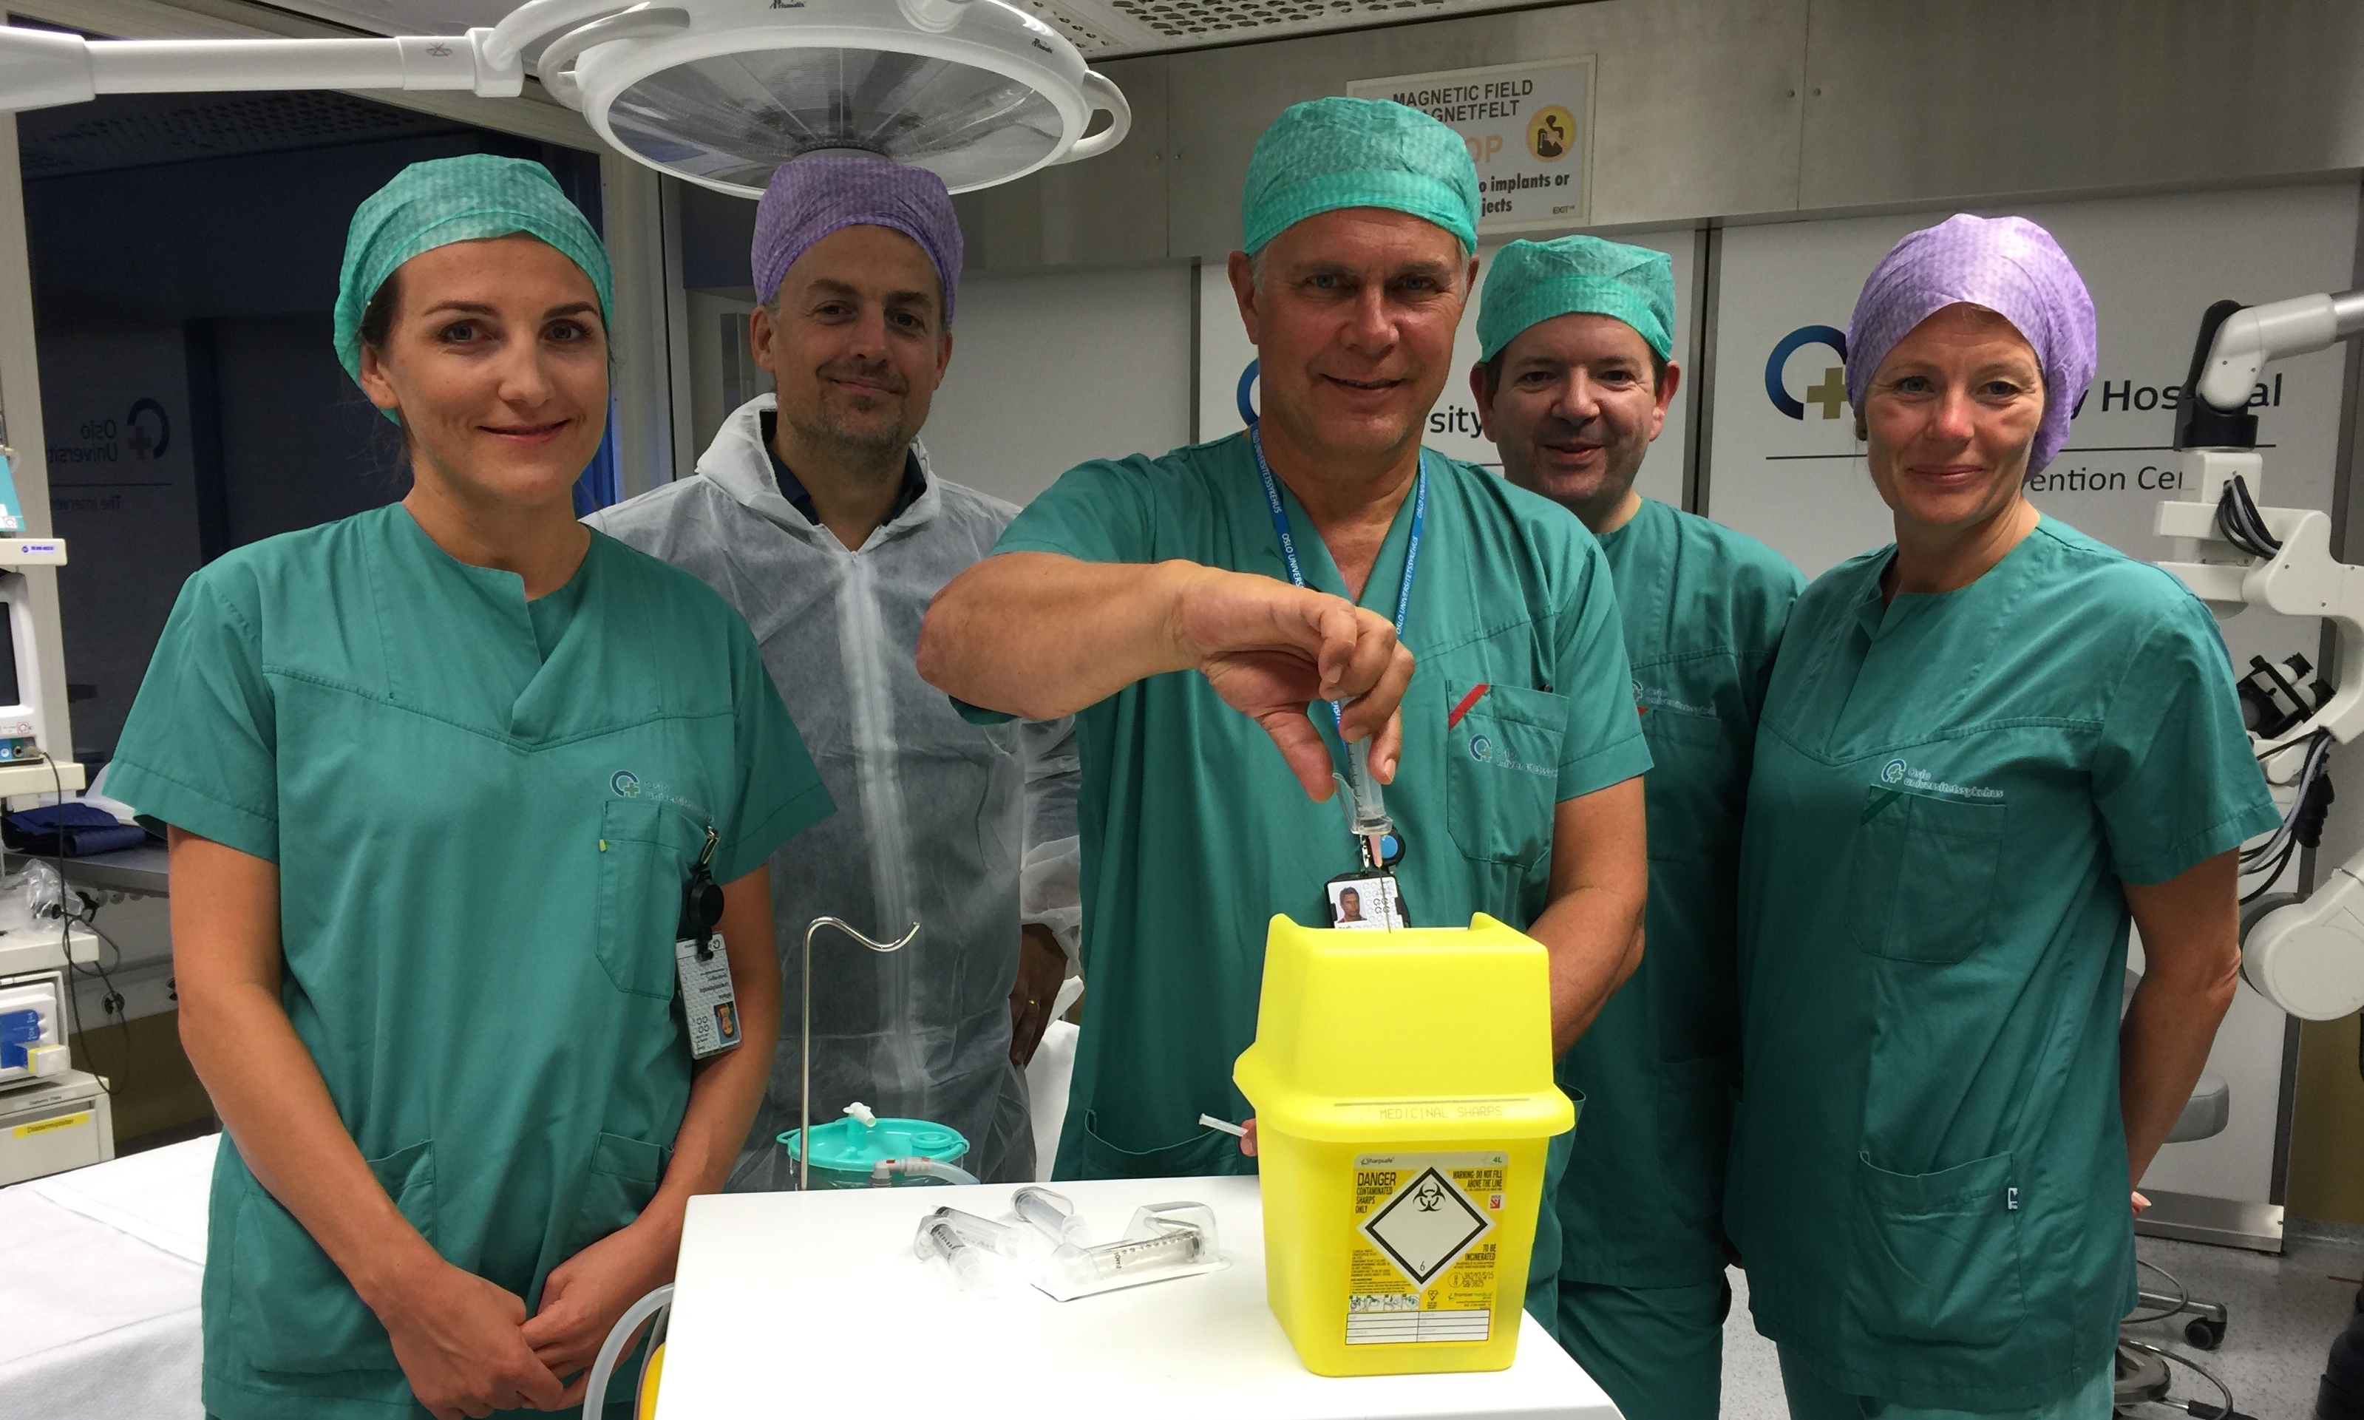
From June 2014 to July 2015, The Norwegian Research Council (VRI) supported an evaluation research study on Luer-Jack®, a new medical syringe with one-hand disconnection from needles/cannulas and luer type connections. The Intervention Centre of Oslo University Hospital has conducted the study, and the final report was submitted to ConceptoMed today, 1st of September 2015.

Project Leader Karl Øyri demonstrating one-hand needle disconnection, one key finding from the study

A main finding in the report is the demonstrated potential of Luer-Jack to improve quality and patient safety in a large number of medical procedures:
- The Luer-Jack®-technology may reduce up to 50% the contamination of syringe tip, needle/catheter hub and needle-less connections, in particular in repeated use situations.
- Needle-stick safety is substantially increased through disconnection of sharps with only one hand.
- Luer-Jack® improves positioning of long needles/catheters in ultrasound guided procedures for several medical specialities – e.g. rheumatology, interventional radiology and anaesthesia - as well as other application areas.

- The findings in the study have been obtained by focus group interviews of medical specialists - both specialists and nurses in different medical areas. We are happy with the constructive process for the execution of the project. The findings from the study demonstrate the importance of user involvement in design processes. There is obvious room for improvement of existing, relatively straightforward and simple, disposable medical equipment. Some improvements, e.g. the Luer-Jack®, may represent high value in the struggle for increased patient safety and user safety. Syringe and needle procedures are executed in extremely high numbers throughout all healthcare services globally, says Karl Øyri, Project Leader, Section for Method Development and Industrial Collaboration, The Intervention Centre, Oslo university Hospital.

Luer-Jack® may become an important contribution for the struggle of improving procedure quality, safety and ensuring aseptic procedures when handling syringes and needles - and thus reduce probability of human error during the disconnection. Current syringes and needles on the market are delivered sterile, in very simple packaging - and it is not obvious that the method of opening the package safeguards sterility during actual use in patient treatment.

- A key element of Luer-Jack® is the development away from using two hands during disconnections. Health authorities and medical professionals now have the option of using medical disposables with integrated safety logic - both on the medical device itself, as well as the package design. We are very happy with the research service from the Intervention Centre, and the parthership with our design team at K8 Industridesign in Oslo. The findings from the current study demonstrate the importance of user-centered design to mitigate risk and meet the challenges of healthcare services of the future, says Christian Mide, M.D. and CEO of ConceptoMed AS.

The Intervention Centre of Oslo University Hospital have established a formal service structure to deliver testbed and research services for National and International life science industry www.ivs.no/testbed

Oslo Medtech administers life science ”VRI funding” from the Norwegian Research Council, Oslo municipality and Akershus Fykeskommune. R&D funding is allocated to companies developing new products and services within healthcare.

ConceptoMed AS is a Medtech company with innovative product categories, unique patent protected Medtech technology and strong finances. ConceptoMed commercialise smart Medtech solutions for an international market. For more information on the company, see www.conceptomed.com.

Luer-Jack® is a registered trademark owned by ConceptoMed AS. The Luer-Jack® technology is widely patent protected throughout the world, currently with almost 40 patents from 5 patent families.

