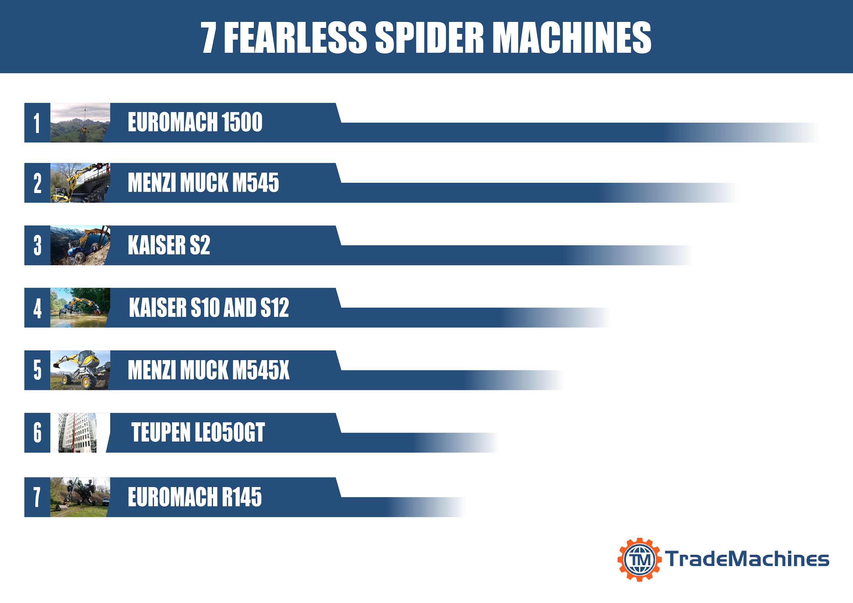
Image gallery: 10 most amazing robotic arms
7 fearless spider machines
Spider excavators (also known as walking excavators) take a firm place in the extraordinary machines category. Inspired by the mesmerizing and complex nature of spiders, an arachnid-like vehicle has been designed - and the result is simply epic! Have a look at the most fearless and powerful spider machines - a ranking prepared by TradeMachines.
Those fierce, robust and reliable machines are ready to work in any type of environment, whether it’s in deep water, forest or uneven terrain with steep slopes. The rotating platform, where the operators sit, coupled with leg-like extensions ensure both versatility and stability.
Despite the extreme capabilities of spider machines and their unusual looks, most people don’t even know about their existence. Those crazy looking vehicles were invented in 1966 by Edwin Ernst Menzi and Joseph Kaiser. The idea behind the invention was to build a truck that could access areas which traditional excavators couldn’t, like mountain slopes. Menzi Muck AG & Kaiser AG are the leading spider excavator manufacturers today.
See our image gallery to discover more about the powerful and agile machines.
See image gallery:
https://press.trademachines.com/latest_media
Contact

Beata Majka
Online Marketing Manager
https://trademachines.com/

Tel. +49 30 61 29 71 16
Email: beata.majka@trademachines.com

Press information:

- TradeMachines is a meta search engine for used machinery. We consolidate offers from traders and auctioneers all over the world, and have every type of machine under one roof. Our platform is a convenient way for potential buyers to search for local and global offers online.
- Reprint free of charge.
- Image source can be found in image gallery.
- In case of usage of our work please credit us by inserting a link to trademachines.com. All pictures used are free of rights.
- For more information about TradeMachines, please contact onlinemarketing@trademachines.com

Sources & Ranking:

No. 1. 1500 Mobile / Euromach srl (Italy)

http://www.euromach.com/eng/spider-mini-excavator.php
No. 2. Menzi Muck M545 / Menzi Muck AG (Switzerland)
https://www.menzimuck.com/en/menzi-muck-world/multimedia/photos/
No. 3. KAISER S2 / KAISER AG (Liechtenstein)
https://www.kaiser.li/products/s2-emission-stage-eu-iiiatier-3/
No. 4. KAISER S10 and S12 / KAISER AG (Liechtenstein)
https://www.kaiser.li/products/new-generation-s10-s12-allroad/
No. 5. Menzi Muck M545x / Menzi Muck AG (Switzerland)
https://www.menzimuck.com/en/product-groups/menzi-muck-walking-excavators/
No. 6. Teupen LEO50GT / TEUPEN Maschinenbau GmbH (Germany)
https://www.teupen.com/en/products/leo50gt
No. 7. Euromach R145 Big Foot - Forester / Euromach srl (Italy)
http://www.euromach.com/eng/big-walking-excavator.php
Image captions:
No. 1. 1500 Mobile / Euromach srl (Italy)
This tiny spider excavator weighs only 1900 kg and is less than a metre wide. Thanks to its compact size and weight it can be transported by helicopter to places which are not easily accessible by vehicles.
No. 2. Menzi Muck M545 / Menzi Muck AG (Switzerland)
Menzi Muck M545 is a machine able to wade in the water. Its biodegradable hydraulic fluid protects the water and its fish habitat. It can work being submerged in up to 1.7 m deep water.
No. 3. KAISER S2 / KAISER AG (Liechtenstein)
Kaiser S2 is a very powerful truck able to work in the toughest of terrain. Its adjustable legs enable maximum standing area on very steep mountains and cliffs. This extremely versatile machine will perform well even on almost vertical slopes.
No. 4. KAISER S10 and S12 / KAISER AG (Liechtenstein)
Were you impressed with Menzi Muck M545? The new generation Kaiser S10 model has an increased maximum wheel leg mobility which allows the truck to wade in the water even deeper than Menzi Muck, up to 2.45m. Additionally, an increased tank capacity extends its working time.
No. 5. Menzi Muck M545x / Menzi Muck AG (Switzerland)
This powerful truck has 155 HP and a P-Vation system allowing for parallel adjustment of the stabilizers in horizontal and vertical direction. On top of that the high-tech chassis and patented boom will allow Menzi Muck M545x to adapt to (almost) any terrain.
No. 6. Teupen LEO50GT / TEUPEN Maschinenbau GmbH (Germany)
Teupen LEO50GT is a perfect solution for those who need assistance in high rise construction. And I mean really high - this aerial lift is able to work at 50m! Additionally, the rotatable platform (180° rotation) allows for extra versatility and very precise maneuvering.
No. 7. Euromach R145 Big Foot - Forester / Euromach srl (Italy)
Euromach R145 Big Foot - Forester is the most powerful walking excavator on the market. Its enormous power (266 HP), increased gearbox and the possibility to install three pumps (for the motion, for the boom and for accessory) makes it the pioneer among all the spider-like machines.

