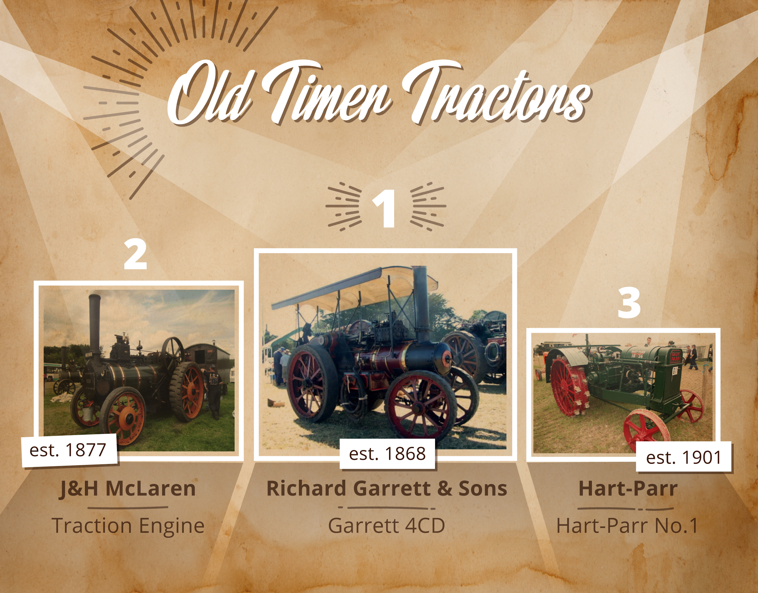

**Full Steam Ahead! 8 Oldtimer tractors that paved the way for future farming**

Playing a key role in the mechanization of agriculture, **tractors made their first appearance in the middle of the XIX century**, thanks to the ingenuity of a group of British and American engineers.   
Powered by steam engines at first, these machines experienced a great technological development in the following century, both in design and power generation.   
  
Having a look at some oldtimers gives a glimpse of **what the future seemed to be like** in the Victorian Era, when a generation of pioneers spread on both sides of the Atlantic fostering the diffusion of tractor companies. Today we look at them as relics from the past, but these pieces of machinery were real game changers. The reduction of mancraft and hours of work in agricultural tasks were among the many factors that shifted the life of millions of workers toward factory jobs and, therefore, a growing urbanisation.   
  
Over time, these **tractors became synonyms for farming**, due to their ability to meet the needs of a developing world, tight between roaring industrialization and ineluctable globalization.  
  
[TradeMachines](https://trademachines.com/) gives us a better understanding of these early stages: a [retrospective gallery](https://press.trademachines.com/latest_media) presents some of the first models and manufacturers that helped shaping the way to modern agriculture.

**See image gallery:**

<https://press.trademachines.com/latest_media>

**Contact**

Beata Majka

Online Marketing Manager

<https://trademachines.com/>

Tel. +49 30 61 29 71 16

Email: [beata.majka@trademachines.com](mailto:beata.majka@trademachines.com)

**Press information:**

* TradeMachines is a meta search engine for used machinery. We consolidate offers from traders and auctioneers all over the world, and have every type of machine under one roof. Our platform is a convenient way for potential buyers to search for local and global offers online.
* Reprint free of charge.
* Image source can be found in image gallery.
* In case of usage of our work please credit us by inserting a link to [trademachines.com](https://trademachines.com/). All pictures used are free of rights.
* For more information about TradeMachines, please contact [onlinemarketing@trademachines.com](mailto:onlinemarketing@trademachines.com)

**Sources & Ranking:**

**No. 1. Richard Garrett & Sons**

<https://tractors.fandom.com/wiki/Garrett>

<https://www.thoughtco.com/history-of-tractors-1992545>

<https://en.wikipedia.org/wiki/Richard_Garrett_%26_Sons>

Image: <https://www.flickr.com/photos/sirwiseowl/424491015/in/photolist-DvCoB-oaDHG2-oaDmCQ>

**No. 2. Hart-Parr**

<https://tractors.fandom.com/wiki/Hart-Parr>

<https://www.thoughtco.com/history-of-tractors-1992545>

Image:

<https://commons.wikimedia.org/wiki/File:Hart-Parr_18-36_s_n_30161_at_GDSF_08_-_IMG_0632.jpg>

**No. 3. Fordson**

<http://oldtractorpictures.com/Ford/>

<https://en.wikipedia.org/wiki/Fordson>

<https://www.gasenginemagazine.com/company-history/fordson-tractor-zmaz68mjzraw>

Image:

<https://www.flickr.com/photos/mdpettitt/15412731375/in/photolist-ptYh4R-bMo4Er-bXS3cL-cY12Lb-rmNHHs-6XGwZM-pPmyS-c1SiCh-8BWGzU-iTgt9m-pPhbg-o9SgjT-o9SZfq-bvXku7-orky9C-pu5vL-oEcWBA-72PMuS-6EmMzM-pu5vV-bvXkGE-Y9jsNc-ophtU7-EAgspS-9TopCT-e6kCeN-ot6q7c-orn71e-o9QzMh-FMq6iT-9WWXtD-e6f4Uc-o9QKe2-71xtDh-2H77NV-e6kKsL-9WWXMV-bVdz4N-71DhKp-or8qGE-U67FB8-orn3Nx-yygJNy-e6kHC5-orm2uQ-c1SjC5-opKSpB-9WWWQa-e6kDhU-4JotfU>

**No. 4. Frick Co.**

<https://www.thoughtco.com/history-of-tractors-1992545>

<https://www.gasenginemagazine.com/tractors/frick-tractor-factory>

Image:

<https://www.flickr.com/photos/jamescanby/29792999/in/photolist-3CGqp-a4A3e5-jdvtCB>

**No. 5. William Foster & Co**

<https://tractors.fandom.com/wiki/William_Foster_%26_Co>

<https://en.wikipedia.org/wiki/File:Foster_Showmans_engine_sn_14431_Robin_Hood_P8030382.JPG>

Image:

<https://commons.wikimedia.org/wiki/File:Foster_Showmans_engine_sn_14431_Robin_Hood_P8030382.JPG>

**No. 6. J&H McLaren**

<https://www.gracesguide.co.uk/J._and_H._McLaren>

<https://tractors.fandom.com/wiki/J%26H_McLaren>

Image:

<https://commons.wikimedia.org/wiki/File:McLaren_traction_engine_sn_127.JPG>

**No. 7. Aultman-Taylor Machinery Co.**

<https://tractors.fandom.com/wiki/Aultman-Taylor_Machinery_Co>.

Image:

<https://www.flickr.com/photos/varnent/39847524715/in/photolist-6A1j72-hcpZM7-hcpZnQ-dF8FFV-fyzRUz-27ckjj-fyQa11-7TPR9S-8Eij8Y-XbJ28i-23HbYQc-XbJ2xr>

No. 8. **Holt 75 (Caterpillar)**

<https://en.wikipedia.org/wiki/Holt_tractor>

<https://en.wikipedia.org/wiki/Benjamin_Holt>

<https://hagginmuseum.org/collections/holt-75-tractor/>

Image:

<https://commons.wikimedia.org/wiki/File:Holt_75_(Caterpillar)_serial_number_3580_at_GDSF_2008_-_IMG_0743.jpg>

**Image captions:**

**No. 1. Richard Garrett & Sons**

Richard Garrett started his business in 1778, in Leiston, Suffolk, England. The company was best known for their steam tractors. A long line of steam engines was introduced in 1830s. The most popular model became Garrett 4CD.

**No. 2. Hart-Parr**

Hart-Parr was founded by Charles W. Hart and Charles H. Parr, who began their work on gas engines in the late 1800s. The company’s first tractor was built in 1901. Hart-Parr is also credited for coining the term ‘Tractor’.

**No. 3. Fordson**

Not many know that Henry Ford was the son of a farmer. Showing his interest in both agriculture and industry, he started his experimental work on tractors in the early 1900s. His first design ‘Automobile Plow’ was ready in 1907. The Fordson tractor production started in 1917 for the English market and a year later for the American one.

**No. 4. Frick Co.**

George Frick started his company already in 1853 manufacturing steam engines. The introduction of a gas tractor was a milestone for the entrepreneur. Like many, he was working hard to make his way into the gas tractor market. Sadly, he did not succeed and the whole Frick Co. tractor production ended in 1928.

**No. 5. William Foster & Co**

William Foster & Co was a Lincoln, Lincolnshire, UK based company, known also as ‘Fosters of Lincoln’. The company founder started his career as a flour miller. Soon he started producing grinding mills, threshing machines and portable steam engines. After Foster’s death, the business was taken over by Gwynnes Engineering and later by W H Allen & co. Ltd. Unfortunately, it closed in 1968.

**No. 6. J&H McLaren**

1876, two brothers from Hylton castle in Sunderland, John and Henry McLaren, started their company producing traction engines and stationary engines. The company developed rapidly, adding new machines to their portfolio: road rollers, ploughing engines, crane engines or railway locomotives. 1940, the company built also a diesel-engined tractor.

**No. 7. Aultman-Taylor Machinery Co.**

Aultman-Taylor Machinery Co. was an American company, known for producing a variety of agricultural machinery, including saw mills, steam engines or threshing machines. The tractor production began in the early 1900s. Their model Aultman-Taylor 30-60 became legendary.

**No. 8. Holt 75 (Caterpillar)**

The Holt tractors were produced by the Holt Manufacturing Company, named after Benjamin Holt - manufacturer of the first track-type tractor, which he trademarked as the “Caterpillar.” The track-type solution prevented the tractor from being stuck, since it provided more traction than round wheels. The Holt tractors were used by armies during World War I for hauling heavy artillery.