PRESS RELEASE 12/8/19
STRAWBEES AB, GOTHENBURG, SWEDEN

Strawbees is incredibly honoured to appoint Fabian Bengtsson and Carl Fhager, esteemed Board members to the Board of Directors.

The Board of Directors of Strawbees AB is pleased to announce the appointment of two new esteemed Board members, Fabian Bengtsson and Carl Fhager, who officially joined the Board June 26th, 2019. Both esteemed Board members are highly respected in the Business community, and bring a wealth of experience in the following areas: entrepreneurship, strategy and innovation, law, business development, tech start-ups/scale-ups, government relations, policy development, angel investing and venture capital funding. Their expertise and guidance will be invaluable in driving Strawbees accelerating growth and tremendous success momentum in the years ahead.

‘I am incredibly honoured that both Fabian Bengtsson and Carl Fhager join the Board of Directors. They will support and advise us in what will become a very exciting future ahead of us, where Strawbees should be a standard product in all classrooms, as well as a great educational product in the retail market,’ states Erik Bergelin, CEO of Strawbees.

‘I am delighted to be part of Strawbees’ vision when it comes to hands-on and learning-by-doing education. I see a huge potential when it comes to combining products from the education and retail sector. Strawbees is filling the gap in relevant and fun education. I was one of the early investors in Strawbees back in 2017 and have since then watched them both grow and develop. I am proud to be part of Strawbees’ future success story as a new Board member going forward,’ comments Fabian Bengtsson, entrepreneur and new Board Member of Strawbees.

Strawbees also appoints Carl Heath, Special Counsel for the Protection of Democratic Dialogue and Vice President Professional Education at RISE, Anna Stenberg, founder of Wes Group (Executive Search) as well as Shams Jorjani, Chief Business Development office at Paradox Interactive to Strawbees’ official advisory board. This stellar advisory board will advise the Strawbees Board of Directors in three key development areas for Strawbees going forward; Educational strategy and development, organizational development, as well as digital development.
‘Carl, Anna and Shams will be key resources for Strawbees going forward. Carl will be our speaking partner when it comes to educational development, Anna will help us build a world-class organisation, and Shams, with his extensive digital experience, will be our go-to person when it comes to platform building, our customer journey and digital development.’ says Strawbees CEO Erik Bergelin.

Notes to Editor:
Fabian Bengtsson is a Swedish entrepreneur with extensive experience in retail and digital commerce. Previous CEO of SIBA and chairman of NetOnNet AB, including as CEO 2001-2014, Chairman of NetOnNet AB 2012-2015 and member / Chairman of CE-Konsumentelektronikbranschen AB. Today Fabian Bengtsson is an active owner and chairman of the family´s investment company, Waldir AB, who owns the consumer electronic retailer; NetOnNet AB among others. He sits on the board of Företagarnas Riksstyrelse AB, Axfood AB, Svensk Fastighetsförmedling AB and several more. Image: Fabian Bengtsson, photo credit Sören Håkenlind
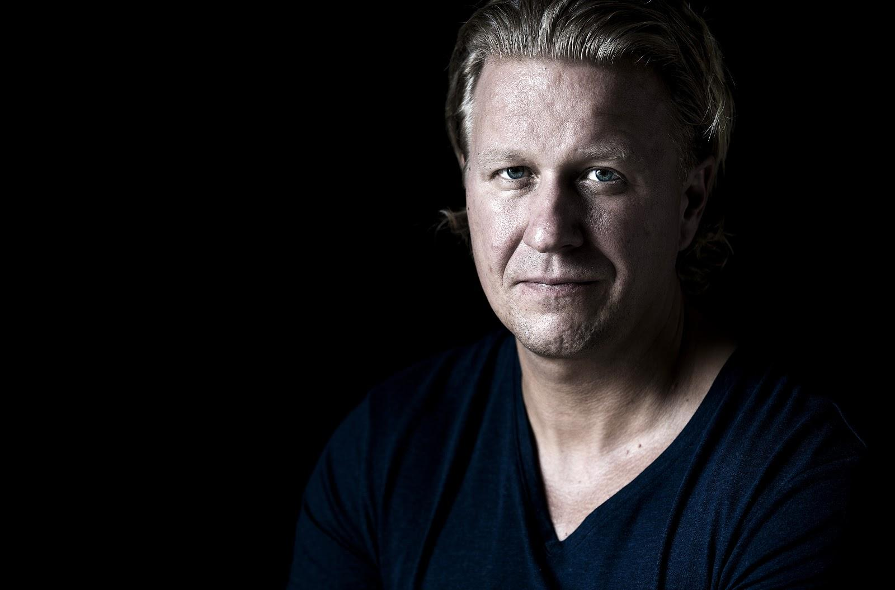
Carl Fhager is a partner at MAQS’ Gothenburg office and leads the practice group for Start-up companies. Considering Carl’s dual legal and managerial background, he is often asked to assist boards in an advisory manner or to join them as a member or a chairman. He also is a guest lecturer at Gothenburg University, lecturing on the topics of sports law, negotiations and agreements. Carl is also running one of the most well known business podcasts in Sweden called “Förhandlingspodden”. Image: Carl Fhager
