Successful first trial for EM 304 MKII echosounder
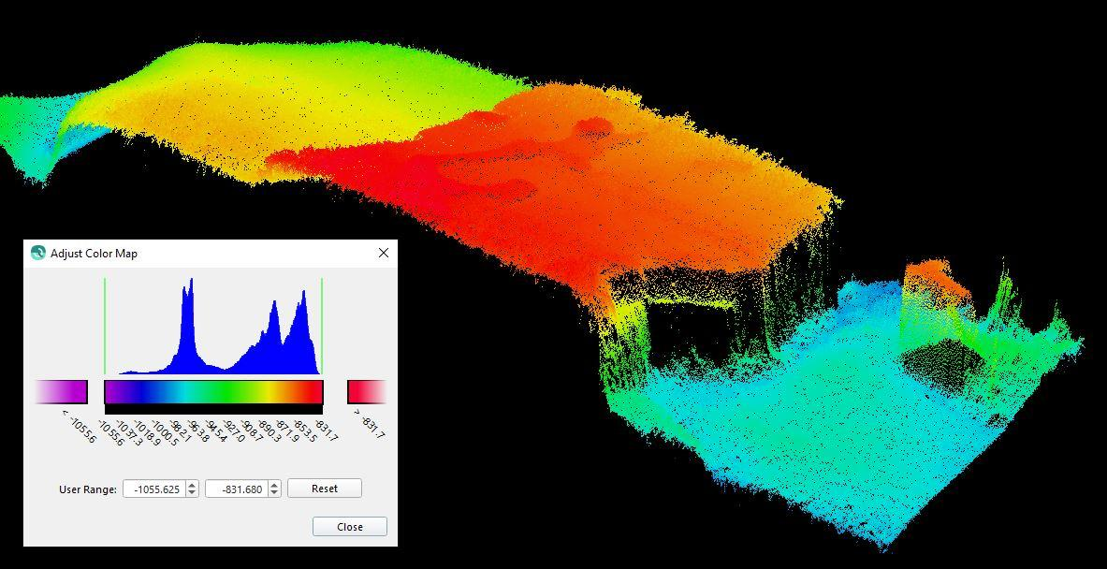
An EM 304 MKII 0.5°x1° image capture from the NOAA vessel Okeanos Explorer. Depth 1,000m, 5km swath

Kongsberg, Norway, 8th July 2021 – Kongsberg Maritime (KM) is pleased to report that its new EM 304 MKII high-resolution deep-water multibeam echosounder system has just successfully completed its first trials on board the NOAA vessel Okeanos Explorer in the waters off the coast of Florida.
Okeanos Explorer is the first vessel in the world to be fitted with the EM 304 MKII transmit array – a comprehensive upgrade to the trusted EM 302 deep-water multibeam system which has been deployed daily since the ship was originally launched in 2008. The new EM 304 MKII was put through its paces over the course of a 25-day expedition on board Okeanos Explorer, conducted by a team from NOAA Ocean Exploration, the US federal organisation devoted to the exploration of deep ocean environments.
The motive behind the expedition was to assess the functionality and readiness of all mapping-related equipment on the vessel – including an official authorisation of the new EM 304 MKII system – before the remainder of the field season commences. Receiving a green light from the NOAA verifies that this equipment is capable of collecting the most accurate, high-quality survey data and sharing it with hydrographic communities. By enabling the team to optimise the planning and execution of surveys, it will ensure that all forthcoming missions produce definitive results in the most cost-effective manner.
The EM 304 MKII has been designed to increase the efficiency of deep-water mapping work by enhancing the quality of harvested data and expanding the achievable coverage area. KM’s multibeam systems have a well-founded reputation for producing exceptionally clean data across the entire swath width, but the improved, future-proof MKII EM platform uses an innovative datagram format which supports several new features including extended backscatter calibration. More new features are currently being developed.
As with all KONGSBERG EM multibeam echo sounders, the EM 304 MKII has been designed to minimise any potential impact on ocean ecosystems, emitting the lowest-possible sound levels so as to help in safeguarding marine organisms within survey areas.
“We are very pleased with the EM 304 system’s performance and with KONGSBERG’s technical support so far,” says Genene Fisher, acting director of NOAA Ocean Exploration, “and are looking forward to using this sonar to explore the deep waters of the United States and beyond, continuing to push the boundaries on deep-ocean mapping and narrowing the gaps in the unmapped global seafloor.
“The successful installation and shakedown of this new sonar is the result of a strong, long-standing and productive relationship between NOAA Ocean Exploration, the NOAA Office of Marine and Aviation Operations and Kongsberg Maritime,” Fisher continues. “With the integration of this new system, we are poised in the next year to pass the milestone of having mapped a total of 2,000,000km² via Okeanos Explorer. We’re looking forward to sharing our experiences with the global seafloor mapping community.”
“It’s a pleasure to be working with NOAA on the first sea trial of the new MKII on Okeanos Explorer,” adds Helge Uhlen, VP Underwater Mapping Sales, Kongsberg Maritime, “and it’s exciting to have confirmation that the new system meets all NOAA and KM expectations. The new EM 304 MKII system has truly remarkable long-range and high-resolution capabilities: it’s an important step towards revealing the secrets of the deep in much greater detail than has ever been possible before.”
Ends

For further information, please contact:
Gunvor Hatling Midtbø, VP Communication
Kongsberg Maritime
Tel: +47 9921 4209
gunvor.hatling.midtbo@km.kongsberg.com
David Pugh
Saltwater Stone
Tel: +44 (0)1202 669244
d.pugh@saltwater-stone.com

About Kongsberg Maritime
Kongsberg Maritime is a global marine technology company providing innovative and reliable ‘Full Picture’ technology solutions for all marine industry sectors including merchant, offshore, cruise, subsea and naval. Headquartered in Kongsberg, Norway, Kongsberg Maritime has manufacturing, sales and service facilities in 34 countries.
Kongsberg Maritime solutions cover all aspects of marine automation, safety, manoeuvring, navigation, and dynamic positioning as well as energy management, deck handling and propulsion systems, and ship design services. Subsea solutions include single and multibeam echo sounders, sonars, AUV and USV, underwater navigation and communication systems.
Training courses at locations globally, LNG solutions, information management, position reference systems and technology for seismic and drilling operations are also part of the company’s diverse technology portfolio. Additionally, Kongsberg Maritime provides services within EIT (Electro, Instrument & Telecom) engineering and system integration, on an EPC (Engineering, Procurement & Construction) basis.
Kongsberg Maritime is part of Kongsberg Gruppen (KONGSBERG), an international, knowledge-based group that celebrated 200 years in business during 2014. KONGSBERG supplies high-technology systems and solutions to customers in the oil and gas industry, the merchant marine, and the defence and aerospace industries.
Web: Kongsberg Gruppen | Kongsberg Maritime
Social media: LinkedIn | Twitter | Facebook

