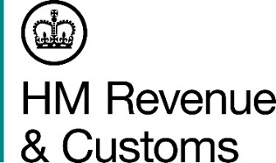
News Briefing

 | For the attention of Newsdesks |  | No. of pages: 2
 | Date: | 29 April 2022 | Ref: | SCO NB 02 22

One million cigarettes seized from West Lothian storage unit

An investigation is underway after 1.1 million suspected illicit cigarettes and more than two dozen pallets of alcohol were seized by HM Revenue and Customs (HMRC).

Officers made the discovery inside a unit at an industrial park in Whitburn, West Lothian, on Wednesday (27 April 2022).

As well as the cigarettes, 28 pallets of alcohol were seized, including vodka, whisky and prosecco.

The goods found in the unit are believed to be worth an estimated £631,000 in lost duty and taxes.

A van and a forklift at the scene were also seized, plus £5,000 cash. No arrests have been made and enquiries are continuing.

Anyone with information about the illegal sale of cigarettes and alcohol should report it to HMRC online at gov.uk.

Notes for editors

- Details of the seizures on Wednesday (27 April 2022):
- 1.1 million cigarettes worth an estimated £510,000 in lost revenue
- 2,600 litres of vodka, 5,000 litres of whisky, 230 litres of gin and 40 litres of rum worth an estimated £105,000 in lost revenue
- 2,900 litres of prosecco and 1,500 litres of wine, worth an estimated £16,000 in lost revenue
- A van and forklift
- £5,000 cash

- The sale of illegal tobacco and alcohol will not be tolerated by HMRC or our partner agencies. Disrupting criminal trade is at the heart of our strategy to clampdown on the illicit tobacco and alcohol market, which collectively costs the UK around £3.3 billion a year. This is theft from the taxpayer and undermines legitimate traders.

- Follow HMRC’s press office on Twitter @HMRCpressoffice

Issued by HM Revenue & Customs Press Office

Press enquiries only please contact:
Will Lyon
Scotland Press Officer
Tel: 07469 023 331
Email: william.lyon@hmrc.gov.uk

Out of hours
Tel: 07860 359 544
Website www.gov.uk/hmrc

