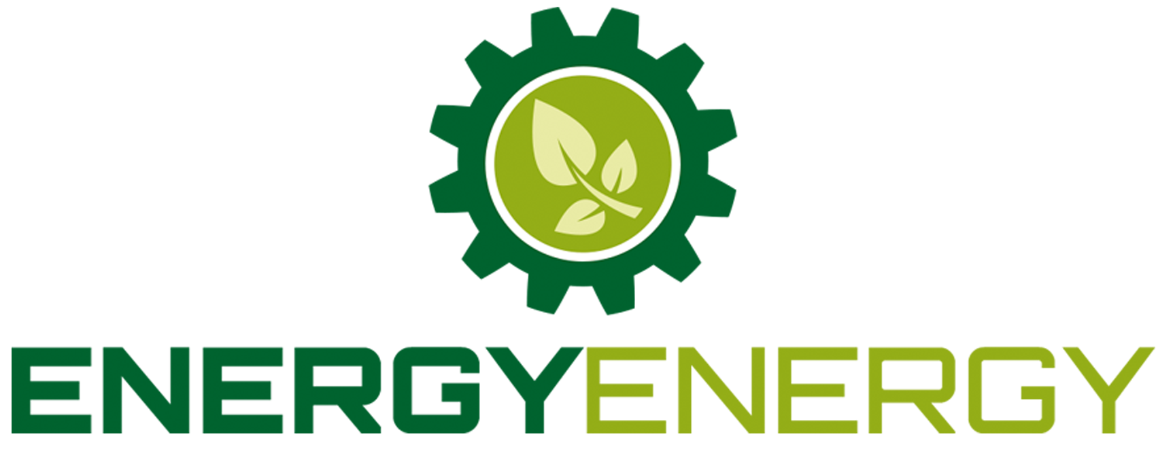
Renewable Industry Growth Creates 5 New Jobs At Local Firm

Thursday, 9 October 2014 - RENEWABLE firm Energy Energy has announced that they are hiring 5 new employees following increased demand for renewable products.

The South Brent-based firm has grown from 2 people since last year, and is now leading the way in biomass installations.

This comes as autumnal weather has swept the region, seeing temperatures getting down to single figures over night.

Energy Energy Managing Director Andy Lackie said “The recent weather has prompted a unprecedented rise in enquires to our company”

“It is getting into the time of the year when many turn to their thermostat, but our enquires are mostly coming from those on heating oil and LPG”

“Our customers are switching to biomass boilers to escape the prices of heating oil, with biomass fuels coming in at up to 50% cheaper than oil and LPG”

Biomass boiler technology has recently been subsidised by the government, with Tier 2 of the Renewable Heat Incentive being announced.

This is letting domestic properties get paid an average of £3000 per year over a guaranteed term of 7 years, drawing many toward the renewable heating solution.

Energy Energy urges anyone with skills relevant to plumbing, engineering and plumbing to get in touch. You can view their current job openings on their careers page.

— End —

