Bäckman's selected for the National Team for the third year in a row
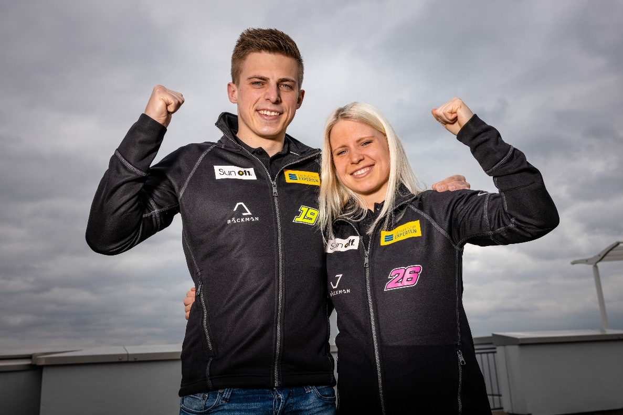
Today it was announced that the Bäckman siblings Andreas and Jessica Bäckman from Sweden has been selected for the Swedish National Team for car racing for the third consecutive year.
- This is a great opportunity for us to continue our development as racing drivers and we are extremely proud to once again be part of the Swedish National Team this season, Andreas Bäckman says.
Today, the Swedish Automobile Sports Federation announced its National Team drivers for 2022. Among all the talented drivers from Sweden, the siblings Andreas and Jessica Bäckman from the North of Sweden were among the names of the selected drivers. Andreas will once again be part of the Senior National Team “Sweden National Team”. New for this year is that Jessica also will be part of the Senior National Team “Sweden National Team”, the previous years she has been part of the Junior National Team “Sweden Junior Team”.
- Very happy and grateful that the Swedish National Team wants to continue to invest in us. It is an important piece of the puzzle for us to be able to continue our path forward in our careers. Being part of the National Team will also help us to develop as a driver and everything that comes with being an elite racing driver, Jessica Bäckman says.
The main purpose of the National Team is to develop the drivers and give them as many tools as possible to reach the top in car racing.
- This is a great opportunity for us to continue our development as racing drivers and we are extremely proud to once again be part of the Swedish National Team this season, Andreas Bäckman says.
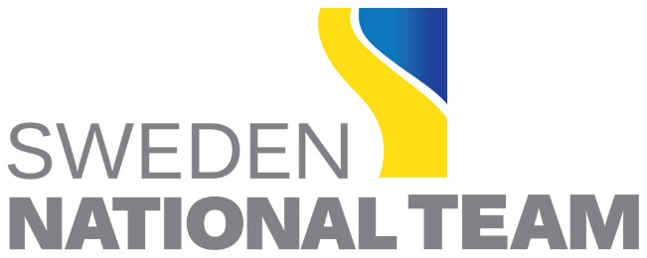

The National Team's elite investment in car racing talents
The Sweden National Team captain Pier Steffansson is looking forward to continuing to work with Andreas and Jessica:
- Great fun to once again welcome Andreas & Jessica into the Swedish National Team, they have developed and gathered experience in the World Cup, FIA WTCR last year which they have worked very hard to achieve. Last year, both siblings showed that they belong to the world elite and this year Jessica has already taken her first victory in TCR. We continue the work and development and together with the siblings' drive, focus and commitment, we put the puzzle together to take the next step in their careers, it will be exciting to see how far we can reach together, Pier Steffansson says.
Andreas and Jessica are looking forward to developing more at all levels in 2022 and are hoping to become more complete as racing drivers with the help of this initiative:
- Before 2020, it came as a positive surprise when we found out that we have been selected for the National Team and that we now being allowed to be part of the National Team for the third year in a row feels amazing. As an athlete in car racing, there is so much behind the few opportunities in the racing season when you must perform on the track, and there the National Team is an important part of our efforts, Andreas Bäckman says.
Free rights to use images.

