Press release
Kongsberg Digital adds Zegeba as a new partner to the Kognifai Marketplace

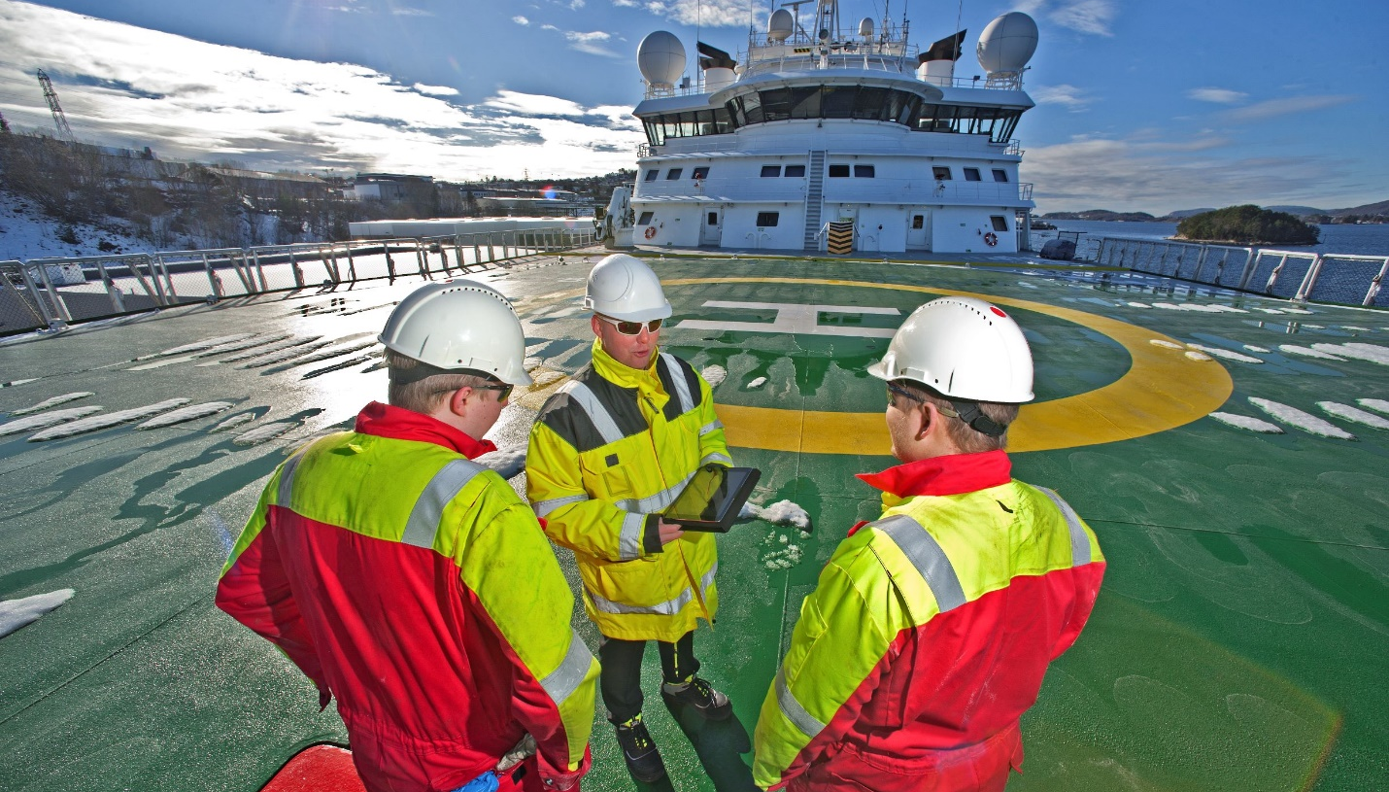
Zegeba’s digitalized documentation service is now available on the Kognifai Marketplace

Asker, Norway, June 24th, 2021 – Kongsberg Digital has signed a partnership agreement with Zegeba, a software company offering a digitalized service for manual documentation processes in the maritime industry. By adding Zegeba to the Kognifai Marketplace, Kongsberg Digital’s Vessel Insight subscribers can easily access the service and streamline documentation data flow at sea and on land.
The Zegeba platform provides companies with a unique combination of features to facilitate and streamline the transition from manual work processes using paper forms and single files to a fully digital work experience. The solution is generic and flexible, so that users gain both the operational benefit of an optimized digital workspace as well as easier data handling and processing. Workflows replace manual steps in both receiving and sending data between people or applications.
Zegeba is easy to configure, does not require any programming to get started, and can be used as a standalone solution or connected to other applications via APIs or plug-ins to create optimized solutions. Companies can create templates and reports that meet their needs, helping to avoid time-consuming and costly digitalization and software development projects.
Vessel Insight infrastructure
Kongsberg Digital’s Vessel Insight is a cost-efficient data infrastructure solution that enables shipowners and operators to start and succeed in their digitalization process. Vessel Insight collects and contextualizes data from vessels, making it available to top-level applications such as Zegeba. These applications are distributed via the Kognifai Marketplace, creating a network of partnerships that provides access to a range of market-leading tools that can be utilized by Vessel Insight subscribers to become more sustainable and gain a competitive edge. The Kongsberg Digital Customer Success Team assists Vessel Insight subscribers wishing to adopt these applications.
“We are very pleased to offer Zegeba’s software solution to our Vessel Insight subscribers through the Kognifai Marketplace,” says Eirik Næsje, Senior Vice President of Vessel Insight, KDI. “Operational efficiency improvements are key drivers in the maritime industry. Electronic data exchange between ship and shore needs further digitalization to ensure fast and secure exchange of data and information, and Zegeba is facilitating exactly this. Digital workflow is an important step towards standardized reporting in the industry, which will take shipping into a new era of efficient and transparent operations.”

Benefits of Zegeba
Zegeba is used to optimize core business processes and has a major impact on many aspects of business operations. For example:
- More efficient tools and better documentation processes reduce time-consuming manual steps and allow employees spend less time performing tasks
- Time savings and streamlined work processes reduce costs
- Access and insight into data provides increased overview and control, helping to prevent delays and costly mission-critical errors
- Improved customer invoicing reduces manual work
Zegeba's software is priced based on the number of users or units, not on upfront purchase, helping to achieve savings and value increases from day one. Depending on how a company uses Zegeba's features, the changes delivered may lead to a direct increase in revenue.
“It is with great enthusiasm that we announce the availability of Zegeba through the Kognifai Marketplace, and we believe this collaboration will further spark the transition to fully digital work tools in the maritime industry,” says Line Skarmyr, COO of Zegeba. “There are great synergies in connecting Zegeba with Vessel Insight and we look forward to exciting projects to promote our common solution. This collaboration will contribute to increasing the value of our customers’ services and empowering them to reach their goals, whether it is more competitiveness, increased revenue or becoming a more sustainable business.”
Through this partnership, Zegeba and Kongsberg Digital are strengthening their common digital offering to the benefit of all Vessel Insight subscribers and the maritime market in general. The application will be available on the Kognifai Marketplace from June 2021.

KONGSBERG DIGITAL
Kongsberg Digital is a provider of next-generation software and digital solutions to customers within maritime, oil and gas, and renewables and utilities. The company consists of more than 500 software experts with leading competence within the internet of things, smart data, artificial intelligence, maritime simulation, automation and autonomous operations. www.kongsbergdigital.com
KONGSBERG
KONGSBERG (OSE-ticker: KOG) is an international, leading global technology corporation delivering mission-critical systems and solutions with extreme performance for customers that operate under extremely challenging conditions. We work with nations, businesses and research environments to push the boundaries of technology development in industries such as space, offshore and energy, merchant marine, defense and aerospace, and more. KONGSBERG has about 11,000 employees located in more than 40 countries, creating a total revenue of NOK 25.6bn in 2020. Follow us on: kongsberg.com, Facebook, Twitter and LinkedIn
Zegeba
Zegeba provides a generic software platform used by businesses, organizations and partners to assist with the digitalization and optimization of core business processes. Zegeba develops tools for companies and organizations where information, observation and experience from humans and their work is needed to provide accurate documentation and real time data for further processing and completion. In collaboration with partners and businesses our aim is to be in the forefront of software development and create solutions that handle the transformation of business-critical human data into a digital format that communicates seamlessly with people, applications, machines and analytics.

CONTACT:  Mathilde Magnussen  VP Communication and Marketing  Kongsberg Digital  (+47) 456 78 255  mathilde.magnussen@kdi.kongsberg.com | Line Skarmyr  COO  Zegeba AS  (+47) 92 25 64 96  line.skarmyr@zegeba.com
David Pugh
Account Manager
Saltwater Stone
(+44) 1202 669244
d.pugh@saltwater-stone.com

