Historic double wins for Jessica Bäckman in Red Bull Ring
Last weekend May 20–22nd Jessica Bäckman won two out of two races at the second round of ADAC TCR Germany in Red Bull Ring. Jessica has now won 3 out of 4 races this season and is now 2nd in the driver championship, just 1 point after championship leader Martin Andersen.
–The weekend was pretty much perfect; I still have a hard time digesting that I won two out of two races this weekend. Unbelievable, especially considering that Red Bull Ring has never been my favorite track, but I think I reversed that trend this weekend, Jessica Bäckman says.
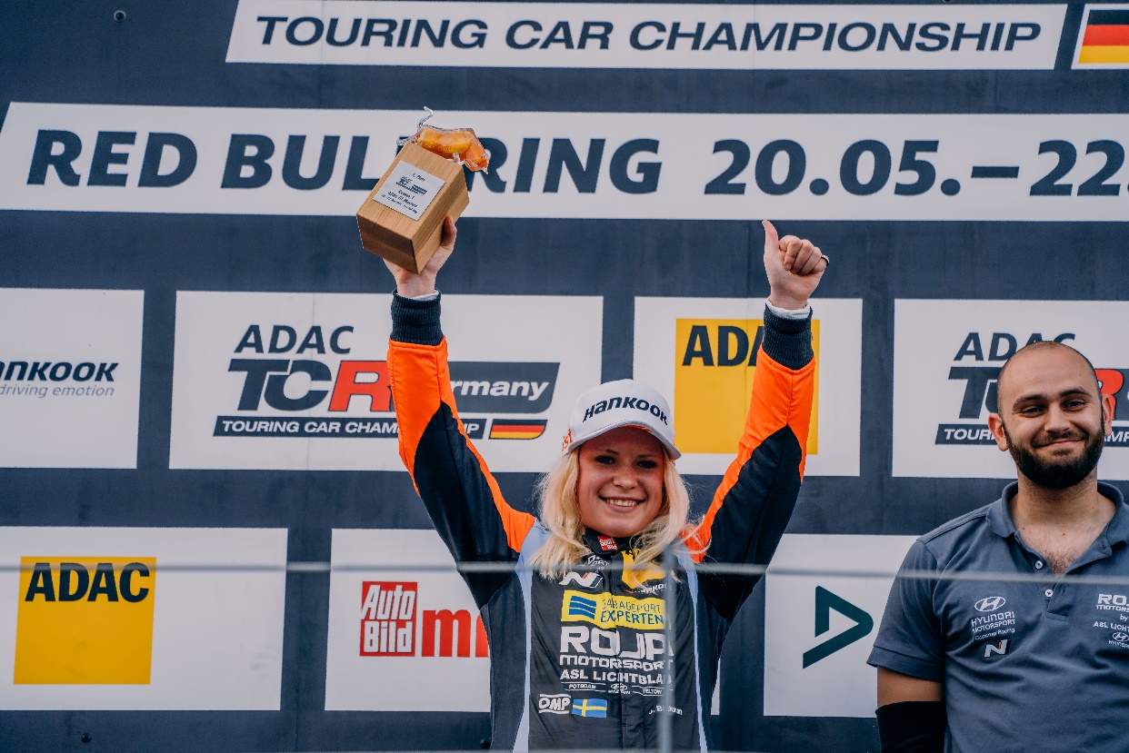
TCR Germany is one of the toughest TCR series in the world and has a high status of drivers coming from several different countries around Europe. Each race weekend is built on two free pracice sessions on Friday, one time qualifying on Saturday which determines the starting position in Race 1 on Saturday, and one time qualifying on Sunday which determines the starting position in Race 2 on Sunday. Points are awarded to the top 8 in the time qualifying and the top 15 in each race. The driver with the most points after the last race at the Hockenheimring at the end of October will take home the driver title "ADAC TCR Germany Drivers Title" in the ADAC TCR Germany series. Last weekend, May 20-22nd, the second round of ADAC TCR Germany was held at the Red Bull Ring track in Austria, where Jessica got Pole-Position on Saturday and then took another win in Race 1. On Sunday, the Sweden National Team driver qualified in fourth place but then raced her way up to another victory whit some tough fights the whole race.
- The weekend was pretty much perfect; I still have a hard time digesting that I won two out of two races this weekend. Unbelievable, especially considering that Red Bull Ring has never been my favorite track, but I think I reversed that trend this weekend, says Jessica Bäckman says.
Three out of four wins for Jessica Bäckman
Jessica started the weekend strong and was third fastest in the first free practice session and was then fastest of all in the second free practice session. In the first qualifying on Saturday, Jessica's time was enough for a strong second place. But then after the qualifying she was told that the fastest driver was forces to start from the back of the grid due to an engine change, which meant that Jessica got to start from Pole-Position. From Pole-Position in Race 1, Jessica got a super start, but then quickly got told from the race director that it was a jump start and therefore got handed a 5 second time penalty. The Sweden National Team driver then had to do everything in her power to pull away from her competitors to get at least 5 second gap. When there were 5 minutes remining of the race, she led by 4.7 seconds and thus 3 tenths were missing to take the lead. But when Jessica then crossed the finish line 5 minutes later, she had a lead of 7.6 seconds, which meant that she won her second victory of the season by 2.6 seconds with the time penalty.
-It made it a little too exciting on Saturday, I was very focused on making a good start but then it became a little too good. Then I had to do everything in my power to try to pull away, but not easily on a track like Red Bull Ring where both brakes and tires take a beating early, so when I then heard on the Radio that I won I was in shock, such an amazing feeling, Jessica Bäckman says.
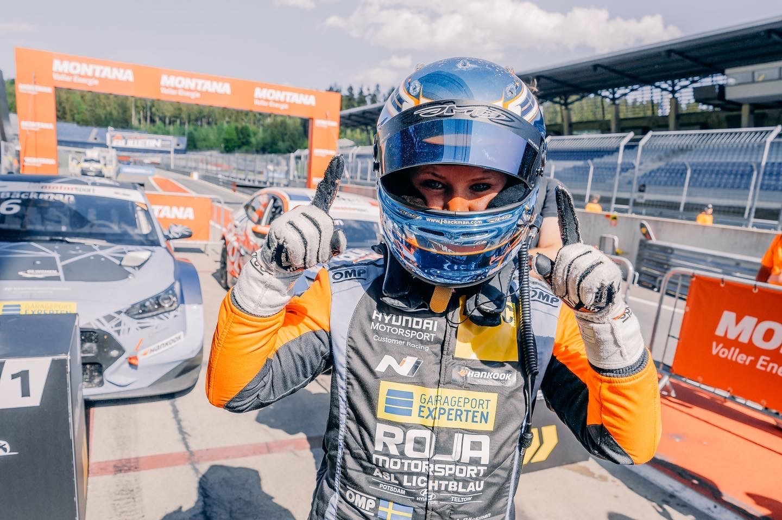
Victory again on Sunday from fourth starting position
During the qualifying 2 on Sunday, Jessica was charged to try to pinch first place. The Sweden National Team driver instead had problems with the grip in the car and had to settle for a fourth place. From fourth starting position in Race 2, Jessica once again got off to a good start and came in fourth. After many hard fights, Jessica then managed to race her way up to third place. When there were then 3 laps left, the first and second driver collided and Jessica managed to get past them both and was up in the lead, which she then kept all the way to the finish. With this result Jessica took her third victory of the season in ADAC TCR Germany out of four possible. Jessica is now in second place in the championship table only 1 point behind Martin Andersen.
-Race 2 on Sunday was tough to say the least, it was warmer in the air and warmer on the track and I had early problems with the brakes that got overheated, so I had to cool them on the straights. I did everything in my power to get past my competitors, and understood that the last laps would be crucial, which they were. To be able to cross the finish line as a winner second race in a row just felt amazing. In addition, a perfect weekend for the whole team, as we are now in the championship lead in the team championship, Jessica Bäckman says.

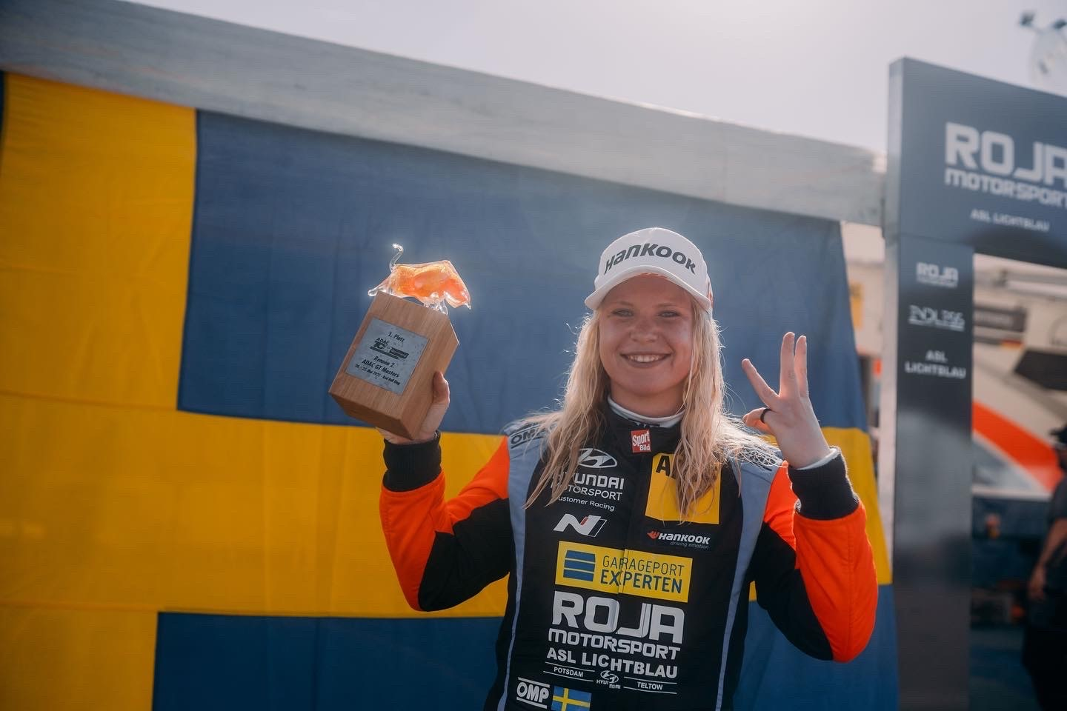
Jessicas results:
Free Practice 1: 3rd place
Free Practice 2: 1st place
Qualifying 1: 2nd place
Race 1: 1st place
Qualifying 2: 4th place
Race 2: 1st place
Championship standings:
ADAC TCR Germany – Total (Top three)
ADAC TCR Germany 2022 (after 1 of 7 raceweekends)
1: Martin Andersen (DKK), 108 p.
2: Jessica Bäckman (SWE), 107 p.
3: Jonas Karklys (LIT), 87 p.
https://www.adac-motorsport.de/adac-tcr-germany/rankings/2022
TV links in case you missed last weekend’s races:
TV link for Race 1﻿
TV link for Race 2﻿

Free rights to use images

