Press release

Olympic Subsea to deploy Vessel Insight across its fleet

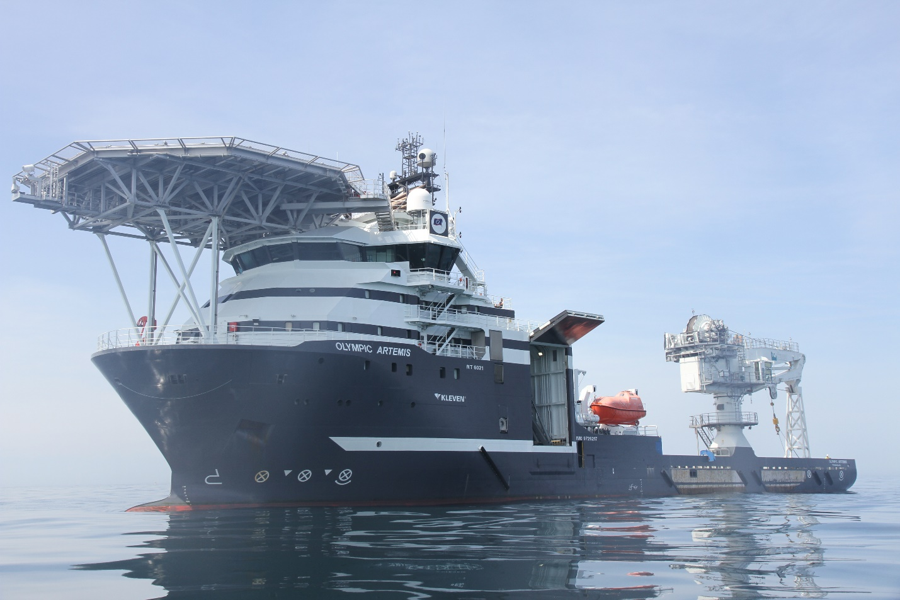

Olympic Artemis will be the first Olympic Subsea ship to deploy Kongsberg Digital’s Vessel Insight and Vessel Performance data infrastructure and performance monitoring solutions (Photo: James Fisher)
Asker, Norway, July 13th, 2021 – Kongsberg Digital is pleased to announce that Olympic Subsea, one of the world’s leading operators in the subsea and renewable energy markets, will be installing Vessel Insight across its entire fleet as a means of accessing, collecting and consolidating a full range of mission-critical data.

With its stated aim of becoming the most specialized and best-performing partner in the blue energy sector, Olympic Subsea’s fleet-wide upgrade to Kongsberg Digital’s Vessel Insight data infrastructure service will enable the company to continue the digitalization journey which began with its implementation of KDI’s Vessel Performance solution for energy usage and operational monitoring. The first vessel in the fleet to deploy the complete KDI rollout will be Olympic Artemis.

With the new Vessel Insight installation, Olympic Subsea plans to collect all essential data points from its vessels in order to extract the full potential from data-driven missions. With complete access to all contextualized data across its entire fleet, the company will come even closer to realizing its goal of operating the most modern, flexible and fit-for-purpose vessels in the field of subsea and renewable operations.

“We always thoroughly enjoy working with companies that are ambitious in setting goals and grasping the massive potential for positive change through technology,” says Andreas Jagtøyen, Executive Vice President of Digital Ocean, Kongsberg Digital. “With Vessel Insight, Olympic Subsea will be able to use data to analyze, predict and improve processes for individual vessels and the whole fleet, enabling the company to deliver on its goals for safety, efficiency, sustainability and cost-effectiveness.”

“Environmental focus has always been and will continue to be at the core of Olympic Subsea’s strategy,” adds Glenn Erik Valø, Commercial Manager, Olympic Subsea.
“By using state-of-the-art diesel-electric hybrid technology, we have minimized our environmental footprint, and KDI’s Vessel Insight will be an invaluable aid for bringing about further optimization. It will provide relevant data and efficiency analyses both for shore management teams and the officers on board our vessels, and will assist us in taking further steps and making better decisions in the continued effort to minimize our environmental footprint. We look forward to working closely with Kongsberg Digital, a company renowned for its future-focused approach, to further develop game-changing digital solutions.”

The Vessel Insight delivery will commence in August 2021.

Ends

For further information, please contact:

Mathilde Vik Magnussen
VP Communications & Marketing
Kongsberg Digital
Tel: +47 456 78 255
mathilde.magnussen@kdi.kongsberg.com
David Pugh
Saltwater Stone
Tel: +44 (0)1202 669244
d.pugh@saltwater-stone.com

About Kongsberg Digital
Kongsberg Digital is a provider of next-generation software and digital solutions to customers within maritime, oil and gas, and renewables and utilities. The company consists of more than 500 software experts with leading competence within the internet of things, smart data, artificial intelligence, maritime simulation, automation and autonomous operations.
Kongsberg Digital is subsidiary of KONGSBERG (OSE-ticker: KOG), an international, knowledge-based group delivering high-technology systems and solutions to clients within the oil and gas industry, subsea, merchant marine, defence and aerospace. KONGSBERG has 11,000 employees located in more than 40 countries.
Web: Kongsberg Gruppen | Kongsberg Digital
Social media: LinkedIn | Twitter | Facebook
About Olympic Subsea
Olympic Subsea is an international company with one of the world’s most modern subsea fleets. Its focus is on safety, cost-efficiency, flexibility and quality. With a strong management team and experienced seafarers, the company’s expertise accommodates work relating to subsea, offshore wind and offshore wave environments, as well as sea currents.
Web: Olympic.no
Contact: Glenn Erik Valø,
Commercial Manager
Olympic Subsea ASA
6099 Fosnavaag – Norway
Tel: +47 70 08 12 30
Cellphone: +47 95 99 14 83
Front desk: +47 70 08 12 00

