Press release
Düsseldorf, 26/05/2023
Aircraft Rims – The Unsung Heroes of Takeoff and Landing
Small yet crucial for taking flight, aircraft rims serve an important function in aviation and must be of the highest quality to ensure a safe flight. They undergo demanding production and maintenance processes. However, the machines required for these processes don't necessarily have to be brand new.
Aircraft rims are an essential yet often overlooked component in the aviation industry. They play a crucial role in the safety and efficiency of aircraft and differ in many ways from conventional rims. Throughout history, the aviation industry has undergone rapid development and produced numerous innovations, with aircraft rims consistently playing an important role in the advancement of aircraft.
From the Beginnings to Modern Aviation
The history of aircraft dates back to 1903 when the Wright brothers invented the first motor-powered airplane. Since then, the aviation industry has made tremendous progress, with groundbreaking developments such as passenger aircraft, jet engines, and modern luxury planes like the Airbus A380 and the Boeing 787 Dreamliner. Over the years, aircraft have become increasingly complex, and every component, from the cabin interior to the intricate electronics, must be meticulously designed and manufactured.
Unmatched Durability
A crucial component for takeoff is the tires. Aircraft tires must withstand extreme loads to support the weight of several hundred tons and endure high speeds of over 300 km/h on the runway. They are filled with nitrogen to prevent freezing moisture and fires at high altitudes. Additionally, aircraft tires are equipped with longitudinal grooves to prevent aquaplaning.
Another factor contributing to tire stress is the wear caused by takeoff and landing. Incorrect tire pressure, high ambient temperatures, braking maneuvers, and cornering can further wear down the tires. For this reason, aircraft tires are inspected before each departure.
You can't do without them: aircraft rims
In addition to tires, the rims of aircraft wheels also play a crucial role. They bear the entire weight of the aircraft and must be extremely stable and durable. Their aerodynamic design contributes to reducing air resistance and improving flight performance. Like the tires, the rims are inspected daily for cracks, wear, and damage.
The production of aircraft rims requires the highest precision and quality to meet the aviation industry's stringent standards. Aircraft rims are typically made from high-strength aluminum alloys and undergo several steps:
- Casting: A blank is cast from the specialized aluminum alloy. The casting is further processed while still hot.
- Forging: The blank is subjected to high pressure in a forging press to achieve the desired shape. This results in high material strength and a compacted surface without voids or irregularities.
- Machining: The rims are then processed on precision machines such as CNC lathes and milling machines.
- Heat Treatment: The rims undergo heat treatment to increase their strength and durability. The material is heated to a specific temperature and then rapidly cooled.
- Surface Treatment: The rims are coated or anodized to prevent corrosion and fatigue.
- Inspection: The rims are subjected to quality checks to ensure they meet the strict requirements of the aviation industry. Various tests, such as non-destructive testing and strength tests, are performed.
- Refurbishment: When an aircraft's tires are replaced, the rims can be refurbished and reused. They are professionally cleaned and inspected for faults. If the rim is deemed still serviceable, it can be installed with a new tire.
High standards and accuracy are essential to ensure the safety of aircraft. However, this does not mean that new machines are always required to meet these requirements. In many cases, existing machines can be adapted to meet the high standards through targeted maintenance and optimization.
High-Quality Machines up for Auction
Until May 31, 2023, businesses have the opportunity to enhance their machinery inventory by participating in an auction of a facility specializing in aircraft rim refurbishment. Surplex subsidiary HT is auctioning over 250 top-notch machines, including automatic cleaning systems for aircraft rims, painting systems, plastic granule blasting systems, and small parts paternoster systems. Additionally, other machines, accessories, and factory equipment will be available for auction. These machines are not only of interest to aircraft rim manufacturers and refurbishers but also offer diverse applications in other industries such as metal or plastic processing.
The production and maintenance of aircraft rims require the utmost precision and quality to meet the industry's high standards. In a market characterized by constant innovation and advancement, it is important that even the unsung heroes of the skies - the aircraft rims - receive the attention and care they deserve.

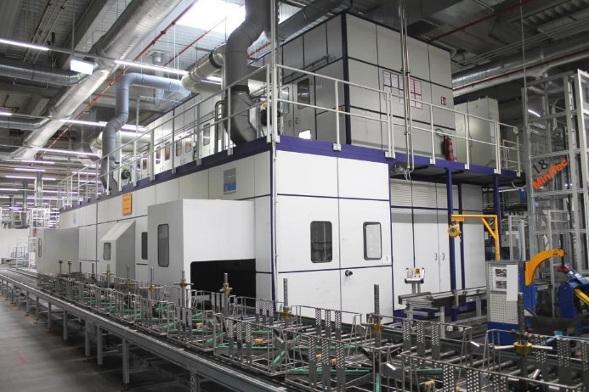 | Image 1  An automatic cleaning system enables aircraft rims to be easily and quickly made ready for use.  (© HT).
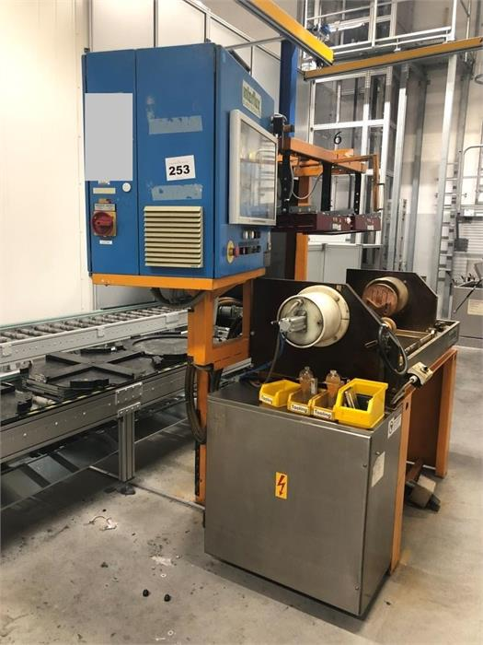 | Image 2  By using a crack detection bench, it is ensured that the rims are intact and suitable for further use.  (© HT).
,

