

News Release 　　　 June 24, 2020

YANMAR HOLDINGS CO. LTD.

YANMAR Engines Power COVID-19 Disinfection

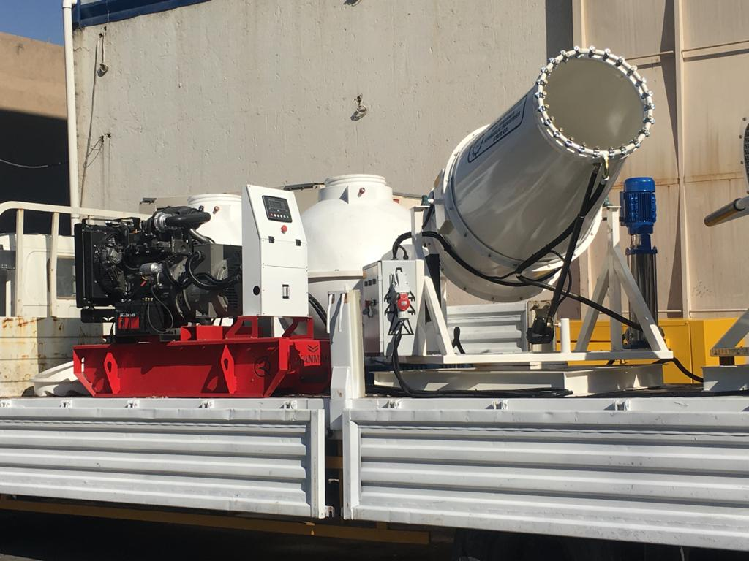

The disinfectant sprayer is powered by a Qaswaa Al-Bararry generator with a Yanmar TNV engine.

Baghdad, Iraq (June 24th, 2020)- Yanmar Europe and Qaswaa Al-Bararry have taken part in a project to disinfect and sanitize public areas in Baghdad in an effort to limit the spread of the coronavirus and protect the Iraqi community.

The disinfection work is being conducted by the municipalities of Baghdad and Basrah using spraying equipment and generators made by Qaswaa. These generators use Yanmar’s heavy-duty but silent TNV engines. The equipment sprays a solution of liquid bleach and is being used to disinfect public areas in the cities.

“We’re proud to be part of this vital work to keep the citizens of Iraq safe,” said Ali Al-Obaidi, Director Manager |Qaswaa Al-Barrary “It’s important that together with support from Yanmar, we can offer a reliable solution that is quiet enough that it doesn’t disrupt citizens’ lives.”

Peter Aarsen, President of Yanmar Europe B.V. added: “We hope that this work will help reduce the chance of infection of COVID-19 and keep the people of Iraq safe. We’re very pleased to have strong partners like Qaswaa Al-Bararry to help us deliver positive health outcomes for their community.”

Residents expressed their gratitude for the work towards a speedy recovery for their community. The disinfecting activities are expected to be expanded to other municipalities and regions to combat COVID-19.

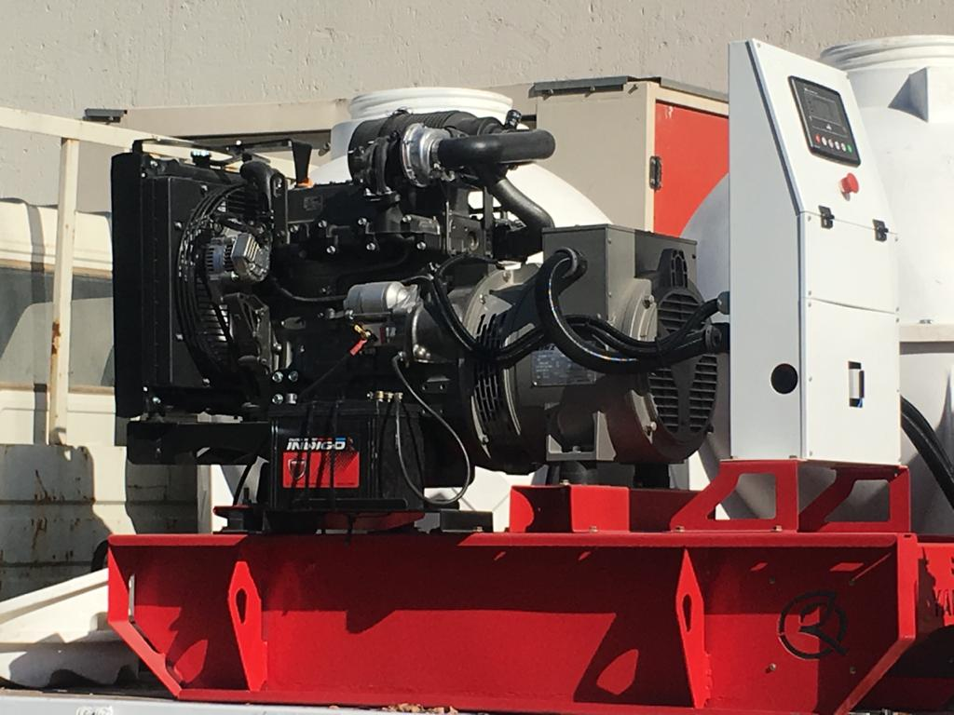

**About Yanmar**

Founded in Osaka, Japan in 1912, Yanmar was the first ever to succeed in making a compact diesel engine of a practical size in 1933. A pioneer in diesel engine technology, Yanmar is a global innovator in a wide range of industrial equipment, from small and large engines, agricultural machinery and facilities, construction equipment, energy systems, marine, to machine tools, and components — Yanmar’s global business operations span seven domains.

On land, at sea, and in the city, Yanmar provides advanced solutions to the challenges customers face, towards realizing A Sustainable Future.

For more details, please visit the official website of Yanmar Holdings Co., Ltd.

<https://www.yanmar.com/global/>

＜NOTE＞

The contents of this news release reflect what was mentioned in the press announcement. Please be aware that the contents of this release may differ with new information and developments.

Inquiries

Corporate Communications, Yanmar Holdings Co., Ltd.

newsroom@yanmar.com