**Automatic Payment Optimizer. Revolutionary solution for big online businesses.**

Do you run an international e-business and sell goods globally? If the answer is yes, you most probably do your best to make the purchasing process as simple and as fast as possible. When your online business is developing and the number of customers, transactions and revenues is increasing, there is nothing worse than payment limits that can stop you. You want your customers to pay for your products with a single click and forget about any possible inconveniences. A typical simple online payments process goes this way: from your website (where a customer chooses a product, a payment method, etc.), the cash flows through payment system and goes to a bank account.

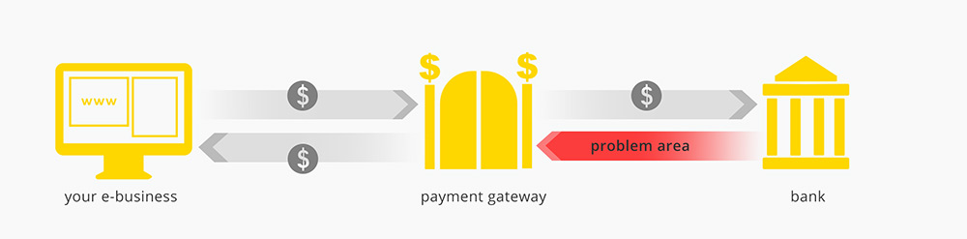

And that’s easy. But sometimes the bank can reject transactions.

**Why can a bank reject an international transaction?**

There is a number of reasons, but the most common are:

* bank may have maintenance services or temporary trouble,
* bank may not accept some types of cards or currencies,
* customer buys from a merchant that is located far away.

The last point requires an explanation. When you live in the UK and suddenly shop in Japan, the bank can treat it as a fraud transaction, because, for example, such card activity may not correspond with your purchasing history. It’s all in order to ensure your money’s safety. Banks sometimes reject payments when they suspect your card might have been stolen. In this case, the distance could be a problem.

When the transaction is rejected, your customer cannot pay for the product and you lose not only money, but also a potential client. Let’s be honest, you have only one chance to convince someone to become your fan and a loyal customer.

**How to avoid such problems?**

The best way is to create more than one merchant account and integrate them in one clever payment system. And that’s what PayLane prepared: [Automatic Payment Optimizer](http://paylane.com/offer/). It’s a perfect tool for sellers who run their businesses globally. APO groups all merchant accounts that an online business has and sends money to the right one. In case of bank transaction rejection, APO attempts to send the funds to other bank accounts until it succeeds and receives a positive response. And what’s most important, the process is automated and takes just a few seconds. Business owners don’t need to manage it manually.

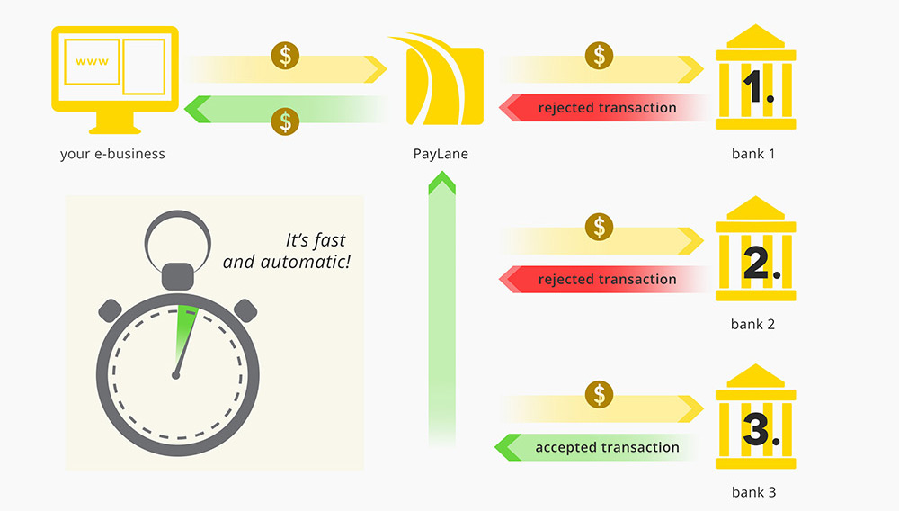

What are **the benefits of using** [**Automatic Payment Optimizer**](http://paylane.com/offer/)?

* Income growth - funds flow optimization resulting in smaller fees.
* Increased payment processing effectiveness - more successful transactions.
* Better conversion.
* Dividing funds between several accounts.
* Less work for your developers.
* Bank maintenance services or failures do not affect you.

**Media Contact:**

Ula Lachowicz

Brand Manager

tel.: +48 784 63 93 81

e-mail: ula.lachowicz@paylane.com

**About PayLane**

PayLane.com is an [online payments provider](http://www.paylane.com/) that offers accepting payments in over 160 currencies from around the world. Besides the most popular payments methods, such as credit and debit cards, wire transfers or PayPal, PayLane also offers solutions characteristic for specific European markets.

Thanks to plugins for ecommerce platforms, transaction descriptors, single-click and recurring payments, PayLane is more than just accepting payments – it’s a way to boost your business internationally.

PayLane’s offering is directed both at the biggest international companies and new businesses – having once been a startup themselves, [PayLane supports even the smallest companies](http://startups.paylane.com/) by enabling them to accept payments.

Additionally, PayLane launched [Developer Zone](http://devzone.paylane.com) – a website for programmers with full documentation and code samples needed to integrate with PayLane. Now, even before signing a contract with PayLane, developers can see what the technical side of such implementation looks like.

PayLane is not only simplicity and functionality, but also safety. PayLane system guarantees the highest standards of security, thanks to which all transactions are protected. <http://www.paylane.com>