Strong comeback by Andreas Bäckman in the STCC season opener
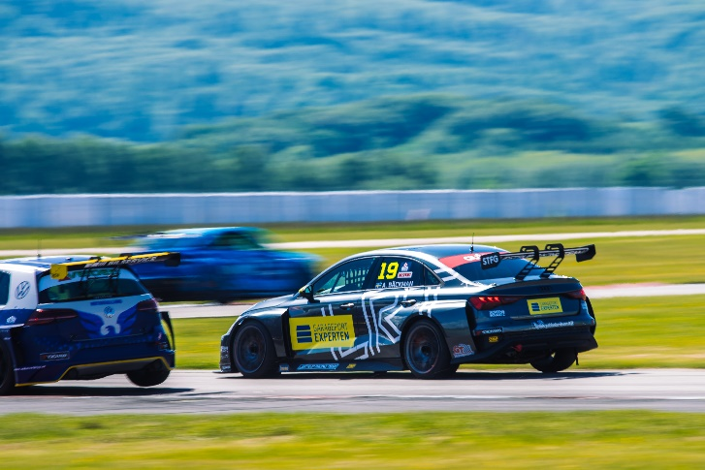
Andreas Bäckman (start number 19) provided the spectators with some overtakes during the STCC season opener in Ljungbyhed, Sweden in his Audi RS 3 LMS TCR for Lestrup Racing Team.
Photo: Martin Öberg (Free rights to use the images)
This weekend, June 3rd-4th, it was time for the STCC season opener in Ljungbyhed, Sweden. Andreas Bäckman, competing for Lestrup Racing Team in his new Audi RS 3 LMS TCR car, had a tough qualifying but had a strong comeback in the race.
- The qualifying didn’t go to plan, but the race went well and the speed is there, so it feels promising for the rest of the season, Andreas Bäckman says.
STCC is Sweden's most prestigious motorsport championship and is today the leading class for Touring Car Racing. The cars are built according to the global TCR regulations, which means that the cars used in STCC are the same as those in the other TCR series around the world. The series consists of six race weekends held on different Swedish tracks.
This weekend, June 3rd-4th, it was time for the STCC season opener at Ljungbyheds Motorbana in Ljungbyhed, Sweden and Sweden National Team driver Andreas Bäckman was on the starting grid, competing in his new Audi RS 3 LMS TCR car for Lestrup Racing Team.
Tough qualifying but a strong comeback in the race
The weekend started well for Andreas with a second place in the first test on Thursday in the new car that had been delivered just a few days before the season opener. Friday's tests also went well and it looked promising before the qualifying and the race on Saturday.
- The Ljungbyhed track is a track I have never competed on before, but I got into the track quite quickly and had good speed in both dry and wet conditions during practice sessions, Andreas Bäckman says.
Saturday's qualifying was a so-called "Shoot-Out Qualifying" where each driver had only one lap to set a lap time, which determined the starting position for the race. Unfortunately, Andreas started the lap with a big lock-up of the brakes into turn 1 on his only qualifying lap, lost a lot of time and finished in a 10th place.
- It was a shame with the mistake towards the turn 1, it came very suddenly and unexpectedly, but that's what happens sometimes in racing. I think we would have had a chance to fight for the pole position without that mistake, Andreas Bäckman says.
This meant that he had to start in 10th place in the race with a great challenge ahead to try to get as far towards the front as possible. He got off to a good start in the race and picked up several places, after which there were some tough fights for the positions, but he managed to get up to a fifth place halfway through the race. However, the distance was a little too far to the front runners so he had to settle for a fifth place, but he accounted for the most overtakes of the day.
- It was a really exciting race where I managed to fight my way from tenth to fifth place. The car worked well and considering how difficult it is to overtake on the Ljungbyhed track, I am happy with the result. Unfortunately, it was too far to the top four, so after that it was about bringing the car to the finish. The weekend has been tough for me as I have never raced in Ljungbyhed, but the season opener was promising for the upcoming competitions, Andreas Bäckman says.

Next up for Andreas is the second round of the STCC championship in two weeks time, June 17th-18th, at Drivecenter Arena in Skellefteå, Sweden.

Andreas’ results:
Free Practice 1 (Test 1): 2nd place
Free Practice 2 (Test 2): 4th place
Free Practice 3 (Test 3): 5th place
Shoot-Out Qualifying: 10th place
Race: 5th place

STCC Championship Standings
STCC – TCR Scandinavia – Drivers’ Championship Standings – Overall (Top 3)
STCC 2022 (After 1 of 6 race weekends)
1: Robert Dahlgren (SWE), 25 p.
2: Tobias Brink (SWE), 20 p.
3: Oliver Söderström (SWE), 19 p.
–
5: Andreas Bäckman (SWE), 11 p.
See the full standings here
STCC – TCR Scandinavia – Teams’ Championship Standings – Overall (Top 3)
STCC 2022 (After 1 of 6 race weekends)
1: CUPRA Dealer Team - PWR Racing, 35 p.
2: Brink Motorsport, 35 p.
3: Lestrup Racing Team, 30 p.
See the full standings here

Did you miss this weekend’s STCC race?
CLICK HERE to see the replay from this weekend’s STCC race at STCC+

Follow the STCC season at:
Live-stream: plus.stcc.se
Other information: stcc.se
Facebook: facebook.com/STCCOfficial/
Twitter: twitter.com/stcc_official
Instagram: instagram.com/stcc_official/
YouTube: youtube.com/c/STCCTV

Free rights to use the images.

Download press-photos here:
http://bit.ly/jabaeckman-photos
https://www.mynewsdesk.com/se/ja-backman/images

