### With 378 million albums sold, ABBA is one of the best-selling pop groups of all time. In a new building on Djurgården a new attraction opens May 7, 2013: Swedish Music Hall of Fame, including ABBA - The Museum. Throughout their career, the members of ABBA continuously used Stockholm as a backdrop on album covers and in videos. Here is our selection of places associated with the pop group ABBA.

**ABBA - The Museum Preview at Arlanda Airport**

A preview of the new museum is found in the arrival hall on the Stockholm international airport Arlanda (Terminal 5).

# ABBA and the island of Djurgården

**New attraction: ABBA The Museum**   
Opening May 7 at Djurgården. The eagerly awaited [ABBA the Museum](http://www.abbathemuseum.com/) is finally opening in a new building on Djurgården between the Liljevalchs art gallery and the Gröna Lund amusement park.  [ABBA the Museum](http://www.abbathemuseum.com/) will be part of a larger interactive music museum. [Swedish Music Hall of Fame](http://swedishmusichalloffame.se/) has three permanent exhibitions: ABBA - The Museum, the History of Swedish Popular Music, and the Swedish Music Hall of Fame.  
[www.abbathemuseum.com](http://www.abbathemuseum.com)

www.swedishmusichalloffame.com

**Kaknästornet and Gärdet**The island of Djurgården and Gärdet plays a key role in videos and covers of ABBA. One of the first pictures of the group together was taken on Gärdet, with the Kaknästornet tower in the background. The nearby Sjöhistoriska museum (National Maritime Museum) was also used. The area outside the Manilla School was used for the video *“Bang-A-Boomerang”*.

[www.kaknastornet.se](http://www.kaknastornet.se)  
[www.sjohistoriska.se](http://www.sjohistoriska.se)

**Gröna Lund**This amusement park is a popular place for live concerts. ABBA performed here in the beginning of their career.   
[www.gronalund.com](http://www.gronalund.com)

|  |  |
| --- | --- |
| Skansen Open Air Museum Skansen, founded in 1891, features some 160 cultural-historic buildings from all over Sweden, one of them being Julius Kronberg’s Ateljé. The cover photo of “*The Visitors”* album was taken in here. All the paintings to be seen on the record are still there. The building is open a few times per year  The big wooden Dala horse seen in several pictures of Björn and Benny is now located on Orsakullen, Skansen.  [www.skansen.se](http://www.skansen.se) | Visitors |

**Cirkus**  
The staging of the Björn and Benny Musical *“Kristina från Duvemåla”* took place at the Cirkus building. The musicals “Chess” and “Mamma Mia!” has also been staged here.   
[www.cirkus.se](http://www.cirkus.se)

|  |  |
| --- | --- |
| **Kaknästornet TV Tower**  The cover photos for the *"People Need Love"* single were taken in a rainshelter just a short walk from the Kaknästornet tower. Cross the bridge to Djurgården and look right.  [www.kaknastornet.se](http://www.kaknastornet.se)   **Djurgårdsbrunnskanalen canal**  Several scenes used in *“ABBA The Movie”* were filmed in Stockholm. The Djurgårdsbrunnskanalen canal has been used several times. The Sightseeing tour “Djurgården Runt” takes you through the canal and around the island.  www.stromma.com | people need love |

**Ulla Winbladh**  
Ulla Winbladh Restaurant, specialized in classic Swedish food, was used for the European & US version of *“Greatest Hits"* and on the French compilation release *"Golden Double Album".*   
www.ullawinbladh.se

# ABBAs historic favorites

|  |  |
| --- | --- |
| **The Drottningholm Palace** The Palace, today the private residence of the Swedish Royal Family and listed on the UNESCO World Heritage list.  ABBA made several photo sessions in the park and even filmed some episodes for *"ABBA The Movie"* here. The single cover of *“The Name Of The Game”* was taken in the garden behind the palace.  www.kungahuset.se | thenameofthegame |

**Dancing Queen - Royal Opera House**  
Did you know that ABBA performed "*Dancing Queen*" for the Swedish King and Queen during their wedding in 1976 at the Royal Opera House. In December 1993 a big gala was held at the Opera House again in conjunction with HRH Queen Silvias 50th birthday. "Dancing Queen" was sung by Anni-Frid Lyngstad together with The Real Group.  
 [www.operan.se](http://www.operan.se)

**Gamla Stan and Riddarholmen**

Many ABBA photo sessions has been taking place on Stortorget square in Gamla Stan (Old Town). The photosession for “ABBA The Album” took place at Riddarholmen island, with the City Hall and the island of Södermalm as back drop.

|  |  |
| --- | --- |
| **The Gripsholm Palace**  Gripsholm in Mariefred is famous for its beauty and rich art collection. The palace dates back to 1537. In 1974 ABBA made the “*Waterloo”* photo session in the Palace. In the Painters Gallery at Gripsholm Palace includes a painting of Benny Andersson painted by Birgit Broms.  [www.kungahuset.se](http://www.kungahuset.se) | waterloo |

# Where to stay

**Melody Hotel**   
A small boutique hotel with 50 rooms situated in the same building as ABBA - The Museum and Swedish Music Hall of Fame.   
http://melody.se/

**The Rival Hotel**

A boutique hotel with its own cinema located in the heart of the bohemian Södermalm island. The hotel is shaped by the vision of its owner, Benny Andersson, who wanted to recapture the glamour of the hotel from when it opened in the 1930s. In addition to The Rival Theatre there are bars, a bistro, a cafe and a bakery.   
[www.rival.se](http://www.rival.se)

**The Sheraton**

The hotel scenes in “*ABBA the Movie”* were filmed at The Sheraton Hotel in Stockholm.  
[www.sheratonstockholm.se](http://www.sheratonstockholm.se)

**The Archipelago**  
Björn and Benny got their inspiration from the Stockholm Archipelago. Several hit songs: *"Fernando", "Dancing Queen"* and *"Thank You For The Music"* were written in a private cottage near Grinda. Visit Grinda instead and stay at the Grinda Wärdshus Inn for the same atmosphere.   
[www.grindawardshus.se](http://www.grindawardshus.se)

# Additional places of interest in Stockholm

**Alexandra Night club**   
Alexandra disco was a well known night club in Stockholm at the end of 70s and in the 80s. The photo sessions for the *"Voulez-Vous”* Album in 1979 was done here. You can enjoy entertainment and dinner at the same premises, nowadays Wallman’s Dinnershow. For some more ABBA era music, visit another Wallman venue, the Golden Hits on Kungsgatan.   
[www.wallmans.com/en](http://www.wallmans.com/en)

|  |  |
| --- | --- |
| **Barkarby Airfield** Picture sessions for the *Arrival* album were taken at the Barkarby airfield north-west of Stockholm City.  **Polar Studio** The famous *Polar Studio*, Sankt Eriksbron Bridge (S:t Eriksgatan 58) is where all ABBA-music produced from 1978 and on was recorded. The studio closed in 2004 and is now home of a SATS gym. | arrival |

**Post Museum**  
The Swedish post issued ABBA stamps in 1983 and 2000. See them at the Postmuseum.   
[www.postmuseum.posten.se](http://www.postmuseum.posten.se)

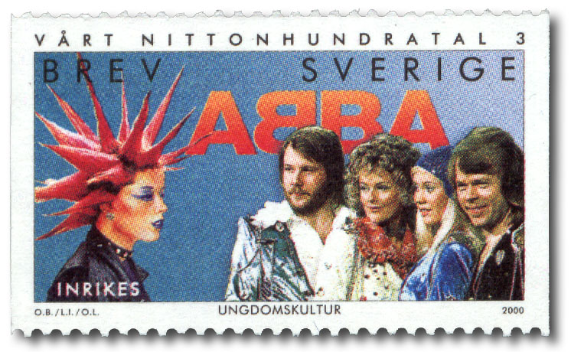 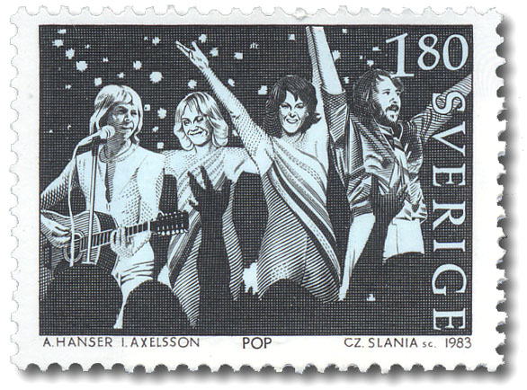

The **Årsta Bridge**, **Tumba** **station** and the **China Theatre** at Berms were featured in “The Day Before You Came” video. The **stairs** situated on Kungsgatan leading up to Malmskillnadsgatan, the crossing **Kungsgatan** and Sveavägen, the department store **NK** on Hamngatan are places seen in the “*Head Over Heals video”*. The video to “*Money Money Money”* was mostly done in the studio. But the canal-lock **Slussen** and The **Centralbron** bridge are two locations in Stockholm used for the video.

**Stallgatan** (behind Grand Hotel) was used for the “*Summer Night City*” video.

**For additional information**

[www.mynewsdesk.com/pressroom/stockholmvisitorsboard](http://www.mynewsdesk.com/pressroom/stockholmvisitorsboard)

[www.visitstockholm.com/press](http://www.visitstockholm.com/press)   
[www.facebook.com/visitstockholm](http://www.facebook.com/visitstockholm)

[www.instagram.com/visitstockholm](http://www.instagram.com/visitstockholm)

Sources: ABBAsite.com, The ABBA Guide to Stockholm  
Writer: Ann-Charlotte Jönsson, PR Manager Stockholm Visitors Board