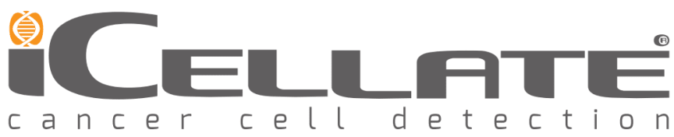
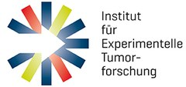
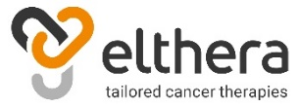

Elthera-led consortium initiates development of novel cancer diagnostics and therapeutics

November 24, 2020. Elthera AG, iCellate Medical AB, Targos GmbH and Prof. Dr. Susanne Sebens at the Institute of Experimental Cancer Research (IET) at the University of Kiel are proud to announce that they have received a non-dilutive grant with a total budget of 2.7 M € from the EUREKA Eurostars programme. The grant will allow the consortium to finalize the preclinical development of Elthera’s proprietary anti-L1CAM antibody and to develop novel L1CAM-based solid and liquid biopsy methods for patient selection and treatment monitoring in clinical trials. The consortium partners bring together a unique set of complementary cutting-edge technologies and a track record in the development of novel diagnostics and therapeutics. Elthera AG (Schlieren, Switzerland) will develop its anti-L1CAM therapy to an IND ready stage and will deliver a translational pharmacology package, which will facilitate entry into clinical trials. The consortium partners iCellate (Solna, Sweden) and Targos GmbH (Kassel, Germany), will develop L1CAM-specific liquid (blood-based) and solid (tumor-based) biopsy methods, respectively. The group of Prof. Dr. Susanne Sebens at the IET (Kiel, Germany) will provide access to primary samples from cancer patients and will evaluate the potential of the anti-L1CAM therapy to be combined with established chemo- and immunotherapies.

Anne Schmidt, CEO of Elthera, commented: “We are very happy that we could attract such outstanding industry and academic experts for this exciting project. The combination of research excellence in the field of L1CAM biology, innovative diagnostic technologies, and access to primary patient samples will build the foundation for the successful translation of our anti-L1CAM therapy into clinical testing.”

Christer Ericsson, CSO of iCellate, said: “Immunotherapies against cancer, such as the anti L1-CAM therapy for pancreatic and ovarian cancer developed by Elthera, have the potential to cure the disease by eradicating the cancer cells. We are pleased to have been given the opportunity to develop the blood-sample based companion diagnostic test that will guide the therapy so that only those patients who will benefit are treated.”

Thomas Henkel, CEO of Targos commented: “It is exciting to be involved in the early phase of development towards a predictive biomarker or companion diagnostic for anti-L1CAM therapy. Targos can contribute its experience in clinical validation of tissue biomarkers and within the consortium we will compare it to the blood-sample based approach on a scientific evidence basis.”

Prof. Susanne Sebens, Director of IET, said: “We are very excited to be part of this innovative project at the interface of industry and science. With this project we ideally continue our longstanding translational research activities in the field of L1CAM biology.”

About Elthera:
Elthera AG, a privately held biotechnology company based in Switzerland, is developing a first in class antibody for the diagnosis and treatment of patients with cancer, using a personalized health care approach. Elthera obtained the exclusive license from the German Cancer Research Center (DKFZ), the largest biomedical research institution in Germany and a leading center in oncology research. The company is led by an experienced management team with a track record of successfully bringing compounds from research to the clinic and market.

About iCellate:
iCellate is a Swedish medical technology company founded in 2011 and its single-site assay laboratory is located in Stockholm. iCellate develops services in the areas of cancer diagnosis and individual cancer treatment. The technologies are based on research from the Karolinska Institute in collaboration with the Karolinska University Hospital and the Royal Institute of Technology in Stockholm.
The company is part of the Karolinska Institute Science Park (KISP) and Uppsala Innovation Center (UIC) and has over the years received many prestigious awards from public and private organizations. iCellate recently launched the GeneMate® test for hereditary cancer predisposition.

About Targos:
Targos’ core business is to provide highly standardized development and application of clinical biomarkers for the international pharmaceutical and diagnostic industry since 2005. An evolving analytical portfolio from molecular pathology to genomics, from immune phenotyping to digital pathology has led to the successful approval of breakthrough targeted and immune therapies and companion diagnostics for our customers.

About IET:
The Institute for Experimental Cancer Research (IET) is an institution of the Medical Faculty of Kiel University and the University Hospital Schleswig-Holstein Campus Kiel. The IET with its different research groups is a central interface in oncology between experimental and translational research as well as between laboratory and clinic. Moreover, IET hosts the oncological Biobank of the Comprehensive Cancer Center (BMB-CCC) comprising tissue samples and liquid biopsies from ~ 6500 patients along with comprehensive clinical data.

