PRESS RELEASE

A Japanese Weekend Brunch at Keyaki
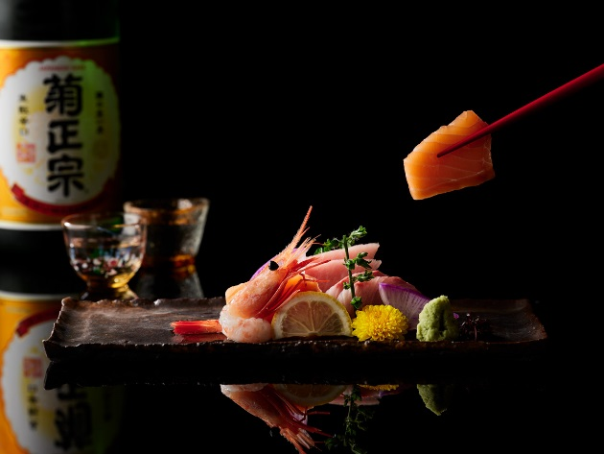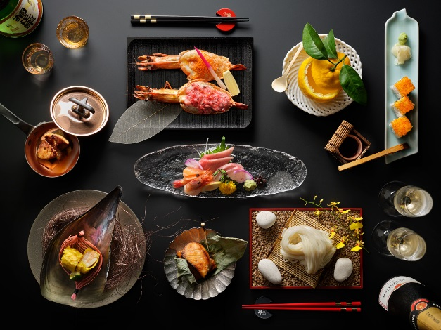

March 2019, Singapore — Celebrate weekends with a kaiseki-style brunch at Keyaki that is presented in an okonomi concept, featuring a curated menu of a selection of perennial Japanese culinary favourites and specialty dishes by Executive Chef Shinichi Nakatake.

Okonomi is a Japanese term which translates to ‘as you like it’ or ‘your preference’ and guests in this customisable dining experience are presented a menu of seven courses with multiple options per course, allowing them to tailor their culinary experience by selecting their delicacy of choice from each course to best suit their tastes.

The okonomi-style menu was crafted with balance in mind starting with lighter, chilled presentations such as Kobachi and Sashimi to slowly awaken the palette, before proceeding to textured, hot dishes such as Yakimono, with options such as Teriyaki Cod, Grilled Miso Marinated Chicken and Grilled Prawn cooked in two styles. The savoury Agemono or Nimono courses continue with dishes such as Deep-fried Pen Shell with Minced Prawn or Simmered Beef and Vegetables with Sukiyaki Sauce in ‘Yanagawa’ Style that highlights the robust flavours of the dashi. Savour Keyaki’s signature Teppanyaki dishes and choose from Beef, Chicken or Prawn and Scallop.

The savoury courses are rounded off with Shokuji dishes which are crafted to cleanse the palette. Highlights include the crowd-pleasing Inaniwa Udon from Akita prefecture that is thinner and smoother than other Udon noodles, fragrant Garlic Fried Rice or Japanese Curry Rice. Conclude your brunch experience on a sweet note with a delightful choice of desserts.

To further heighten the luxurious experience, guests may choose to enjoy brunch with unlimited flow of Taittinger Brut Réserve Champagne, Tiger Beer and Selected Sake, Red and White Wines.

A Japanese Weekend Brunch at Keyaki
Date: Every weekend (and public holidays)
Time: 11.30am to 2.30pm
Price:
SGD75 per person (includes unlimited green tea)
SGD135 per person (includes unlimited Taittinger Brut Réserve Champagne, Tiger Beer and Selected Sake, Red and White Wines)
Venue: Keyaki (Level 4), 7 Raffles Boulevard, Singapore 039595
Reservations: +65 6826 8240 / dining.sin@panpacific.com

Menu

Kobachi
Three Kinds of Appetisers

Sashimi
Assorted Sashimi (Yellowtail, Salmon and Sweet Shrimp)
* Additional SGD25 to change one type of Sashimi to Toro (2 pieces)

Yakimono
Choice of:
- Teriyaki Cod
- Grilled Miso Marinated Chicken
- Grilled Prawn in two-styles

Agemono or Nimono
Choice of:
- Assorted Tempura
- Deep-fried Pen Shell with Minced Prawn
- Steamed Pork with Onion Miso Sauce
- Steamed Oysters topped with Tofu Refuse
- Simmered Beef and Vegetables with Sukiyaki Sauce in ‘Yanagawa’ Style

Teppanyaki
Choice of:
- Beef
- Chicken
- Prawn and Scallop
* Additional SGD12 to change one of the choices to Foie Gras and SGD40 for Wagyu Beef

Shokuji
Choice of:
- California Roll
- Inaniwa Udon
- Garlic Fried Rice
- Japanese Curry Rice

Dessert
Choice of:
- Seasonal Fruits
- Ice Cream (Green Tea or Red Bean)
- Homemade Orange Jelly
* SGD12 for additional Japanese Musk Melon

Dishes may vary slightly depending on seasonality of ingredients. Prices listed are subject to service charge and prevailing government taxes.

High-resolution Images can be downloaded here.

For dining reservations and enquiries, please speak with us at +65 6826 8240 or email dining.sin@panpacific.com.

ENDS

Media Contact

Gillian Teo
Senior Marketing Communications Manager
Pan Pacific Singapore
Email: gillian.teo@panpacific.com
Tel: +65 6826 8095

Annie Choy
Director of Marketing Communications
Pan Pacific Singapore
Email: annie.choy@panpacific.com
Tel: +65 6826 8079

About Pan Pacific Singapore
Located in the heart of Marina Bay and with easy access to world-class shopping, Suntec Singapore International Convention and Exhibition Centre and the Central Business District, Pan Pacific Singapore offers 790 contemporary rooms and suites that are ideal for business or leisure. Savour epicurean delights at our award-winning restaurants and bars or rejuvenate at our swimming pool and spa. Pan Pacific Singapore is proud to be named Asia’s Leading Business Hotel by the World Travel Awards from 2006 to 2012, World’s Leading Business Hotel by the World Travel Awards from 2007 to 2010 and 2012, and World’s Leading City Hotel by the World Travel Awards in 2011. The hotel was also recently named a “Four-Star Hotel” by Forbes Travel Guide 2017 and Top 25 Hotels in Singapore in Tripadvisor’s 2017 Traveller’s Choice Awards.

About Pan Pacific Hotels and Resorts
With hotels, resorts and serviced suites across Asia, Oceania and North America, Pan Pacific provides a safe harbour in an ever-changing world. Places with less worry about because, when you stay with us, rest assured that all will be taken care of. For this is where you will find your balance.

About Pan Pacific Hotels Group
Pan Pacific Hotels Group is a wholly-owned hotel subsidiary of Singapore-listed UOL Group Limited, one of Asia’s most established hotel and property companies with an outstanding portfolio of investment and development properties.

Based in Singapore, Pan Pacific Hotels Group owns and/or manages more than 40 hotels, resorts and serviced suites including those under development across 24 cities in Asia, Oceania, North America and Europe.

Voted “Best Regional Hotel Chain” by readers in Asia in 2017 and 2018, Pan Pacific Hotels Group comprises two acclaimed brands: its signature brand, Pan Pacific and its deluxe brand, PARKROYAL.

Sincerity is the hallmark of Pan Pacific Hotels Group. The Group is known to its guests, partners, associates and owners for its sincerity in people and the sense of confidence which alleviates the stresses of today’s complex world.

