JAYS develops the product line for Mobile Music with a-JAYS One+
Swedish Jays develops the Mobile Music concept to deliver an authentic and exceptional musical experience for all mobile phone users, regardless of platform. Jays is now launching a-JAYS One+, an upgrade to the successful a-JAYS One model that includes a microphone, an additional control button, new functionality and a free app for users of the Android platform.
Swedish earphone manufacturer Jays AB (publ) is now taking further steps with the concept Mobile Music to unite music and telecommunications with freedom and flexibility. The idea is aimed at delivering more intuitive functionality to the company's proprietary and award winning products based on the key drivers of passion for music and value.
a-JAYS One+ is an upgrade to the successful model a-JAYS One. As well as featuring a flat, tangle-free, cable and an award-winning sound, it is now equipped with a microphone and a control button that allows the user to manage calls and music. JAYS also opens the door to Android with a free app, JAYS Headset Control, that for the first time provides users of different mobile platforms with a full set of controls to provide an unrivalled and powerful musical experience. a-JAYS One+ can be used to control mobile phones from HTC, Samsung, LG, Motorola, BlackBerry and the Apple iPhone and will be available in stores during Q4 2011.
“It’s impossible for us to stand still – Jays is all about innovation so it’s vital for us that we continually move forwards and challenge ourselves to break new ground”, says product manager Peter Cedmer, Jays AB (publ). “We’ll continue to develop our products to enable wider use and higher quality at ever greater value for money. Our products have generated international success and both ourselves and our fans know that they deliver the most important core values; great sound and an authentic experience. The Mobile Music concept is aimed at developing that experience even further and ensures that users of all mobile platforms can benefit from our unique, world-beating products at a great price.”

Price: 49.99 USD
See a-JAYS One+ here:
www.jays.se/products/earphones/a-jays-one-plus.html
The app will be released here:
www.jays.se/android
For more information, please contact:
Peter Cedmer, product manager, Jays AB (publ)
Cell: +46 (0)738 28 52 36
E-mail: peter.cedmer@jays.se

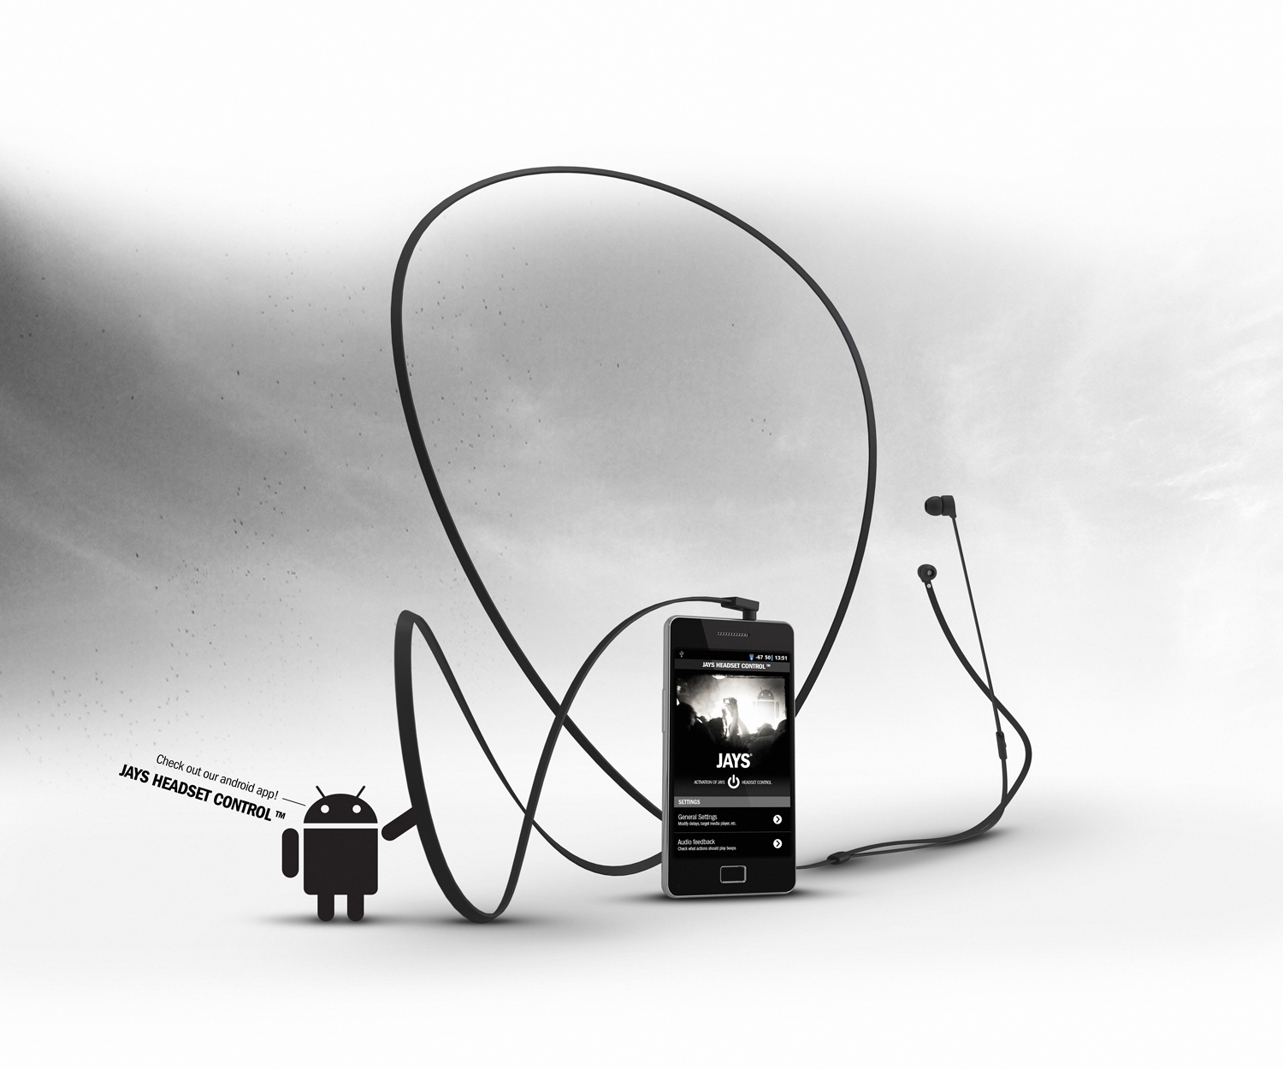

Jays AB (publ) develops designs and produces earphones and equipment for portable media players. Jays supplies high quality products, aimed to provide the user with maximum sound experience. Jays passion is the quest for the perfect sound – the sound that affects and inspires user’s body and soul. The company is expanding rapidly and its products are being sold in more than 25 countries worldwide.

