**Solving clinical challenges with new treatment solutions from DENTSPLY Implants**

*June 2015*—Several clinical challenges are solved with the introduction of DENTSPLY Implants’ new treatment solutions. Buccal and lingual marginal bone preservation in sloped ridge situations are enhanced with the new OsseoSpeed Profile EV implant design, and bone formation and stability are advanced with two new products in the SYMBIOS regenerative solutions portfolio.

“When we develop new implant therapy solutions, it is important that they meet actual clinical needs. With these introductions, we can offer clinicians various solutions for compromised cases related to marginal bone,” says Björn Delin, DDS, and Vice President Global Platform Implant Systems at DENTSPLY Implants.

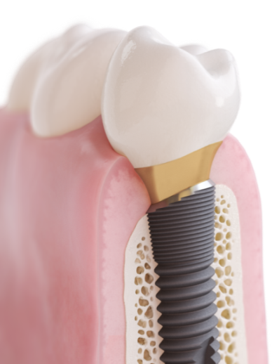**360-degree bone preservation in sloped ridge situations**

Marginal bone preservation is an important factor to achieve excellent esthetic results. However, it is a clinical reality that crestal bone resorbs after tooth extraction or tooth loss. This resorption is often pronounced on the buccal side, resulting in a lingual-to-buccal sloped ridge.

The new OsseoSpeed Profile EV implant is placed level with both buccal and lingual marginal bone, where the design supports the soft tissue by preserving marginal bone 360 degrees around the implant.  
In addition, it may reduce the need for bone augmentation.

This is the second generation of the uniquely shaped, patented implant specifically designed for sloped ridge situations that was first introduced in 2011. The implant is now upgraded with the simplicity and design principles of the ASTRA TECH Implant System EV and a welcome addition to the portfolio.

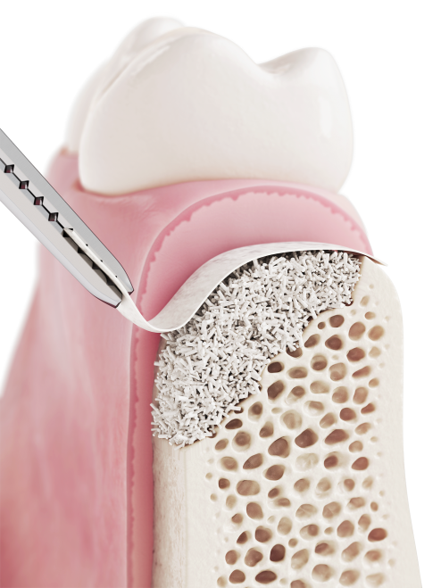**Promoting bone formation and stability**

In clinical cases where patients lack bone quantities for stable implant placement, bone graft material can help create new bone or remodel existing ridges.

SYMBIOS Regenerative Solutions offers a comprehensive range of products for bone augmentation and periodontal procedures designed to promote bone formation and stability. Two new products are now available: the SYMBIOS Biphasic Bone Graft Material and the SYMBIOS Collagen Membrane SR (slow resorbable).

From plant origin, SYMBIOS Biphasic Bone Graft Material is a composition of 20% hydroxyapatite and 80% ß-tricalciumphosphate, resorbing significantly faster than pure hydroxyapatite; it is used for reconstruction of bony defects in maxillofacial surgery and augmentations. With the SYMBIOS Collagen Membrane SR, DENTSPLY Implants introduces a slow resorbable collagen membrane, designed to be absorbed in order to eliminate the   
need for surgical removal.

**About DENTSPLY Implants**

*DENTSPLY Implants offers comprehensive solutions for all phases of implant therapy, including   
ANKYLOS®, ASTRA TECH Implant System™ and XiVE® implant lines, digital technologies, such as ATLANTIS™ patient-specific CAD/CAM solutions and SIMPLANT® guided surgery, SYMBIOS®   
regenerative solutions, and professional and business development programs, such as STEPPS™.   
DENTSPLY Implants creates value for dental professionals and allows for predictable and lasting   
implant treatment outcomes, resulting in enhanced quality of life for patients.*

**About DENTSPLY International**

*DENTSPLY International Inc. is a leading manufacturer and distributor of dental and other healthcare products. For over 115 years, DENTSPLY’s commitment to innovation and professional collaboration has enhanced its portfolio of branded consumables and small equipment. Headquartered in the United States, the Company has global operations with sales in more than 120 countries.*

**For further information, please contact:**

Kerstin Wettby—Senior Manager, Global Marketing Communication & PR, DENTSPLY Implants, Sweden

Cell phone +46 705 16 32 02 | [kerstin.wettby@dentsply.com](mailto:kerstin.wettby@dentsply.com) | [www.dentsplyimplants.com](http://www.dentsplyimplants.com)

As a member of the press, you can also visit our News & Press Room at:

[www.dentsplyimplants.com/en/Resources/News-and-Press](http://www.dentsplyimplants.com/en/Resources/News-and-Press)



###