FOR IMMEDIATE RELEASE

ConferenceLabs launches free conference call service with visual interface.

Startup provides web interface to the standard conference call, allowing users to see who’s on their conference and who’s speaking in real time.

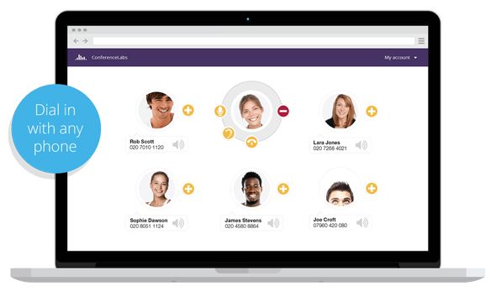

LONDON (UK), 10th February 2014.

ConferenceLabs announces the launch of its free audio conferencing service with a visual interface, solving some of the most common problems with traditional conference calls.

Standard conference calls can be expensive, difficult to use, and filled with call annoyances, like identifying who’s on the call, who said what, and endless interference from callers with background noise.

ConferenceLabs’ conferencing service provides an innovative solution, presenting users with an attractive visual interface that allows them to view and control their calls in real time via the web. No software required.

Accounts are completely free, with 1-click signup, and no contract or fees. Simply enter your email address, share your unique PIN, dial in and start your call. Callers can dial in with any phone and start a conference immediately.

Users can see who’s on the call and who’s speaking at any time, via an intuitive visual interface that’s simple and easy to use. Callers can even sync their contacts to provide detailed social profiles of each participant. Gone are the days of asking for awkward roll calls, or endlessly repeating “who said that?”. Advanced controls allow users to manage calls with a robust feature set. Users are able to mute selected callers, ‘earmuff’ them to temporarily exclude them from listening to the call, or drop them altogether. Conferences can include up to 100 participants.

Premium features such as custom greetings, custom hold music, and unlimited call recording are included as standard. Services are available for UK callers, with plans for international access coming soon.

To learn more about ConferenceLabs’ innovative approach to conference calls, please visit http://www.conferencelabs.com/features.

About ConferenceLabs

ConferenceLabs provides smart, simple, conference calls. Launched in 2014, the company is one of the UK’s most exciting startups, focused on developing innovative solutions to disrupt the traditional audio conferencing market.

ConferenceLabs provides a free audio conferencing service with an intuitive visual interface, allowing users to see who’s on the call and who’s speaking at any time. Sign up with 1-click, share your PIN, and start your call. Dial in with any phone, no software required.

To learn more about ConferenceLabs please visit http://www.conferencelabs.com.

CONTACT press@conferencelabs.com
SOURCE ConferenceLabs
RELATED LINKS http://www.conferencelabs.com
http://www.conferencelabs.com/features

Photos can be downloaded here: http://www.conferencelabs.com/press, further are available on request.

###

