**MEDIA RELEASE**

**Celebrating a record SGD75,000 raised towards a good cause**

*with the launch of “Snowmen on Holidays”, an eco-art installation*

11 December 2018, Singapore – This year, Pan Pacific Hotels Group raised a record **SGD75,000** in its annual fund-raising campaign, together with its Pan Pacific and PARKROYAL hotels in Singapore, in partnership with Mastercard®.

**“World Food Day” campaign raises record SGD75,000**

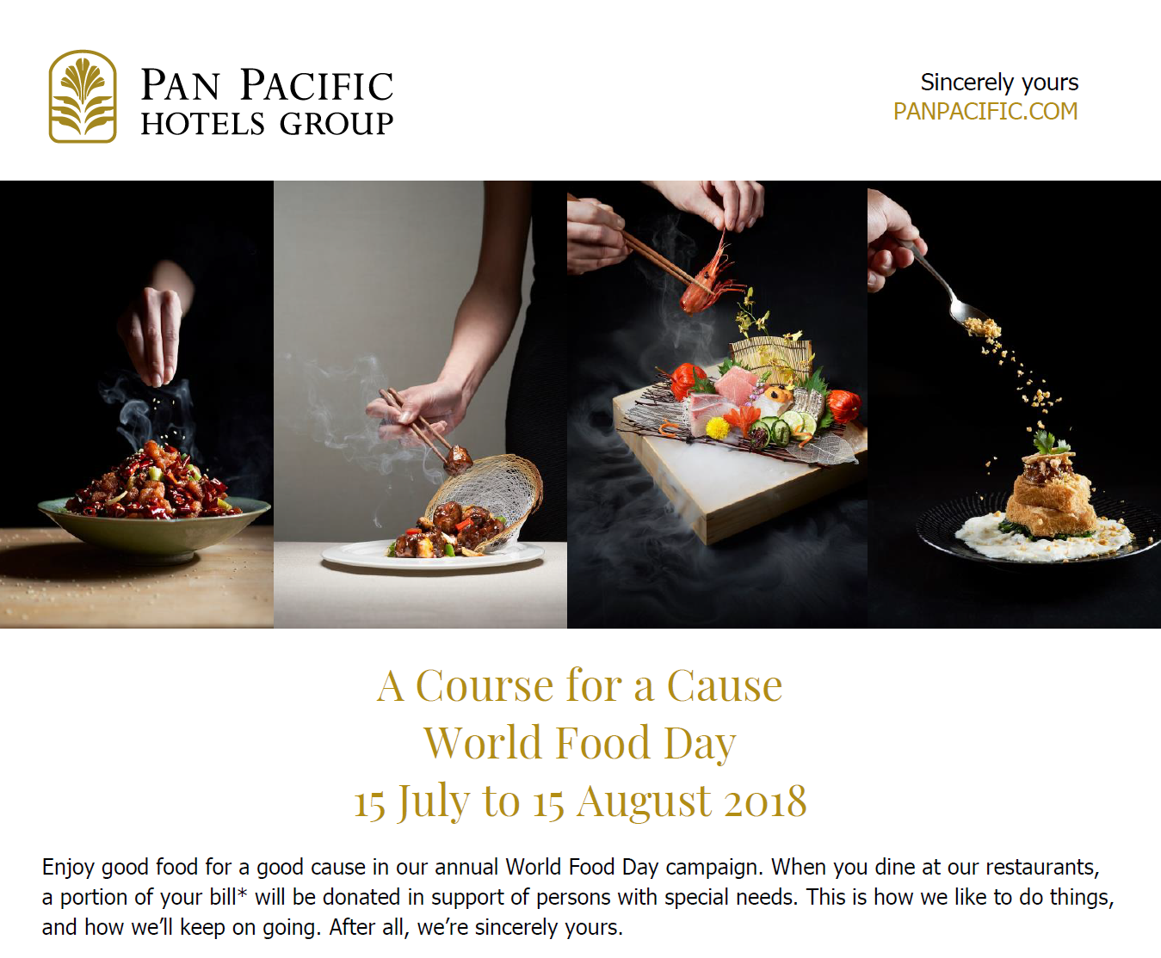

From July to August this year, four Singapore hotels under Pan Pacific Hotels Group donated 1 per cent of the total revenue from their all-day dining restaurants towards purchasing NTUC vouchers for adults with intellectual disabilities from six Day Activity Centres (DACs)[1].

In addition, four specialty restaurants within the hotels donated 20 per cent of the proceeds from their mouth-watering signature dishes towards the cause.

Pan Pacific Hotels Group also partneredMastercard® for the first time this year, where the latter pledged a $10 NTUC voucher for every transaction charged to a Mastercard® at the eight participating restaurants (Annex A). A total of SGD75,000 was raised towards this cause.

**“Snowmen on Holidays” – an eco-art piece co-created with beneficiaries**

To celebrate this achievement, Pan Pacific Hotels Group collaborated with Singapore’s eco-artist Didier Ng on an art installation for Gardens by the Bay, just in time to welcome the festive season. Titled “**Snowmen on Holidays**”, the art work is made completely from recycled materials to demonstrate the Group’s commitment towards sustainable travel.

Under Didier’s guidance, associates and volunteers from Pan Pacific Hotels Group and the beneficiaries from the Day Activity Centres co-created “snowmen” from plastic bottles and discarded fabrics.

The “snowmen” are styled with cameras, suitcases, and sunglasses, and depicted on holiday, swinging leisurely from hammocks. Handcrafted ornaments, similarly made from recycled materials, adorn the Christmas trees. This art installation can be viewed in the Children’s Garden at Gardens by the Bay from now till 2 January 2019.

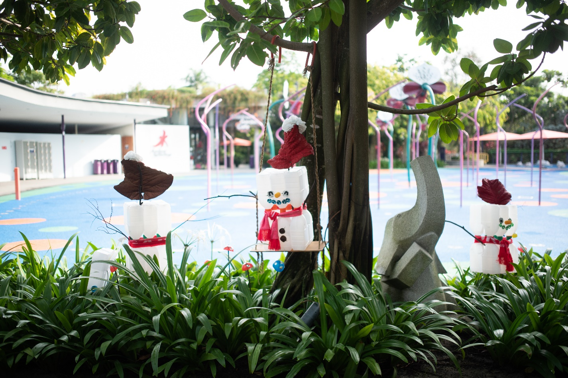

St. Andrew’s Autism Centre (SAAC) DAC client Shawn Soon's sister, Ms Luisa Soon, says, "I appreciate the generosity and initiative by Pan Pacific Hotels Group and SAAC in supporting this event. It's a great opportunity for the clients to celebrate Christmas in line with Disney tsum tsum theme, which I think would have been some part of their childhood too. I am also glad to be able to accompany my brother for the outing and spend quality time with him."

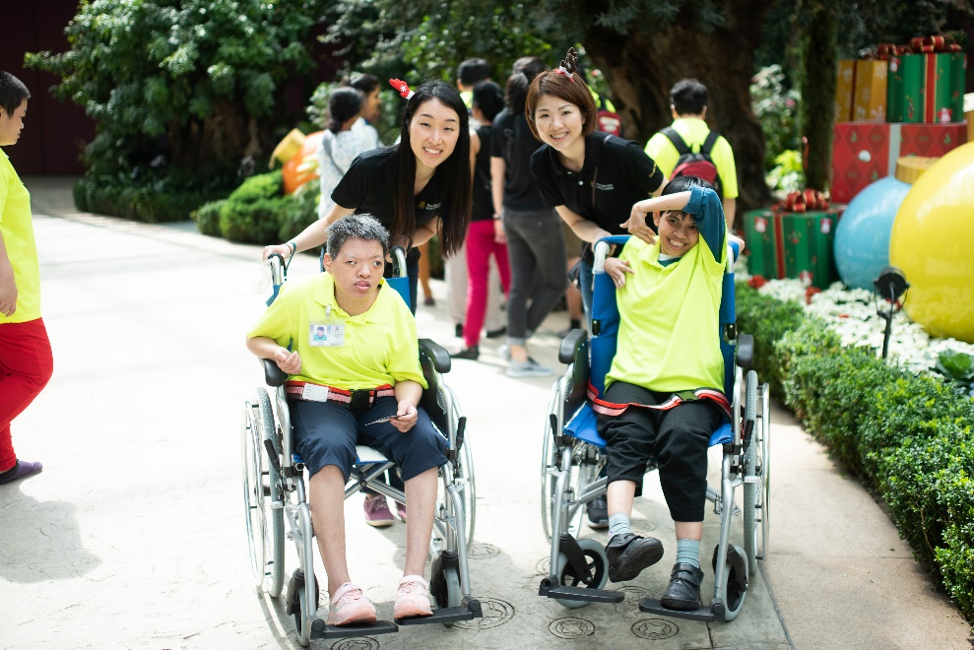

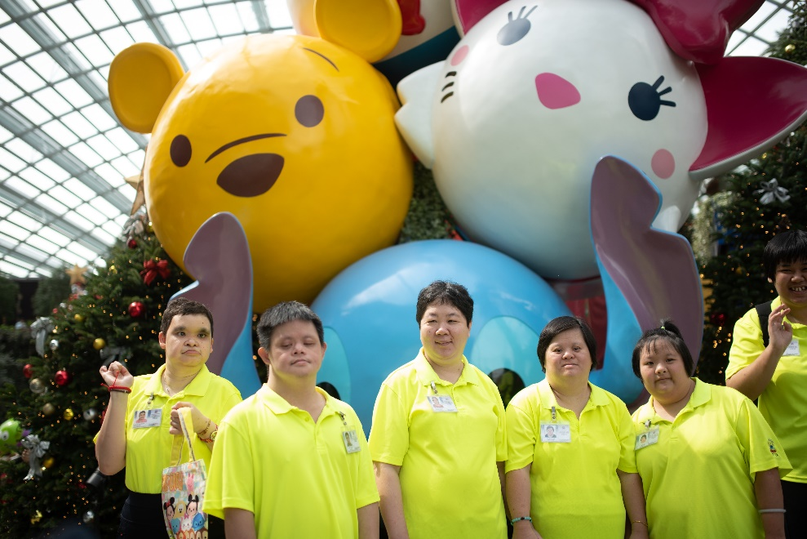

Ms Wee Wei Ling, Executive Director (Asset & Lifestyle), Pan Pacific Hotels Group says, “Throughout the year, we advocate and encourage disability inclusion by training and hiring persons with disabilities at our hotels and serviced suites. Aligned with this cause, we’re delighted to have raised a record amount this year at our annual fundraising campaign, which will allow us to make an even bigger impact on individuals with disabilities and their families. We hope our efforts have brought more joy to them.”

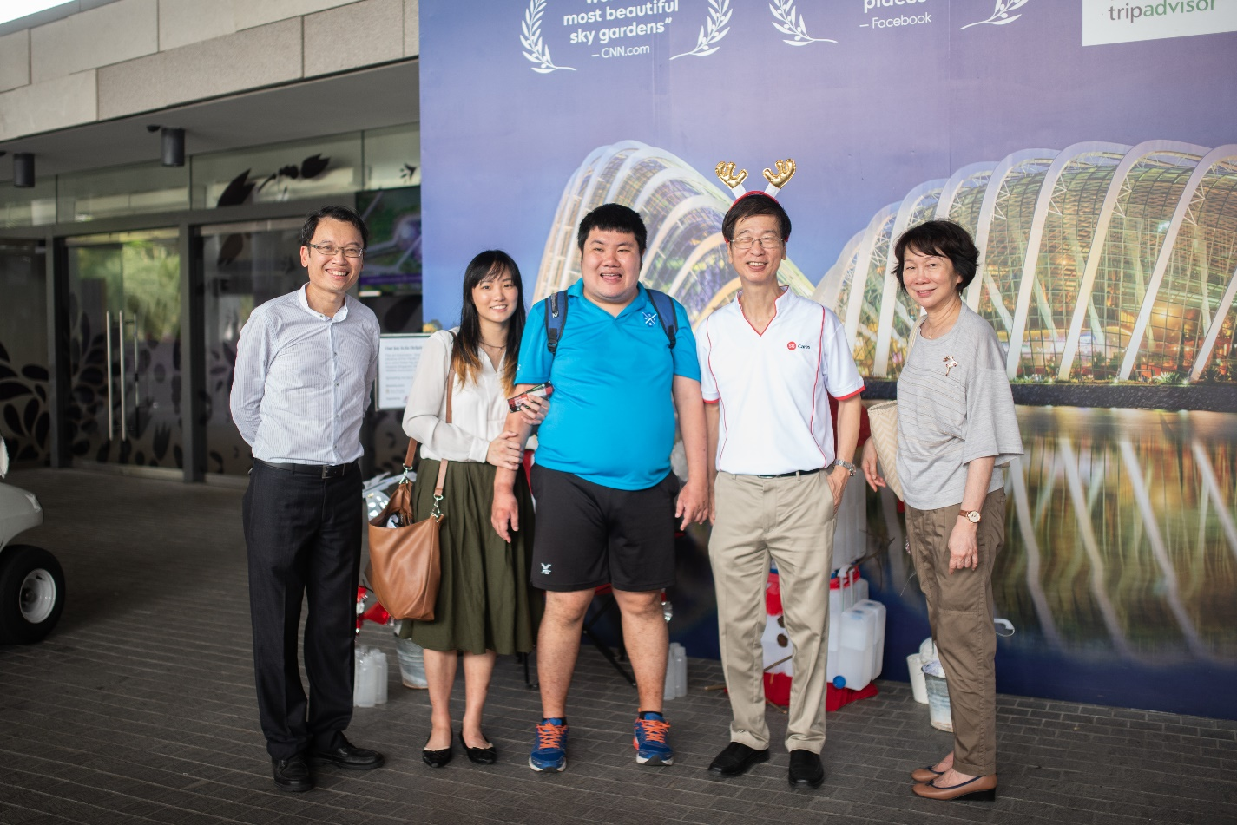

Ms Deborah Heng, Country Manager, Mastercard Singapore, says, “We are delighted to be part of this meaningful initiative with Pan Pacific Hotels Group to support and bring some joy to these beneficiaries. It’s a great opportunity to play our part, whether through the sponsorship of food vouchers with every transaction Mastercard cardholders make at the selected restaurants or by encouraging our employees to lend a hand in co-creating the art installation at the Gardens by the Bay.”

-ENDS-

High-res images can be downloaded [here](https://drive.google.com/open?id=1Gp-SKmusIsT6iaUrCaU63uh6HzHCQP9b).

**Media Contact**

Cuili NG  
Brand & Corporate Communications Manager

Pan Pacific Hotels Group  
Mobile: +65 9634 4425  
Email: [ng.cuili@pphg.com](mailto:ng.cuili@pphg.com)

Kit Pui LEE

Vice-President, Brand Marketing & Communications

Pan Pacific Hotels Group

Mobile: +65 9027 3092

Email: lee.kitpui@pphg.com

**About World Food Day fund raising campaign**

Named Asia’s “Best Regional Hotel Chain”, Pan Pacific Hotels Group is passionate about giving back to the community, and making wholesome food accessible to all has become our annual mission. Each year, we mark World Food Day with a fund raising campaign where a portion of our diners’ food bills is donated towards our adopted charities, which care for individuals with special needs.

This year, a record SGD75,000 was raised from the dining proceeds of 8 hotel and specialty restaurants operated by Pan Pacific Hotels Group in Singapore, which will all go towards purchasing grocery vouchers for our beneficiaries. In a strong bid of support for our fund raising campaign, our partner Mastercard® also contributed SGD40,000 in grocery vouchers.

In Singapore, Pan Pacific Hotels Group partners seven charity homes for the elderly, women, and those with intellectual disabilities by cooking meals for the residents and imparting healthy and tasty recipes to their resident cooks throughout the year.

**About Pan Pacific Hotels Group**

Pan Pacific Hotels Group is a wholly-owned hotel subsidiary of Singapore-listed UOL Group Limited, one of Asia’s most established hotel and property companies with an outstanding portfolio of investment and development properties.

Based in Singapore, Pan Pacific Hotels Group owns and/or manages more than 40 hotels, resorts and serviced suites including those under development in 24 cities across Asia, Oceania, North America and Europe.

Voted “Best Regional Hotel Chain” by readers in Asia-Pacific in 2017 and 2018, Pan Pacific Hotels Group comprises two acclaimed brands: its signature brand, Pan Pacific and its deluxe brand, PARKROYAL.

Sincerity is the hallmark of Pan Pacific Hotels Group. The Group is known to its guests, partners, associates and owners for its sincerity in people and the sense of confidence which alleviates the stresses of today’s complex world.

Visit us at [www.panpacific.com](http://www.panpacific.com).

|  |  |  |  |
| --- | --- | --- | --- |
|  | Name of restaurant/hotel | Signature dish | Contribution amount  (15 Jul – 15 Aug 2018) |
| 1 | Edge, Pan Pacific Singapore |  | 1% of revenue from restaurant including buffets and ala carte dishes |
| 2 | Lime, PARKROYAL on Pickering |
| 3 | Ginger, PARKROYAL on Beach Road |
| 4 | Spice Brasserie, PARKROYAL on Kitchener Road |
| 5 | Hai Tien Lo Chinese Restaurant, Pan Pacific Singapore | Wok-fried Diced Beef Tenderloin with Mushrooms in Black Pepper Sauce | 20% of revenue from signature dish |
| 6 | Keyaki Japanese Restaurant,  Pan Pacific Singapore | Five Varieties of Seasonal Sashimi |
| 7 | Si Chuan Dou Hua Restaurant, PARKROYAL on Beach Road | Chong Qing Diced Chicken with Dried Chilli |
| 8 | Si Chuan Dou Hua Restaurant, PARKROYAL on Kitchener Road | Bean Curd Medley |

Annex A

1. These Day Activity Centres are operated by Autism Association Singapore, Cerebral Palsy Alliance Singapore, Metta Welfare Association, and St Andrew’s Autism Centre. Day Activity Centres equip adults with intellectual disabilities with living and community living skills to maximise their independence, and also provide respite to their caregivers.