Essential tips on how to better interact with potential clients on the Internet
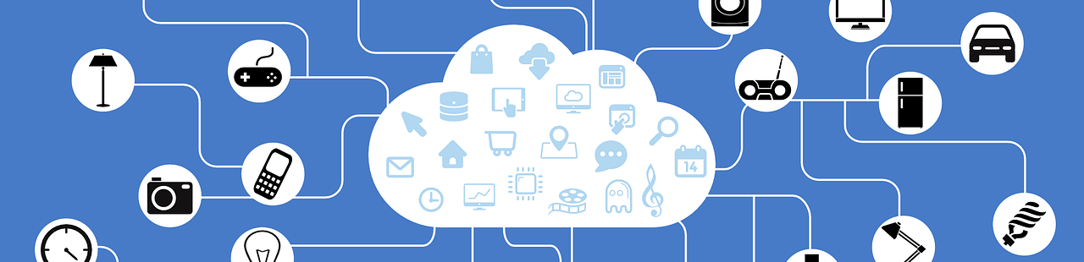

As a trader, your goal is to sell machines, improve your business and increase your revenue. It cannot be said enough: in order to achieve this, you need to be online. Internet is where everything happens. Everything is being digitalized – even the machinery market – and you need to follow the trend in order to grow your business and not just leave parts of the market to competitors.
In the traditional sales funnel, consumers start with a bunch of different company options and end up by reducing that number to your brand. In this article, we’ll go through the customer journey, and see how you can adapt this model to your website.
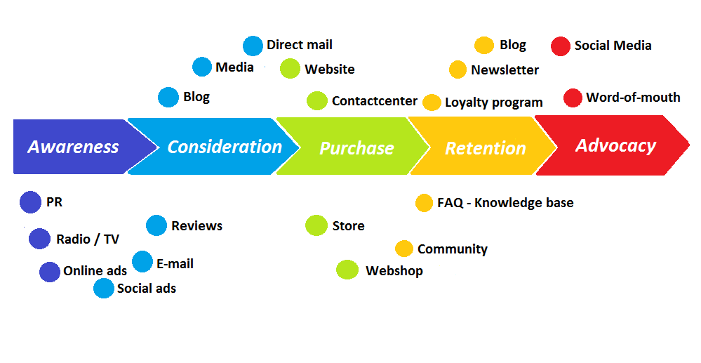
1. HOW TO GET PEOPLE TO KNOW YOU ON THE INTERNET?
In order to buy your products, people need to know that you exist and they need to know that your website will fulfill their needs.
What can you do?
- Talk about your website with current or former clients.
- Be sure that potential clients know who you are! Maybe you can have a free article in the local newspaper with an introduction to your business?
- Be sure to appear in Google (or Yahoo or Bing or any other search engine). This is a pretty long-term undertaking, but there are so many easy little steps that you can do to quickly improve your visibility:
  - Improve the technical aspects of your website
  - Have a responsive design, in order to be well featured on the mobile searches
  - Improve the way you appear in Google searches
  - The more relevant links you have to your website, the more valuable in the eyes of Google you will be. So, as said, you can try to contact specialized websites to have them write about you, and link to your website.
2. HOW TO MAKE USERS TO CONSIDER BUYING YOUR PRODUCTS?
Once the relevant users are aware of your business, you need to build trust that will make them want to buy on your website.
What can you do?
- Remind them you exist! Send regular emails with your most appealing offers.
- Fulfill their expectations when they click on your website in Google searches. Don’t make promises you can’t keep, so adjust your meta description accordingly.
- Give customers reasons to trust you: they need to choose your website over your competitors!
  - Have a nice and clear structure: Be sure to have relevant categories and filters displayed, like Surplex has:
  - 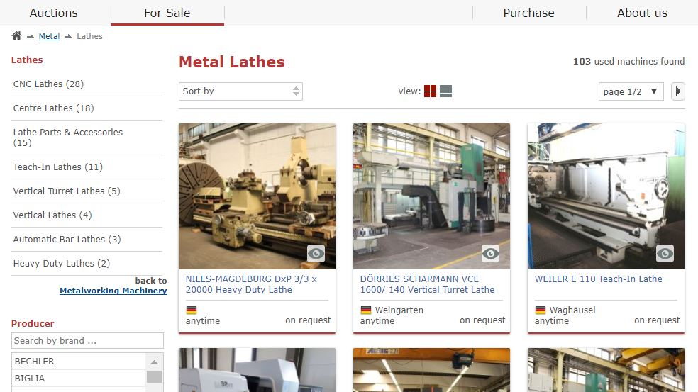
  - Display testimonials from your former buyers: Would you buy a machine on a website knowing you’re the first one to do so? I doubt it…
- Give users the possibility to directly contact you, in case they have questions.
3. HOW TO MAKE POTENTIAL CLIENTS BECOME REAL CLIENTS?
Once you gained your visitors’ trust, you need to turn them into clients, and trust me, it is not as easy as it seems. Just consider your own user experience! It is very common to compare different websites before buying. Now, you need to make your visitor think: “That’s the one!”.
What can you do?
- Overcome consumers’ fear to buy online: Buying a machine online is much more involvement than just buying a book, so you need to make sure that your website looks secure.
- Clean your website from old offers: You don’t want visitors to get crazy for an offer that no longer exists.
- Keep in mind the user experience. Buying a machine requires several steps: the user will ask for a cost estimation and more details/photographs, make the decision of buying or not, pay online, etc. Just be sure that every step is optimized for users: clear, easy to understand, secure.
- Work on your machine representation
4. HOW TO BUILD A TRUSTWORTHY RELATIONSHIP WITH YOUR CLIENTS AND KEEP THEIR TRUST?
Research shows that it costs up to 30 times as much to get a new client than to keep one. Also, increasing customer retention rates by 5% boost profit by 25% to 95%. It is therefore essential that you retain your clients after their first purchase! You should build a trustworthy relationship with your customers instead of forgetting their existence after they enter their credit card information on your website.
What can you do?
- Satisfy them with the machine and the buying process: This might sound obvious, but an easy way to satisfy your client is simply to make the purchase process as smooth as possible:
  - Have all the relevant information on your website: a guide on what to pay attention to when buying used machinery, location, size, volume, payment information, shipping information
  - Be available for any questions via phone or via emails
  - Offer a secure platform
  - Thank them for their purchase!
- Value their opinion as users: After they bought a product from you, try to get constructive feedback from them. What did they like? What did they not like? Why? It will help you improve your platform and be more user-friendly.
- They shouldn’t forget about you! You can keep in touch with them via email, since you know what they are interested in. For example, you can send them your best offers a week before putting them on your website!
5. HOW TO MAKE YOUR CLIENTS SPREAD THE WORD?
A dissatisfied customer will tell between 9-15 people about their experience. However, a happy customer who gets an issue resolved will only tell about 4-6 people about their experience. So it is very important to encourage your satisfied customers to spread the word!
What can you do?
- Ask them to spread the word around! As any professional, they have a network and work with people who might be interested in your product. Maybe you could even set up a sponsor system: if they recommend your website to someone who buys, then they’ll get a discount.
- Ask them to help you improve your online reputation! You can, for example, set up a review system that will appear on Google.
- 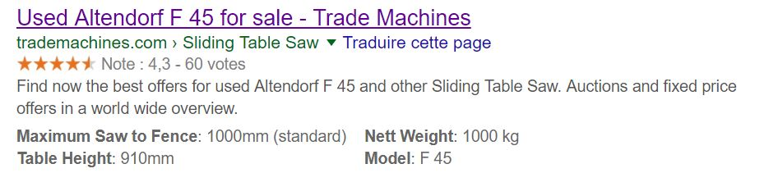

There are plenty of little things that you can do in order to improve your user experience and, therefore, increase your revenue. Be ready to step up your game online!

