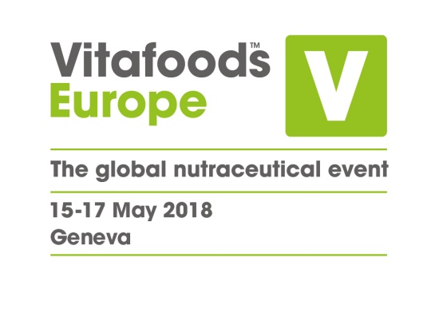

**15 February 2018**

**PRESS RELEASE**

**Regulation frustration:**

One in three industry professionals

finds EU framework unhelpful

The number of nutrition industry professionals who find the EU regulatory framework unhelpful has risen sharply over the past year, research shows.

One in three (33%) industry professionals surveyed by the organisers of Vitafoods Europe said the current EU regulatory environment is unhelpful, up from 25% at the start of 2017.* Although 34% find the framework helpful, this figure has dropped from 37%.*

Experts believe dissatisfaction has risen because of the EU’s tough stance on health claims and the continuing regulatory deadlock on botanicals. “The increasing frustration is not surprising,” says Dr Annegret Nielsen, Senior Consultant at analyze & realize. “Despite progress in some areas, the regulatory challenges for the industry have remained, or even increased, over the past year. It is currently very hard for companies to develop innovative products that comply.”

**Call for overhaul of health claims regulations**

Over a quarter (28%) of respondents to the Vitafoods Europe survey said the EU policy change that would most help their business was an overhaul of health claims regulations.

This may be because it has become too difficult to get a health claim approved. “I think many in the food and supplement industry are frustrated with EFSA’s tough stance on the Nutrition & Health Claim Regulation,” said Dr Elinor McCartney, President, Pen & Tec Consulting Group. “Once they established the GAS (Generally Accepted Science) claims list, companies found it extremely hard – and very expensive – to achieve new claims. The industry has worked hard to comply but many feel the compliance pendulum has swung too far towards ‘mission impossible.’”

Dr Iris Hardewig, Head of Consulting & Strategic Innovation at analyze & realize, said the low number of approvals is a disincentive to research and development. “The frustration is high because clinical trials are a major investment for food companies. If it doesn’t lead to any competitive advantage, they refrain from investing in science. In that sense, the execution of the health claim regulation is not satisfactory, either for the industry or for the consumer.”

**Botanical bottleneck**

A particular area of concern is the current deadlock on the regulation of botanicals. Thousands of botanical health claims have been on hold for several years while EFSA considers how to evaluate them.

“The regulation of botanicals is a hot topic and a legal disaster area” said Dr McCartney. “The EC and member states seem unable to agree on how to sort out the anomaly that health claims are allowed on traditional herbal remedies, but the same claims are prohibited on food botanicals unless a dossier passes EFSA.”

One solution that has been proposed is sector-specific regulation for botanicals. A fifth (19%) of respondents to the Vitafoods Europe survey said this was the policy change that would most benefit their business.

Whatever the way forward, experts believe the current regulatory void is stifling innovation. “For large companies who invest strongly into product development, legal certainty is absolutely necessary,” said Dr Hardewig. “Not only are botanical claims applications on hold, but the situation also discourages new developments.”

**Guidance through the regulatory maze**

Vitafoods Europe 2018 (May 15-17 in Palexpo, Geneva) offers a range of support and advice for visitors trying to navigate the regulatory maze. Resources will include the Advice & Expertise Trail – a self-guided tour leading visitors to top consultancy agencies with expertise in regulation (as well as product development, clinical research, market research and marketing). Many of the event exhibitors will offer a wealth of knowledge on regulation and there will also be expert presentations on Vitafoods Centre Stage, as well as sector-specific advice in areas such as the Sports Nutrition Zone.

Meanwhile, a series of Business and Development Forums in the Vitafoods Education Programme, which runs alongside the Exhibition, will provide insights on recent and upcoming regulatory developments. In one of these, Patrick Coppens of EAS Strategies will outline the step by step process to register health claims. As a case study, the Forum will evaluate the current status of probiotics and why it is so difficult to register a claim in this category. Other Forums will explore topics such as microbiome product development and the new Novel Food Regulation and authorisation process.

**Hope for the future**

The EU is currently reviewing nutrition regulation through the Commission’s Regulatory Fitness and Performance (REFIT) programme, which aims to keep EU law simple. Experts hope it will reduce the burden on the industry: “REFIT will hopefully bring a sense of proportion as well as insights into how the situation can be improved” said Dr Nielsen. “There are useful products between conventional food and drugs that might evaporate due to the current regulations.”

“EFSA plays a key role in the evaluation of existing and new food components” said Dr McCartney. “But it would be even better if they looked at reducing bureaucratic delays. They should listen to stakeholders then do what needs to be done, focusing on maximum effect for minimum investment while preserving the EU’s excellent food safety record.”

Vitafoods Europe takes place between the 15th and 17th of May in Palexpo, Geneva. For more information visit:

<http://www.vitafoods.eu.com/?utm_source=PR&utm_campaign=REG&utm_medium=PRE>

* Vitafoods Europe surveyed 208 nutrition industry representatives between 14 November and 4 December 2017. The same questions about regulation were previously asked in a survey of 190 nutrition industry professionals between 6 December 2016 and 3 February 2017.

**About Vitafoods Europe**

Vitafoods Europe is the global nutraceutical event, featuring exhibitors from all over the world in four key market areas: ingredients & raw materials; branded finished products; contract manufacturing & private label; and services & equipment. The event offers a range of visitor attractions, including an industry-leading Education Programme.

Vitafoods Europe is part of Informa Exhibitions’ Global Health & Nutrition Network (GHNN), which brings together a portfolio of events, digital media and publishing for marketers, manufacturers and formulators of nutrition and dietary supplements, healthy foods/beverages and personal care products. GHNN’s events include Vitafoods Europe, Vitafoods Asia, SupplySide West, SupplySide East and SupplySide China.

Natural Products INSIDER is the global media brand covering healthy ingredients and finished applications. Vitafoods Insights offers expert online content and a series of topic-specific digital magazines that bring highlights of the Vitafoods events to a global audience. [SupplySide](http://storefronts.supplysideshow.com/) Connect is the always-on directory of ingredients, products and services that provides in-depth information about the companies that supply to the market. For more information, visit [www.informaglobalhealth.com](http://www.informaglobalhealth.com/).

Informa’s Global Exhibitions Division organises transaction-oriented exhibitions and trade shows, which provide buyers and sellers across different industries and communities with a powerful platform to meet face-to-face, build relationships and conduct business. Informa has a portfolio of more than 150 exhibitions, serving a number of core verticals, including Health & Nutrition, Beauty, Property & Construction and Pop Culture.