Jessica Bäckman is ready for the season finale at Hockenheimring
October 21st–23rd it’s time for the season finale in ADAC TCR Germany at the Hockenheimring track in Germany. The Sweden National Team driver Jessica Bäckman is ready for the final race and aims high.
- Hockenheim is my favorite track on the calendar, it has all kinds of corners and the race is usually exciting there. I will enjoy every lap I get in the car this weekend and of course aim to end the season the same way I started, with a victory, Jessica Bäckman says.
The 2022 ADAC TCR Germany season consists of five rounds in Germany and two rounds in Austria. The series is one of the toughest TCR series in the world and has a high status for the drivers who come from several different countries around Europe. The season started at the Oschersleben track in Germany where Jessica took her first win of the season, and will end next weekend at the well-known Formula 1 track Hockenheimring in Germany.
Jessica competes just like at the Sachsenring round together with the Belgian Comtoyou team in her Audi RS 3 LMS car and is currently placed in second place in the drivers' championship ahead of the season finale.
- I am looking forward to drive again at Hockenheim, the last time I drove there was in 2019 in TCR Europe and TCR Germany and it went well both times. Now I hope for another good weekend with good speed right from the start. Then I will do everything I can to end a very successful season on top, Jessica Bäckman says.
﻿
﻿
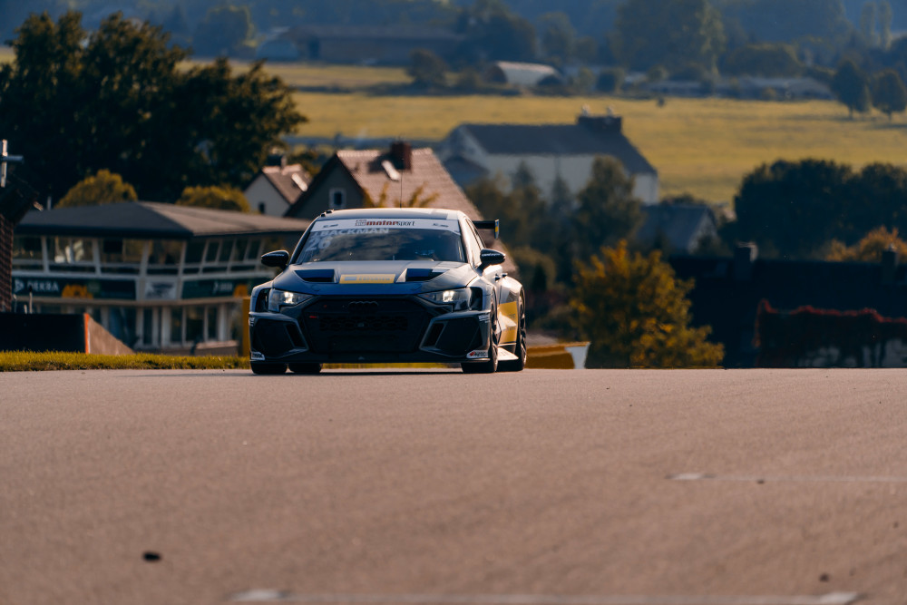
Structure of the race weekend
On Friday, the weekend starts with two practice sessions of 25 minutes, and the day ends with the first time qualifying in the afternoon. The time qualifying(Q1) is 20 minutes long and determines the starting position for Race 1 on Saturday, where it is important to drive as fast as possible when the lap times are counted. On Saturday, Race 1 runs in the morning and then the second time qualifying (Q2) runs in the afternoon, which determines the starting position for Race 2 on Sunday. Points are awarded to the top eight in the time qualifying’s and the top 15 in each race. The driver the most points after Race 2 on Sunday takes home the ADAC TCR Germany drivers’ championship.
﻿﻿
Time schedule for this race weekend:
(all times in CET)
Friday October 21st:
09:40 Free practice 1
13:40 Free practice 2
17:40 Qualifying 1 (Q1)
Saturday October 22nd:
11:35 Race 1 TV link for Race 1
17:40 Qualifying 2 (Q2)
Sunday October 23rd:
11:35 Race 2 TV link for Race 2
Live-streaming
Both races can be live streamed at motorsport.tv
Race 1: Click to watch Race 1
Race 2: Click to watch Race 2
Both races can also be seen in replays at www.youtube.com/adacmotorsports och Motorsport.tv﻿
Live-timing
﻿﻿﻿All free practice sessions, qualifying and races can be followed via live timing ﻿https://www.adac-motorsport.de/adac-gt-masters/live-timing﻿
﻿About the track:
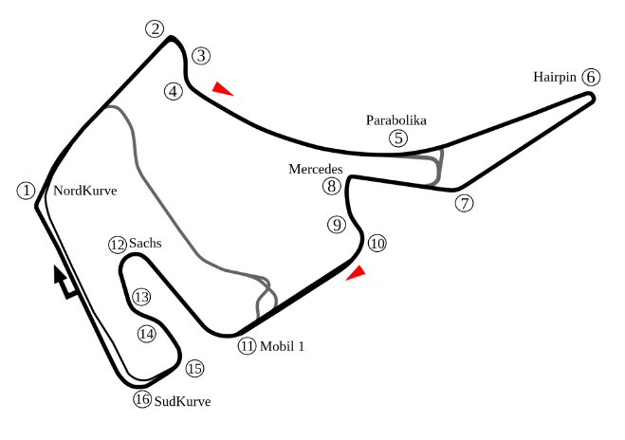
Location: Hockenheim, Germany
Length: 4,574 km
Corners: 16
Race length: 30 minutes + 1 lap
ADAC TCR Germany Calendar 2022:
April 22nd-24th - Oschersleben, Germany
May 20th-22nd - Red Bull Ring, Austria
June 17th-19th - Salzburgring, Austria
August 5th-7th - Nürburgring, Germany
August 19th-21st - Lausitzring, Germany
September 23rd-25th - Sachsenring, Germany
October 21st-23rd - Hockenheim, Germany
Championship Standings:
ADAC TCR Germany - Overall (Top Three)
ADAC TCR Germany 2022 (after 6 out of 7 race weekends)
1: Martin Andersen (DKK), 374 p.
2: Jessica Bäckman (SWE), 281 p.
3: Szymon Ladniak (POL), 243 p.
Click to see the full championship standings
Free rights to use images

