**KYLIE GETS FESTIVE WITH HER NEW ALBUM ‘KYLIE CHRISTMAS’ ON NOVEMBER 13TH ON PARLOPHONE RECORDS. GUESTS ON THE ALBUM INCLUDE IGGY POP, JAMES CORDEN - AND A POSTHUMOUS APPEARANCE BY FRANK SINATRA.**

**A DUET WITH DANNII MINOGUE APPEARS ON THE DELUXE VERSION OF THE ALBUM**

**KYLIE WILL PLAY A VERY SPECIAL CHRISTMAS SHOW AT LONDON’S ROYAL ALBERT HALL ON DECEMBER 11TH – HER FIRST EVER HEADLINE SHOW AT THE PRESTIGIOUS VENUE.**

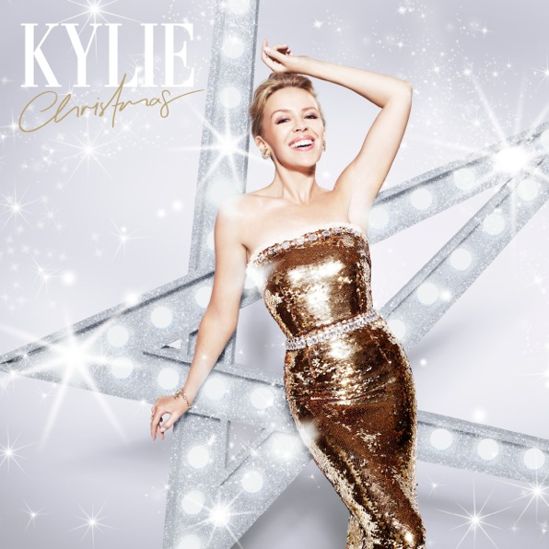

Kylie will release her brand new album ‘Kylie Christmas’ on November 13th. All tracks on the album were produced by Kylie’s long-standing musical director Steve Anderson, except ‘White December’ and ‘Cried Out Christmas’ which were produced by Matt Prime and ‘Everyday’s Like Christmas’ by Stargate.

Recorded at Angel Studios and Sarm Music Village, the album features 13 tracks – including several duets and a mix of original and classic songs. Kylie has enlisted the help of her sister Dannii Minogue for the deluxe version of the album, recording the brand new song 100 degrees – set to be a disco Christmas classic! James Corden features on Yazoo’s brilliant ‘Only You’, Iggy Pop joins Kylie on the Waitresses festive hit, ‘Christmas Wrapping’ while Frank Sinatra posthumously completes the roll call of collaborators, appearing on ‘Santa Claus Is Coming To Town’.

Three brand new tracks feature on the main album, ‘White December’, ‘Christmas Isn’t Christmas ‘Til You Get Here’ and ‘Every Day’s Like Christmas’ and a further three on the deluxe edition – ‘Oh Santa’, ‘100 Degrees’ and ‘Cried Out Christmas’. Ranging from slow and sultry to disco, all six of the tracks truly encompass the Christmas spirit.

A DVD featuring 6 of the tracks will also be available, giving fans a glimpse of Kylie in the studio.

To celebrate the album, Kylie will be performing at the Royal Albert Hall on December 11th.

Kylie said, *“to perform at the Royal Albert Hall will be a dream come true. I can’t wait for the 11th December to share a night of joy and celebration with everyone”*

Tracklisting for ‘Kylie Christmas’:

Standard

1.       It’s The Most Wonderful Time Of The Year

2.       Santa Claus is Coming to Town featuring Frank Sinatra

3.       Winter Wonderland

4.       Christmas Wrapping (With Iggy Pop)

5.       Only You (With James Corden)

6.       I’m Gonna Be Warm This Winter

7.       Every Day’s Like Christmas

8.       Let It Snow

9.       White December

10.   2000 Miles

11.   Santa Baby

12.   Christmas Isn’t Christmas ‘Til You Get Here

13.   Have Yourself A Merry Little Christmas

Deluxe

14.   Oh Santa

15.   100 Degrees (With Dannii Minogue)

16.   Cried out Christmas

DVD

1. It’s Most Wonderful Time of the Year
2. 2000 Miles
3. Christmas Isn’t Christmas ‘Til You Get Here
4. 100 Degrees (With Dannii Minogue)
5. I’m Gonna Be Warm This Winter
6. Oh Santa

‘Kylie Christmas’ will be released on November 13th on digital standard, digital deluxe, CD standard, CD deluxe through Parlophone.

The album will be released on vinyl on November 27th

Tickets for the Royal Albert Hall show will go on sale at XXX on XXXXX from the following website:

[www.royalalberthall.com/tickets/events/2015/a-kylie-christmas](http://www.royalalberthall.com/tickets/events/2015/a-kylie-christmas)

<http://www.kylie.com/>

For more information please contact:

Murray Chalmers PR

[www.murraychalmers.com](http://www.murraychalmers.com)

020 7361 0730

[sarah@murraychalmers.com](mailto:sarah@murraychalmers.com)

[murray@murraychalmers.com](mailto:murray@murraychalmers.com)

02/10/15