World Summit Tour 2017
—a brand new scientific experience
within implant dentistry
Press Contact
Kerstin Wettby
Senior Manager
Global Communication & PR

Dentsply Sirona Implants
Aminogatan 1
SE-43121 Mölndal, Sweden
Phone: +46 705 16 32 02
kerstin.wettby@dentsplysirona.com

About Dentsply Sirona Implants
Dentsply Sirona Implants offers comprehensive solutions for all phases of implant therapy, including
Ankylos®, Astra Tech Implant System™ and Xive® implant lines, digital technologies, such as Atlantis™ patient-specific CAD/CAM solutions and Simplant® guided surgery, Symbios®
regenerative solutions, and professional and business development programs, such as STEPPS™. Dentsply Sirona Implants creates value for dental professionals and allows for predictable and lasting implant treatment outcomes, resulting in enhanced quality of life
for patients.

About Dentsply Sirona
Dentsply Sirona is the world’s largest manufacturer of professional dental products and technologies, with a 130-year history of innovation and service to the dental industry and patients worldwide. Dentsply Sirona develops, manufactures, and markets a comprehensive solutions offering including dental and oral health products as well as other consumable medical devices under a strong portfolio of world class brands.
As The Dental Solutions CompanyTM, Dentsply Sirona’s products provide innovative, high-quality and effective solutions to advance patient care and deliver better, safer and faster dentistry. Dentsply Sirona’s global headquarters is located in York, Pennsylvania, and the international headquarters is based in Salzburg, Austria. The company’s shares are listed in the United States on NASDAQ under the symbol XRAY.
Visit www.dentsplysirona.com for more information about Dentsply Sirona and its products.
Press Release

September 2016—In 2017, Dentsply Sirona Implants welcomes dental professionals from all over the world to the World Summit Tour, a scientific congress on implant dentistry. The combination of renowned international and regional speakers and a highly multifaceted program makes this state-of-the-art scientific congress unique to the dental industry.

The foundation of Dentsply Sirona Implants is innovation based on a thorough scientific approach. This commitment is also at the core of the World Summit Tour. From February to November 2017, this interactive, dynamic scientific congress will visit Tokyo, San Diego, Nice and Shanghai. The theme is “Because inspiration and confidence matters,” which mirrors Dentsply Sirona Implants’ dedication to improved oral health and enhanced quality of life for patients worldwide.

The objective of the World Summit Tour is to inspire clinicians and researchers to share scientific knowledge and clinical experience and discover the latest developments in implant dentistry. Thanks to the mix of internationally renowned speakers and local speakers, each tour stop will be exclusive to the participating audience. This gives dental professionals the possibility to attend a congress that is geographically close and tailored to the needs of the regional market. Also, the program is personalized to best fit each participant’s interests and needs by combining general sessions, hands-on workshops, and a choice of various parallel sessions. All in all, around 150 speakers and moderators will attend the four tour stops to discuss the latest ideas, innovations and scientific data in their area of ​​expertise. In addition, each tour stop features a Poster Competition in the two categories Clinical Application and Research.

Each tour stop lasts for two days and will help researchers, clinicians and the dental team to share their knowledge. The development of the scientific program is managed by the International Scientific Committee, including acclaimed scientists Jan Lindhe (Sweden), Clark Stanford (US), Christoph Hämmerle (Switzerland), Tomas Albrektsson (Sweden), Ye Lin (China), Meike Stiesch (Germany) and Tetsu Takahashi (Japan).

Destinations/dates for the World Summit Tour:
Tokyo, February 18-19
San Diego, May 12-13
Nice, June 23-24
Shanghai, November 25-26

For more information about the World Summit Tour, registration dates, the venues and the development of the scientific program, please visit worldsummittour.com

IMAGES
are available in our News & Press Room at:
www.dentsplyimplants.com/en/Resources/News-and-Press
 | 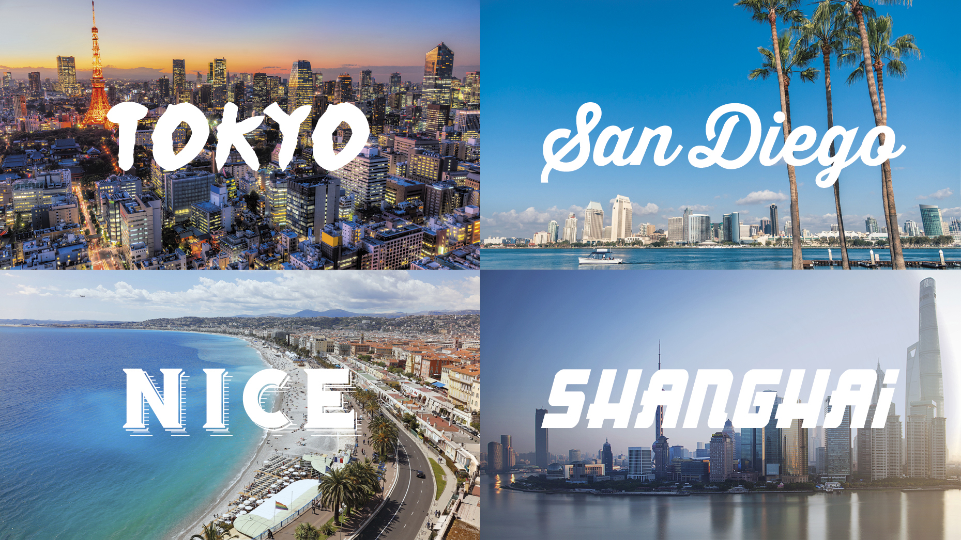
Fig.1: World Summit Tour 2017 | Fig.2: World Summit Tour 2017

