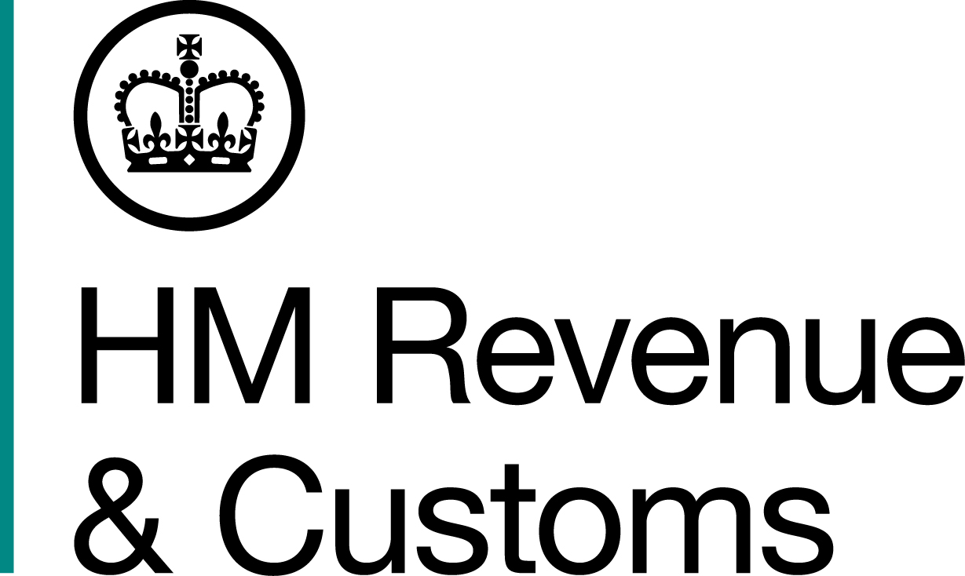
News Release

 | For the attention of News Desks |  | No of pages: 3
 | Date: | 9 November 2016 | Ref: | NTH 09 16

Glazing salesman in double tax scam

A South Yorkshire double glazing salesman who was convicted of a £144,000 tax fraud has been jailed – after evading a further £20,000 while on bail awaiting sentence.

Self-employed Jonathan Wright, 36, formerly of Clough Road, Rotherham, admitted failing to declare five years’ income – totalling more than £530,000 – to HM Revenue and Customs (HMRC) at Leeds Crown Court in March 2016.

The conman’s sentencing was postponed for six months to allow him to repay the money, but Wright went on to offend further, submitting a false VAT return in a plot to reduce his debt to HMRC by £20,346.

Sandra Smith, Assistant Director, Fraud Investigation Service, HMRC, said:

“Wright was given an opportunity to make good what he owed. Instead, he stole yet more money from the taxpayer. He blew his chance, and that greed and naivety has cost him his liberty.

“Crooks like Wright create an uneven playing field for the honest majority. That’s something we won’t tolerate, and I urge anyone with information on this type of fraud to contact the Customs Hotline on 0800 59 5000.”

Wright’s lucrative time under HMRC’s radar was first brought to an end by a taskforce set up to examine the tax affairs of self-employed salespeople working in the double glazing industry.

During interview, in February 2015, Wright said he believed his taxes were deducted ‘at source’, and that he wasn’t required to submit a Self Assessment return. The fraudster answered ‘no comment’ to all questions when interviewed for a second time in September 2016.

Wright pleaded guilty to nine counts of being knowingly concerned in the fraudulent evasion of Income Tax and VAT at Leeds Crown Court on 8 March 2016 and two further counts on 8 November 2016. He was sentenced to 12 months in prison by His Honour Judge Spragg.

Notes to Editors
- Jonathan Wright, Clough Road, Rotherham, South Yorkshire. DOB: 18/06/1980
- Taskforces bring together various HMRC compliance and enforcement teams for intensive bursts of activity targeted at specific sectors and locations where there is evidence of high risk of tax evasion and fraud. The teams visit traders to examine their records and carry out other investigations. More than 140 taskforces have been launched since 2011 bringing in more than £404 million, protecting this money for public services.
- Wright made a repayment of £61,200 after his conviction and before the new offences came to light.
- Follow HMRC Press Office on Twitter @HMRCpressoffice
- HMRC's Flickr channel: www.flickr.com/hmrcgovuk

Issued by HM Revenue & Customs Press Office

Press enquiries only please contact:

Joshua Shrimpton-Dean
Tel: 03000 554556 / 07469 023 445
Email: joshua.shrimpton-dean@hmrc.gsi.gov.uk
Or
Natalie Brown
Tel: 03000 519123 / 07464 982 005
Email: natalie.brown@hmrc.gsi.gov.uk

Out of hours
Tel: 07860 359544

Website www.gov.uk/hmrc

